PHASE TWO MECHANICAL PUMPING PRINCIPLES AND
CENTRIFUGAL PUMPS TEST

CANDIDATE NAME: ……………………………………… GROUP NO: …………..

PASS
Needs more training: DATE: ……………………….

ASSESSOR: ………………………………PRINT: ………………………………SIGN

- Describe three methods of increasing a centrifugal pumps performance and delivery pressure without reducing its flow.

- Increase the impeller diameter

- Increase the speed

- Raise the suction head pressure

2 List and describe the procedures involved in starting up a centrifugal pump

1. Ensure the bearing arrangement has an oil supply
2. Check that all auxiliary feeds are working (seal or gland flush, bearing oil heating/cooling feeds)
3. Fully open the suction valve making sure any suction filters are clear.
4. Prime the pump by flooding the volute case and venting any gas.
5. Ensure the discharge valve is throttled in to no more than ¼ open.
6. Start the pump and ensure it turns in the correct direction (note; - if the electric motor wiring has been changed and the motor is running in the wrong direction, the pump will still pump but with a greatly reduced performance)
7. Slowly open the discharge valve to fully open while monitoring the discharge pressure increase.
8. Check for any leakage, undue noise, vibration and signs of overheating and adjust any shaft glands very carefully as required.

3 Give one application for each of the following types of impellers and describe why it’s used.

Closed

General purpose liquid trasfere

Open

Slurries or high level of solids

Double Suction

Low suction head condisions

4 Which valve should never be restricted on a centrifugal pump?

The suction valve

5 What is meant by the term Axial Thrust and describes how this happens in regard to centrifugal pumps?

The rotating element pull towards the suction eye of the pump

6 Describe three ways that the effects of axial thrust can be eliminated or controlled

a Fitting an impeller with balance holes

b Double suction impeller

c Using a discharge balance piston

7 What does N.P.S.H.A. stand for and describe what the effect is if it is a low value or a high value.

(Net Positive Suction Head Available), and it is directly linked to the pump discharge pressure

8 A centrifugal pump has been electrically wire up the wrong way resulting in the impellor rotating in the wrong direction what effect would this have on the on the process fluid flow direction , the pump performance , and how would this mistake be identified by the operator.

The pump will pump but the performance is very poor

9 Draw and compare a system curve graph (pressure head and flow) to a pump curve graph describe the relationship between the two and where the duty point should be in percentage terms for a correctly sized pump for that system.

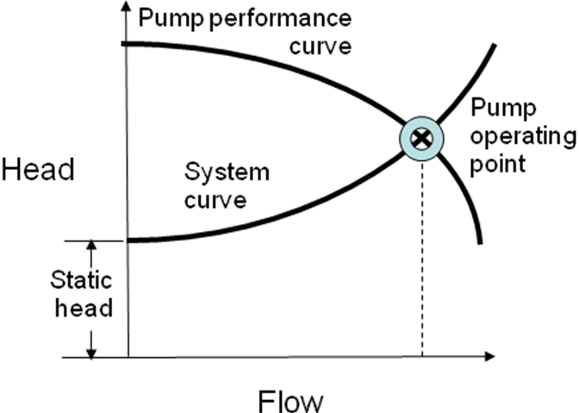

10 Cavitation can have a very detrimental effect on a centrifugal pump, what is cavitation and describe two route causes.

Cavitation occurs when vapour bubbles form
and then subsequently collapse as they move
along the flow path of the impeller.

