Mechanical Seals

General Information
A mechanical seal is a sealing device which forms a running seal between rotating and stationary parts. They were developed to overcome the disadvantages of compression packing. Leakage can be reduced to a level meeting environmental standards of government regulating agencies and maintenance costs can be lower. Advantages of mechanical seals over conventional packing are as follows:
- Zero or limited leakage of product (meet emission regulations.)
- Reduced friction and power loss.
- Elimination of shaft or sleeve wear.
- Reduced maintenance costs.
- Ability to seal higher pressures and more corrosive environments.
- The wide variety of designs allows use of mechanical seals in almost all pump applications.
The Basic Mechanical Seal
All mechanical seals are constructed of three basic sets of parts as shown in Fig. 9:
- A set of primary seal faces: one rotary and one stationary ? shown in Fig. 9 as seal ring and insert.
- A set of secondary seals known as shaft packing’s and insert mountings such as 0-rings, wedges and V-rings.
- Mechanical seal hardware including gland rings, collars, compression rings, pins, springs and bellows.

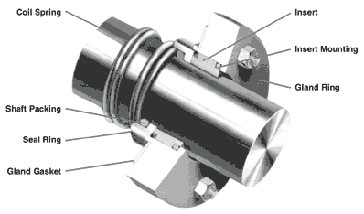

Fig. 9 A Simple Mechcanical Seal

How A Mechanical Seal Works
The primary seal is achieved by two very flat, lapped faces which create a difficult leakage path perpendicular to the shaft. Rubbing contact between these two flat mating surfaces minimizes leakage. As in all seals, one face is held stationary in a housing and the other face is fixed to, and rotates with, the shaft. One of the faces is usually a non-galling material such as carbon-graphite. The other is usually a relatively hard material like silicon-carbide. Dissimilar materials are usually used for the stationary insert and the rotating seal ring face in order to prevent adhesion of the two faces. The softer face usually has the smaller mating surface and is commonly called the wear nose.

There are four main sealing points within an end face mechanical seal (Fig. 10). The primary seal is at the seal face, Point A. The leakage path at Point B is blocked by either an 0-ring, a V-ring or a wedge. Leakage paths at Points C and D are blocked by gaskets or 0-rings.
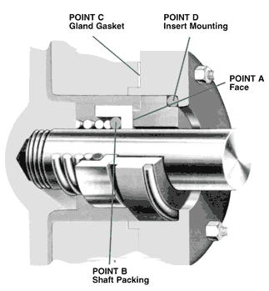

Fig. 10 Sealing Points for Mechanical Seal

The faces in a typical mechanical seal are lubricated with a boundary layer of gas or liquid between the faces. In designing seals for the desired leakage, seal life, and energy consumption, the designer must consider how the faces are to be lubricated and select from a number of modes of seal face lubrication.
To select the best seal design, it's necessary to know as much as possible about the operating conditions and the product to be sealed. Complete information about the product and environment will allow selection of the best seal for the application.
Section B -- Pump Application Data
Mechanical Seal Types
Mechanical seals can be classified into several tvpes and arrangements:

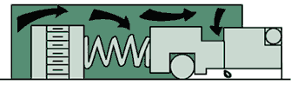
PUSHER:
Incorporate secondary seals that move axially along a shaft or sleeve to maintain contact at the seal faces. This feature compensates for seal face wear and wobble due to misalignment. The pusher seals' advantage is that it's inexpensive and commercially available in a wide range of sizes and configurations. Its disadvantage is that ft's prone to secondary seal hang-up and fretting of the shaft or sleeve. Examples are Dura RO and Crane Type 9T.

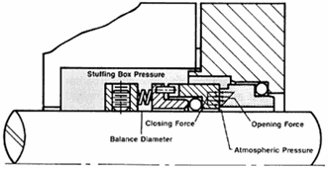
UNBALANCED:
They are inexpensive, leak less, and are more stable when subjected to vibration, misalignment, and cavitation. The disadvantage is their relative low pressure limit. If the closing force exerted on the seal faces exceeds the pressure limit, the lubricating film between the faces is squeezed out and the highly loaded dry running seal fails. Examples are the Dura RO and Crane 9T.

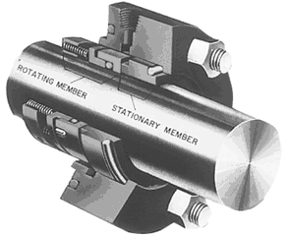

CONVENTIONAL:
Examples are the Dura RO and Crane Type 1 which require setting and alignment of the seal (single, double, tandem) on the shaft or sleeve of the pump. Although setting a mechanical seal is relatively simple, today's emphasis on reducing maintenance costs has increased preference for cartridge seals.

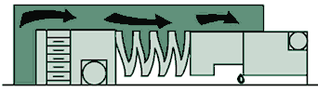

NON-PUSHER:
The non-pusher or bellows seal does not have to move along the shaft or sleeve to maintain seal face contact, The main advantages are its ability to handle high and low temperature applications, and does not require a secondary seal (not prone to secondary seal hang-up). A disadvantage of this style seal is that its thin bellows cross sections must be upgraded for use in corrosive environments Examples are Dura CBR and Crane 215, and Sealol 680.

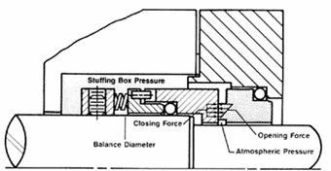

BALANCED:
Balancing a mechanical seal involves a simple design change, which reduces the hydraulic forces acting to close the seal faces. Balanced seals have higher-pressure limits, lower seal face loading, and generate less heat. This makes them well suited to handle liquids with poor lubricity and high vapor pressures such as light hydrocarbons. Examples are Dura CBR and PBR and Crane 98T and 215.

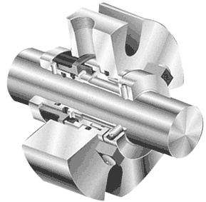

CARTRIDGE:
Examples are Dura P-SO and Crane 1100 which have the mechanical seal premounted on a sleeve including the gland and fit directly over the Model 3196 shaft or shaft sleeve (available single, double, tandem). The major benefit, of course is no requirement for the usual seal setting measurements for their installation. Cartridge seals lower maintenance costs and reduce seal setting errors

Section B -- Pump Application Data
Mechanical Seal Arrangements
SINGLE INSIDE:
This is the most common type of mechanical seal. These seals are easily modified to accommodate seal flush plans and can be balanced to withstand high seal environment pressures. Recommended for relatively clear non-corrosive and corrosive liquids with satisfactory' lubricating properties where cost of operation does not exceed that of a double seal. Examples are Dura RO and CBR and Crane 9T and 215. Reference Conventional Seal.
SINGLE OUTSIDE:
If an extremely corrosive liquid has good lubricating properties, an outside seal offers an economical alternative to the expensive metal required for an inside seal to resist corrosion. The disadvantage is that it is exposed outside of the pump which makes it vulnerable to damage from impact and hydraulic pressure works to open the seal faces so they have low pressure limits (balanced or unbalanced).
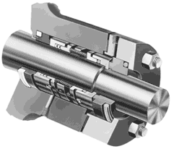

DOUBLE (DUAL PRESSURIZED):
This arrangement is recommended for liquids that are not compatible with a single mechanical seal (i.e. liquids that are toxic, hazardous [regulated by the EPA], have suspended abrasives, or corrosives which require costly materials). The advantages of the double seal are that it can have five times the life of a single seal in severe environments. Also, the metal inner seal parts are never exposed to the liquid product being pumped, so viscous, abrasive, or thermosetting liquids are easily sealed without a need for expensive metallurgy. In addition, recent testing has shown that double seal life is virtually unaffected by process upset conditions during pump operation. A significant advantage of using a double seal over a single seal.
The final decision between choosing a double or single seal comes down to the initial cost to purchase the seal, cost of operation of the seal, and environmental and user plant emission standards for leakage from seals. Examples are Dura double RO and X-200 and Crane double 811T.

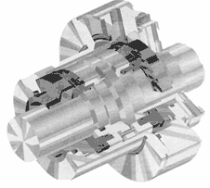

DOUBLE GAS BARRIER (PRESSURIZED DUAL GAS):
Very similar to cartridge double seals ... sealing involves an inert gas, like nitrogen, to act as a surface lubricant and coolant in place of a liquid barrier system or external flush required with conventional or cartridge double seals. This concept was developed because many barrier fluids commonly used with double seals can no longer be used due to new emission regulations. The gas barrier seal uses nitrogen or air as a harmless and inexpensive barrier fluid that helps prevent product emissions to the atmosphere and fully complies with emission regulations. The double gas barrier seal should be considered for use on toxic or hazardous liquids that are regulated or in situations where increased reliability is the required on an application. Examples are Dura GB2OO, GF2OO, and Crane 2800.

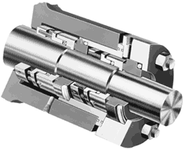

TANDEM (DUAL UNPRESSURIZED): Due to health, safety, and environmental considerations, tandem seals have been used for products such as vinyl chloride, carbon monoxide, light hydrocarbons, and a wide range of other volatile, toxic, carcinogenic, or hazardous liquids.

Tandem seals eliminate icing and freezing of light hydrocarbons and other liquids which could fall below the atmospheric freezing point of water in air (32? F or 0? C). {Typical buffer liquids in these applications are ethylene glycol, methanol, and propanol.) A tandem also increases online reliability. If the primary seal fails, the outboard seal can take over and function until maintenance of the equipment can be scheduled. Examples are Dura TMB-73 and tandem PTO.

General Seal Layout and useful Information

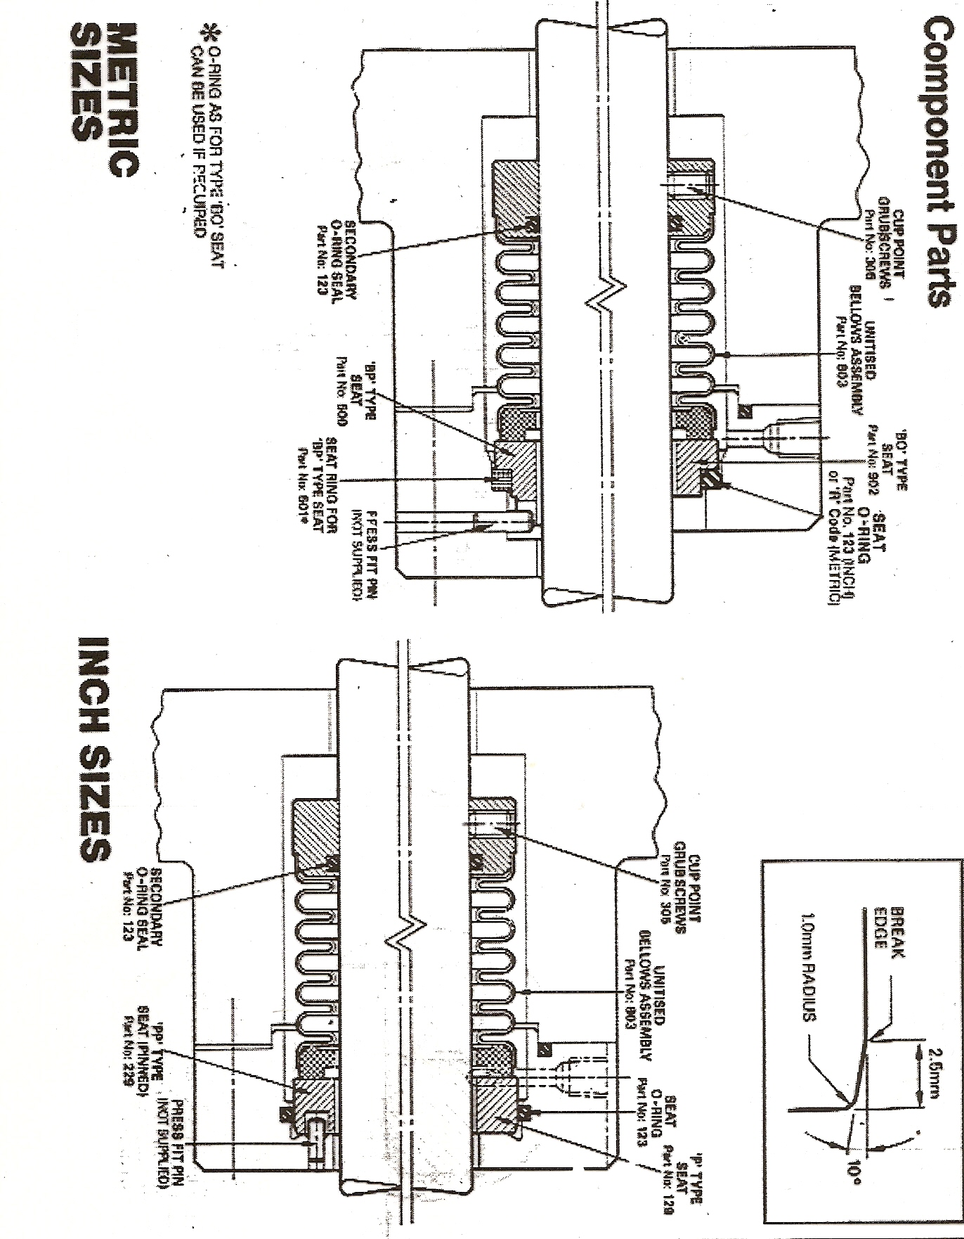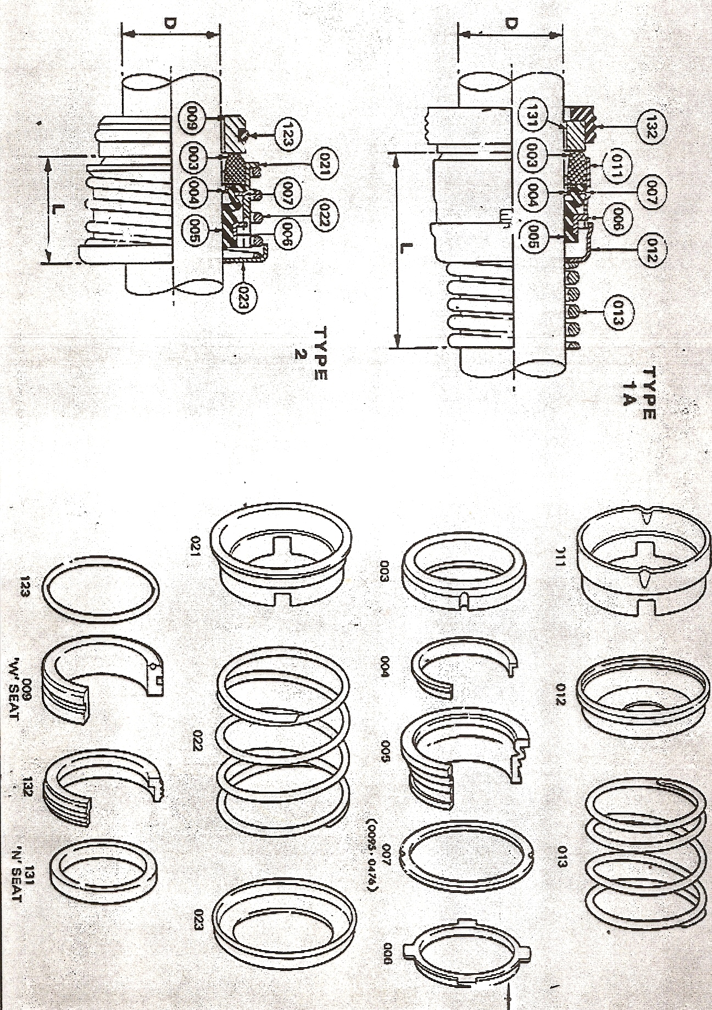
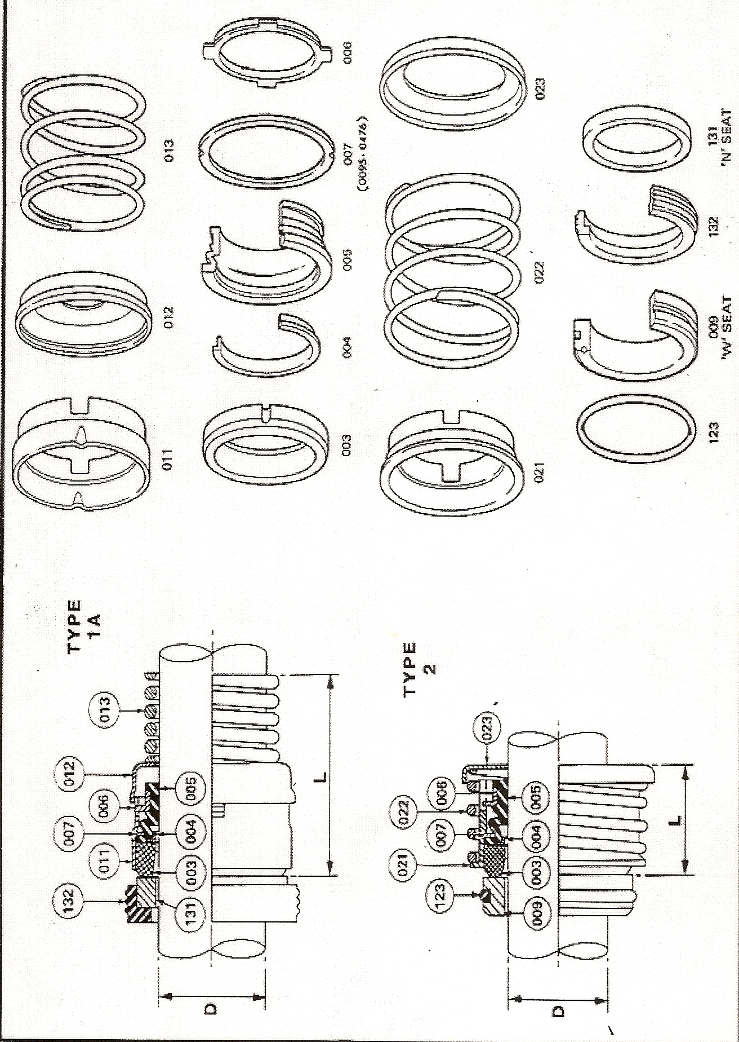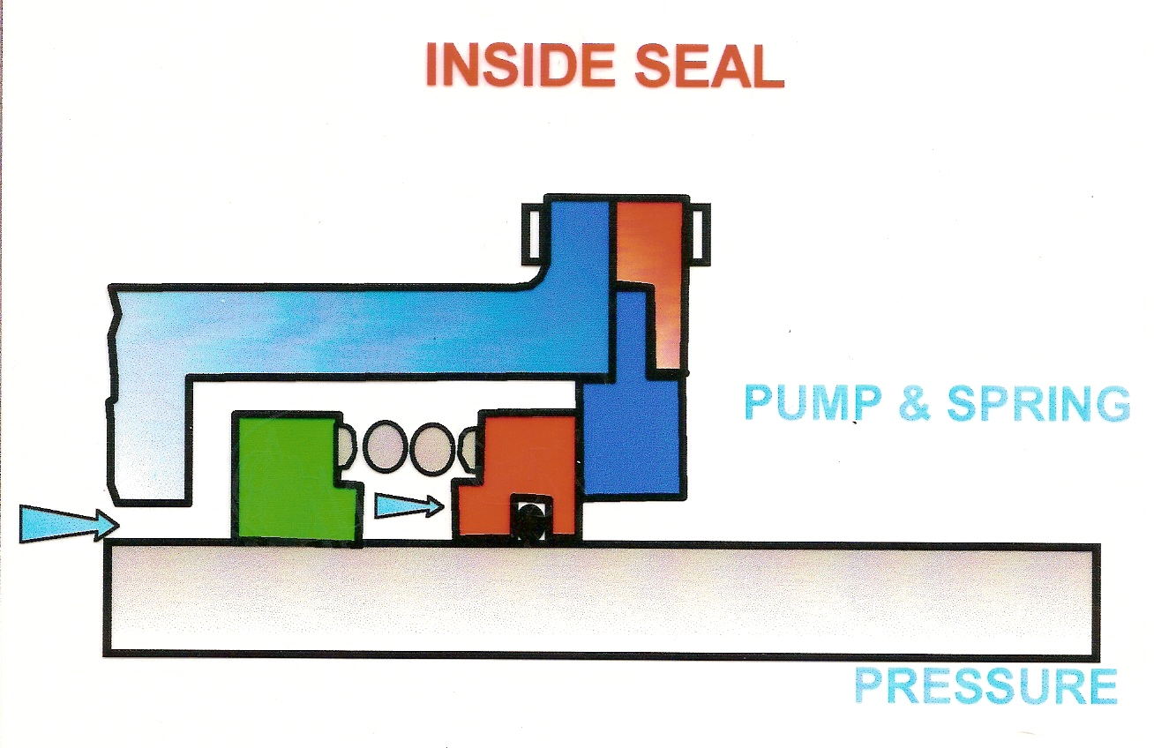

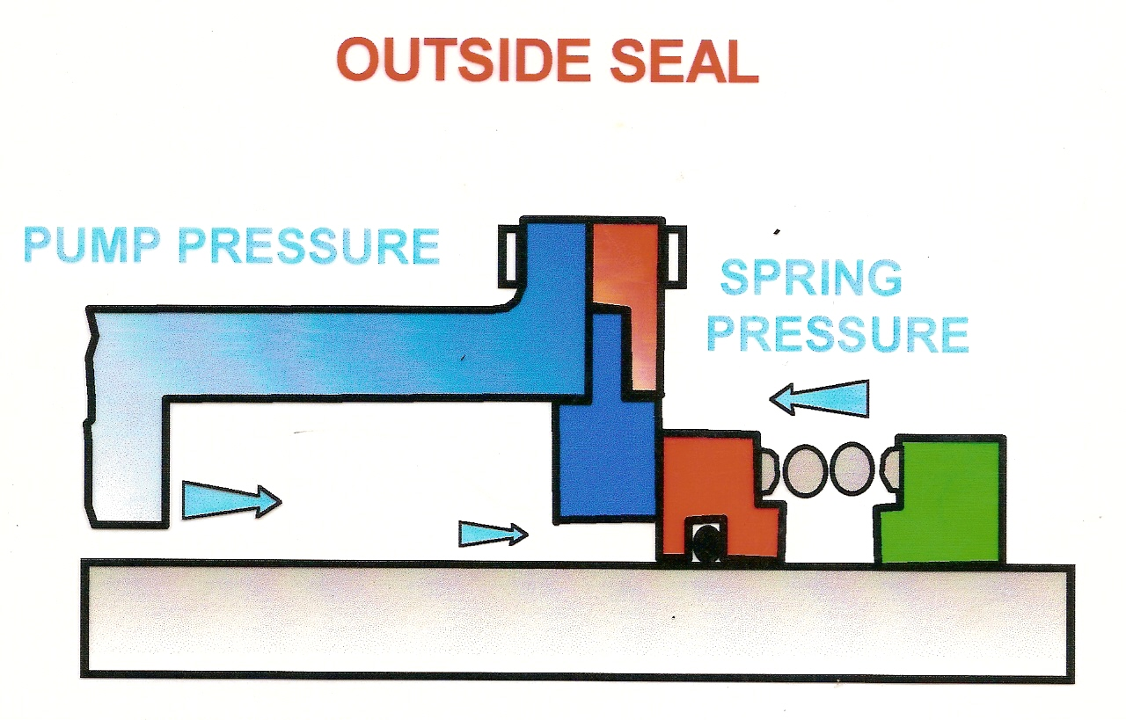

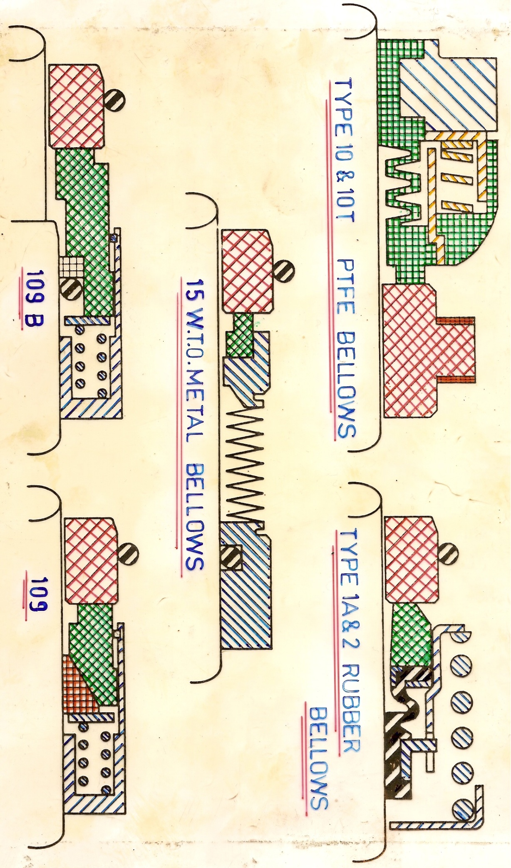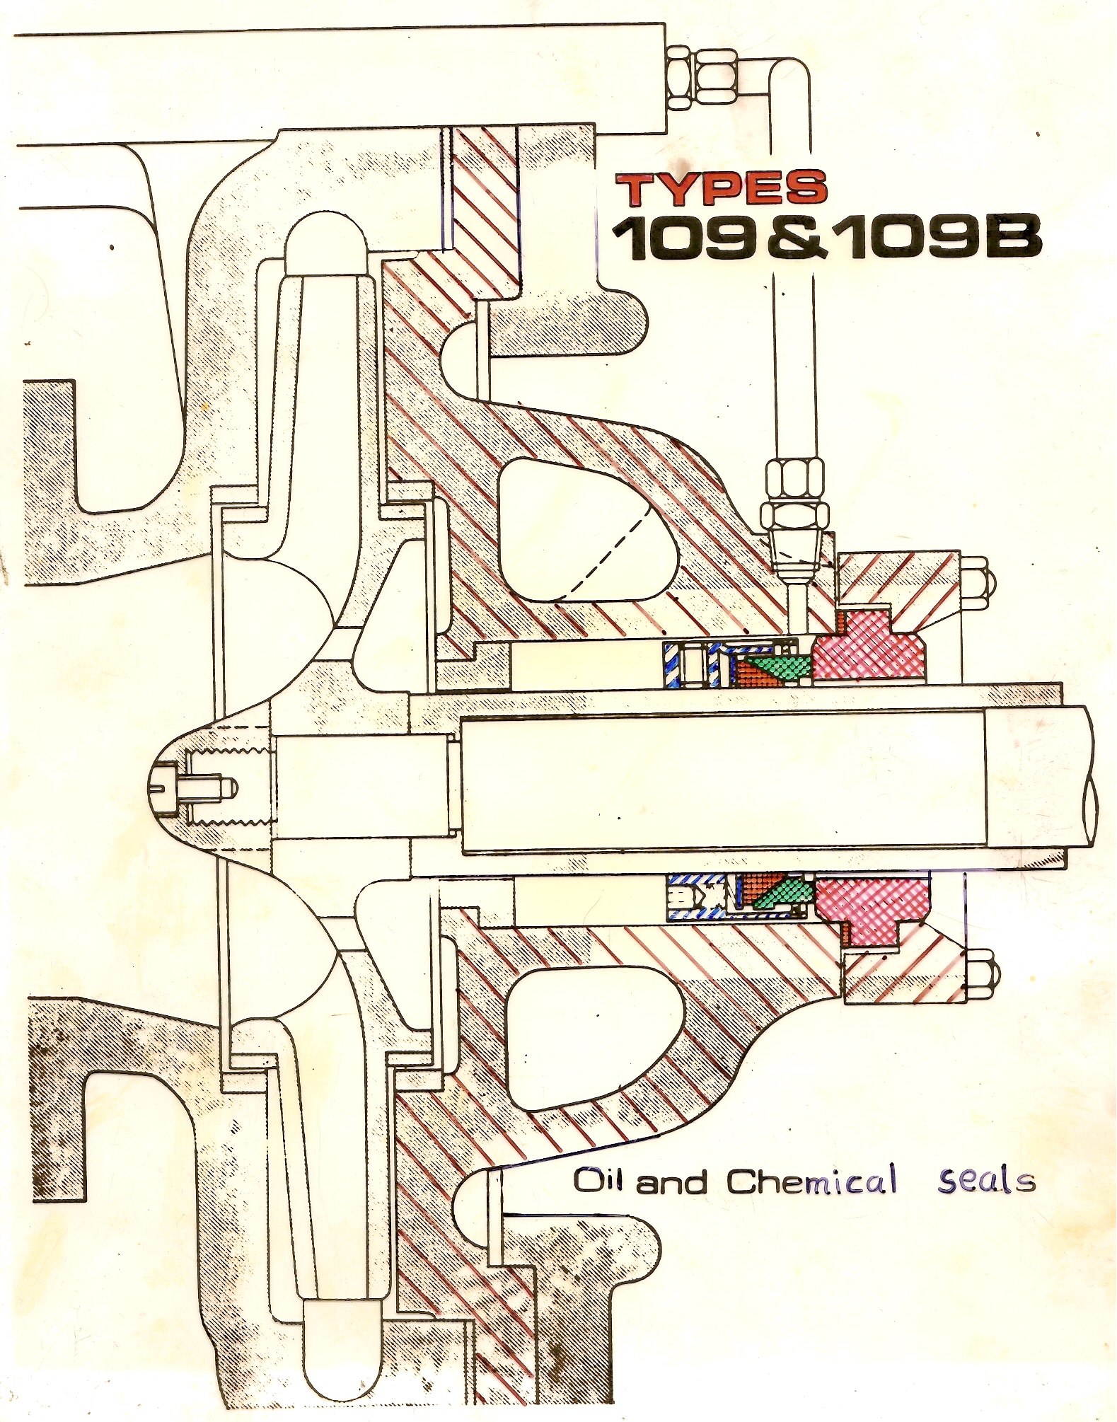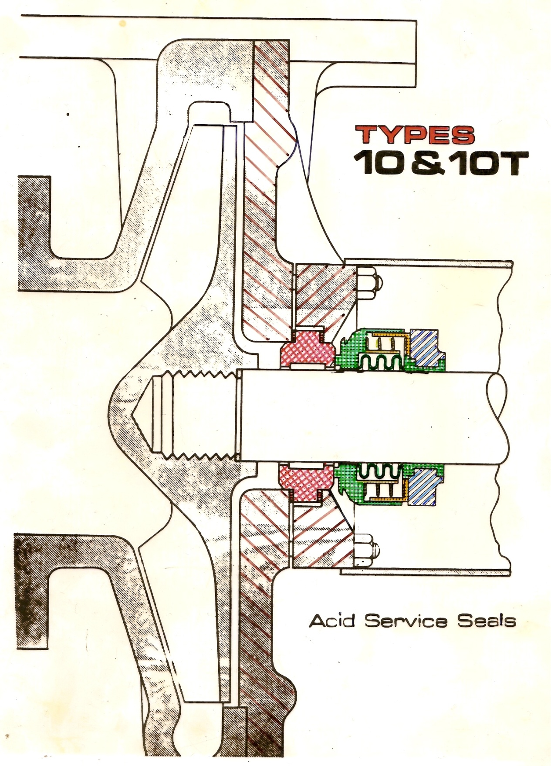

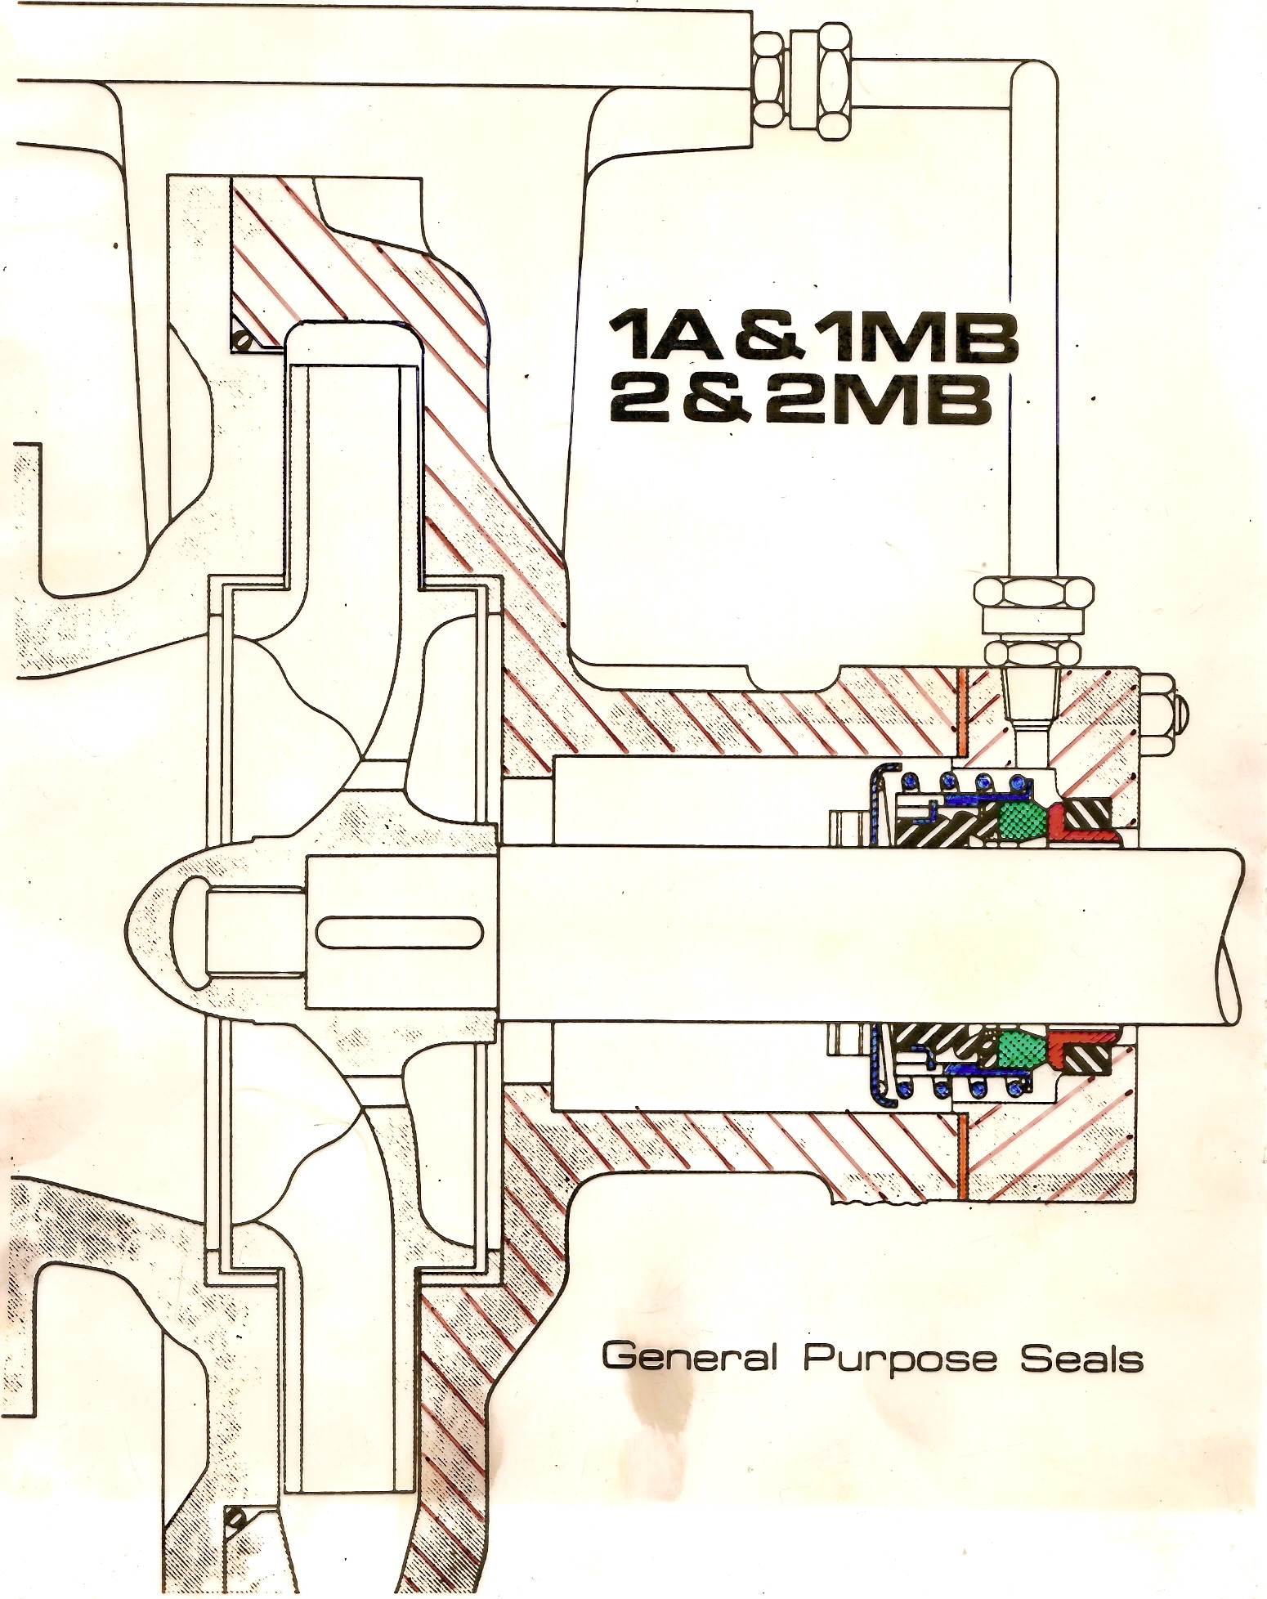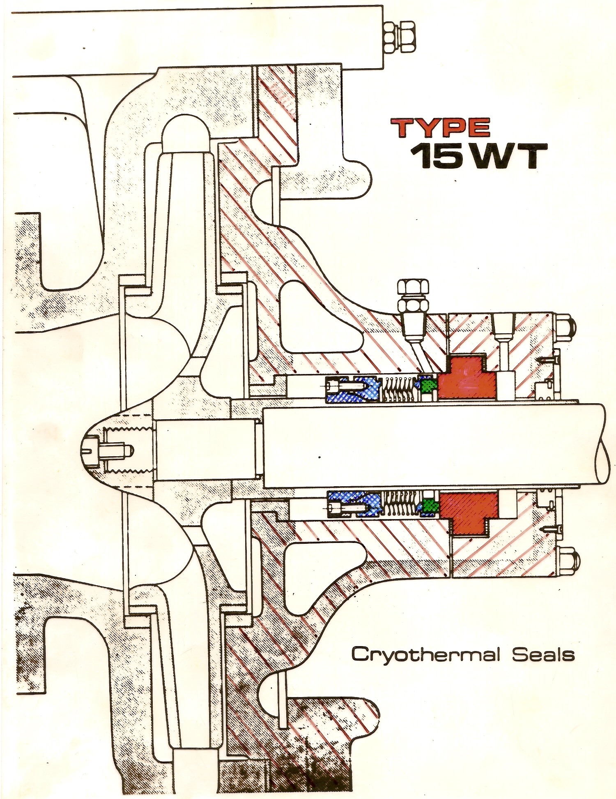
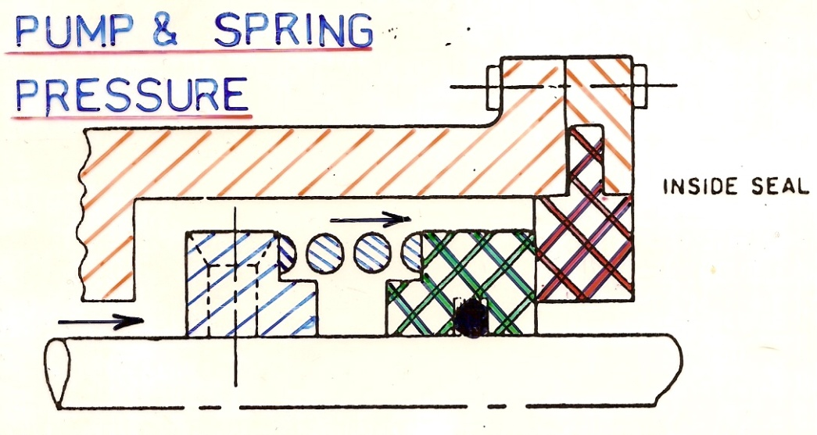



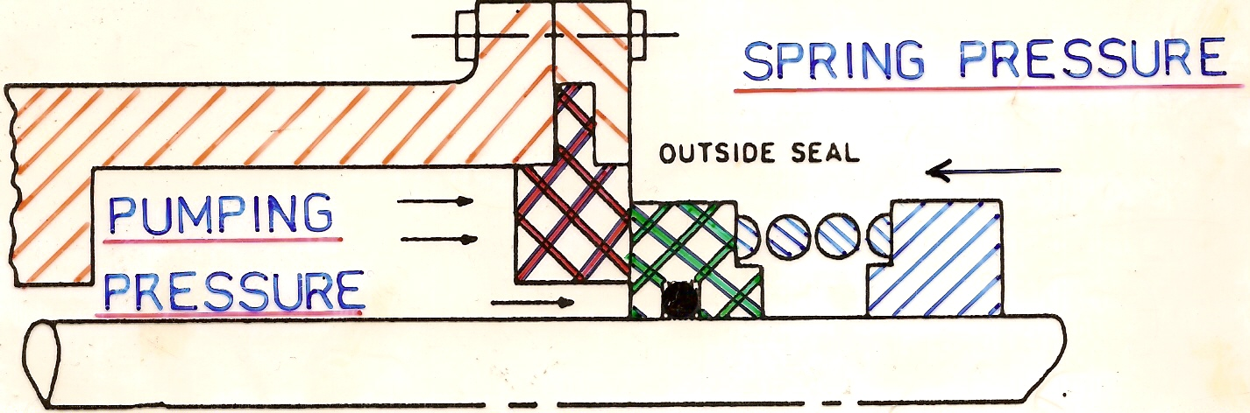

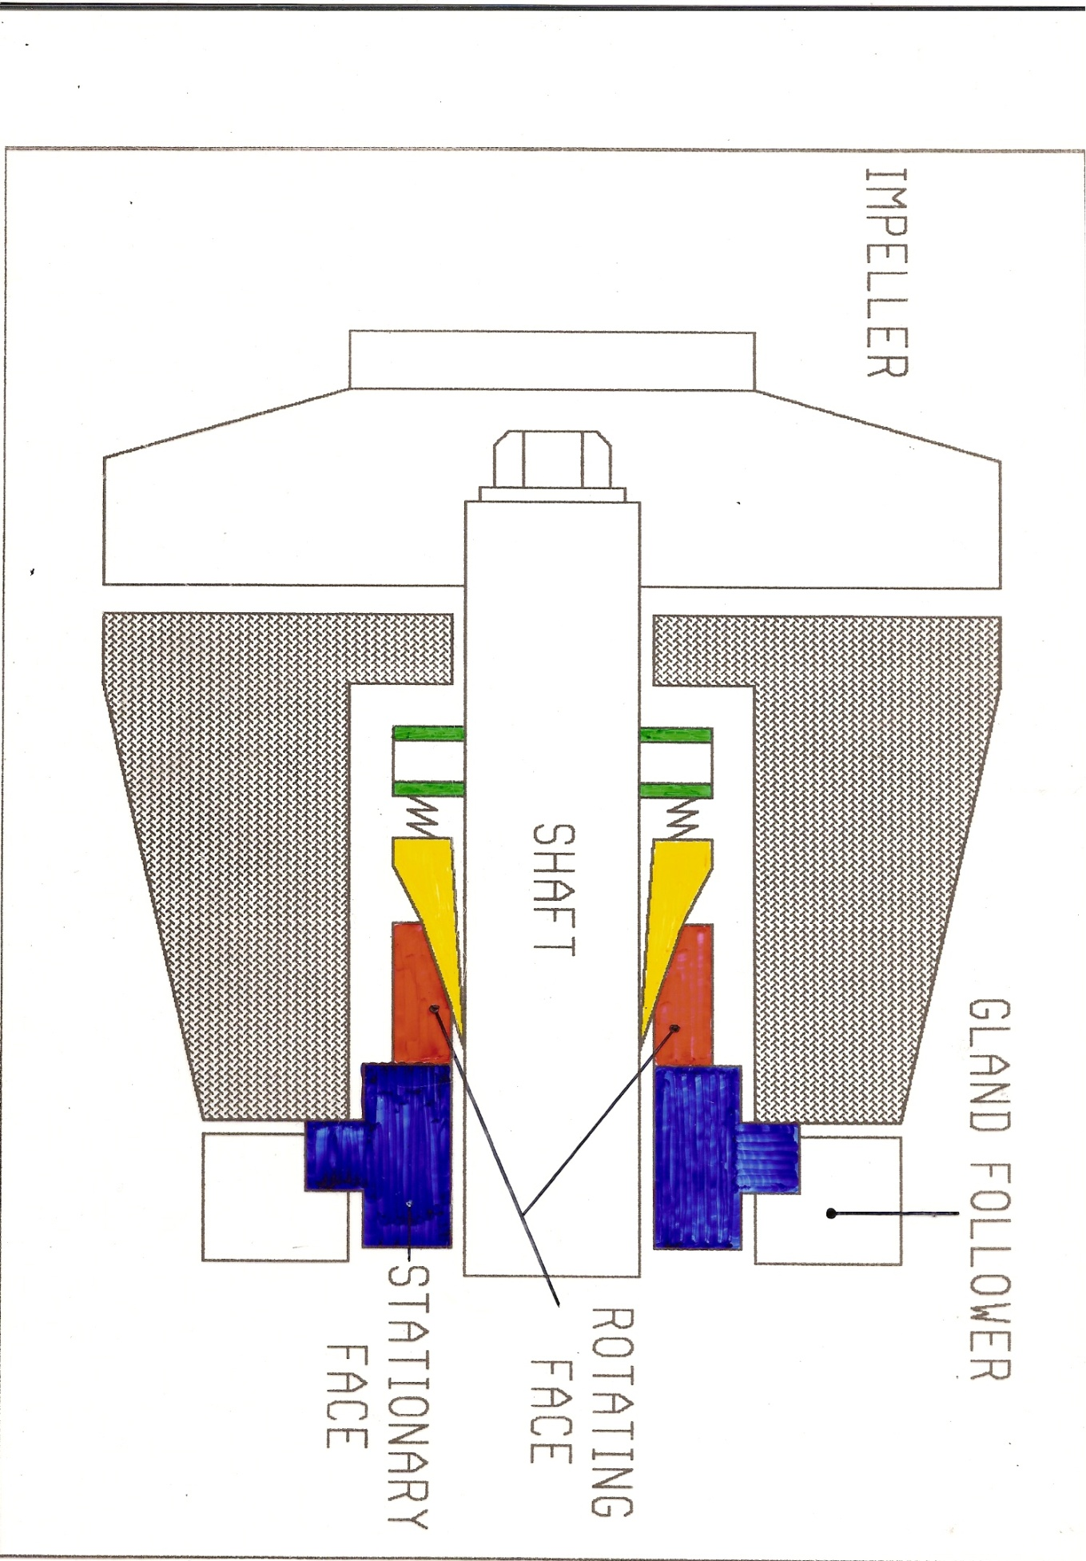
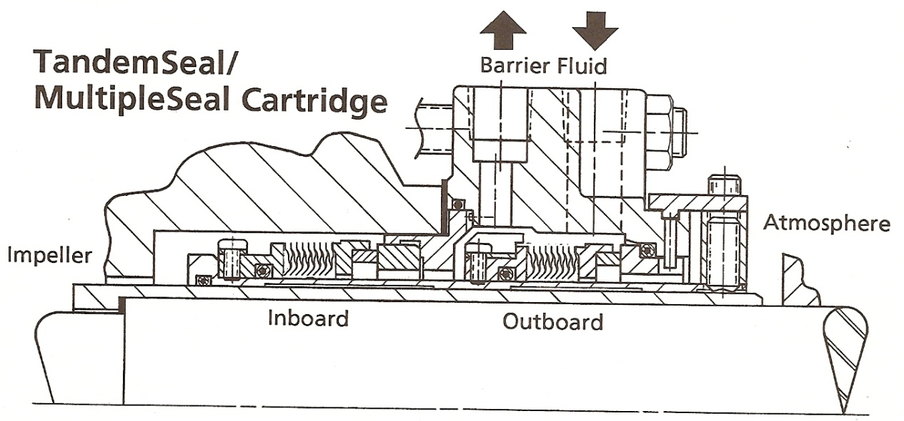

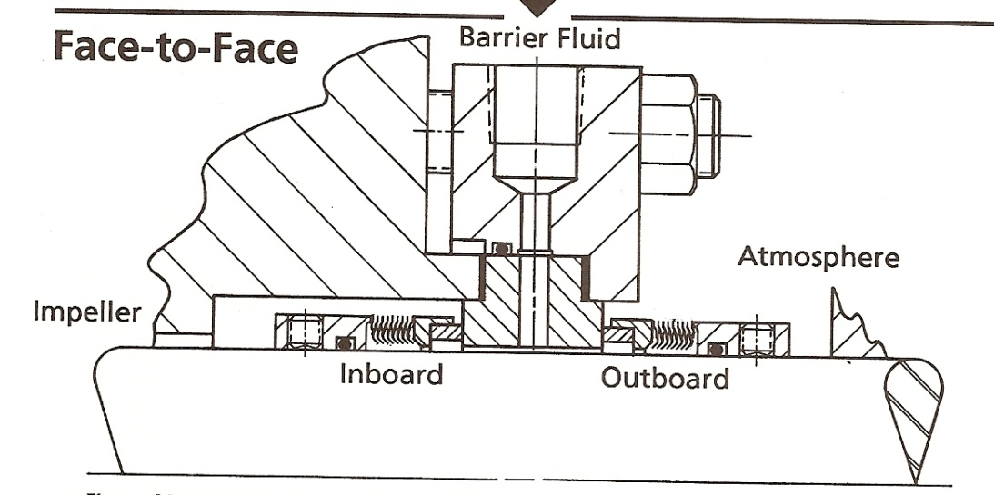

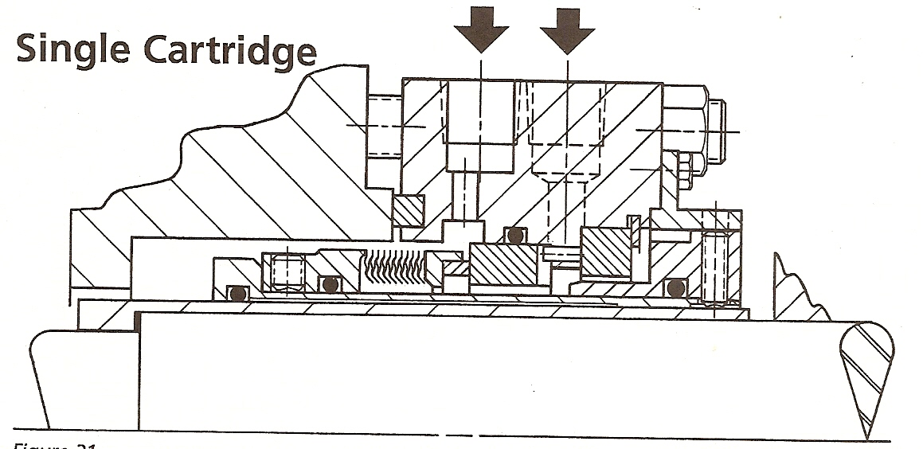

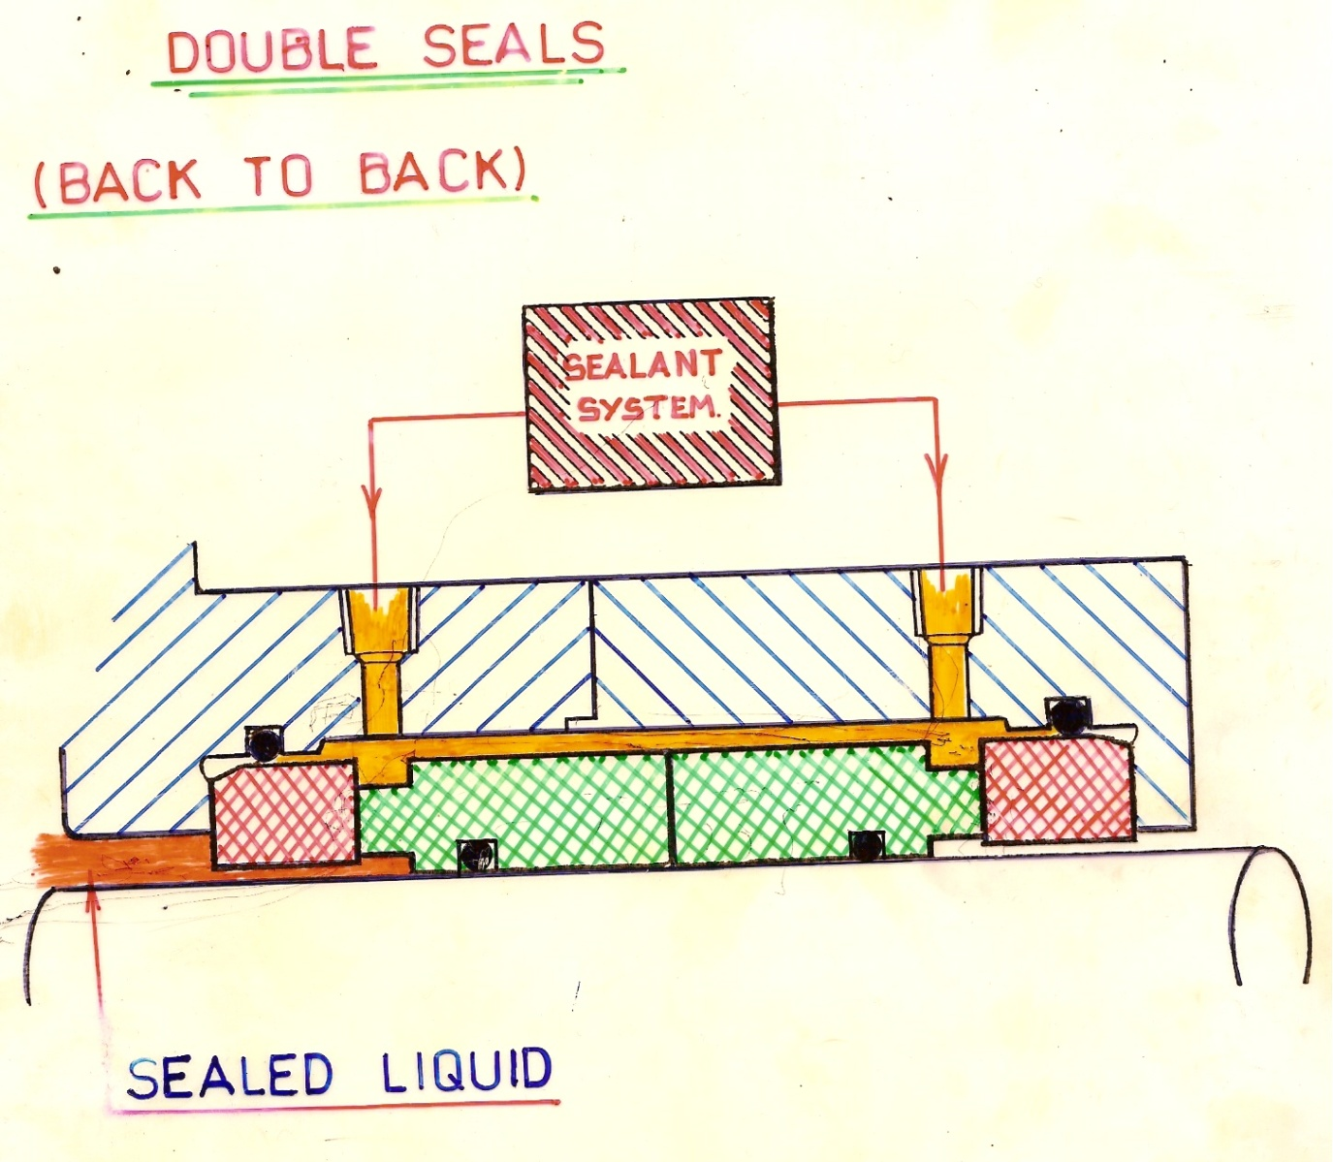

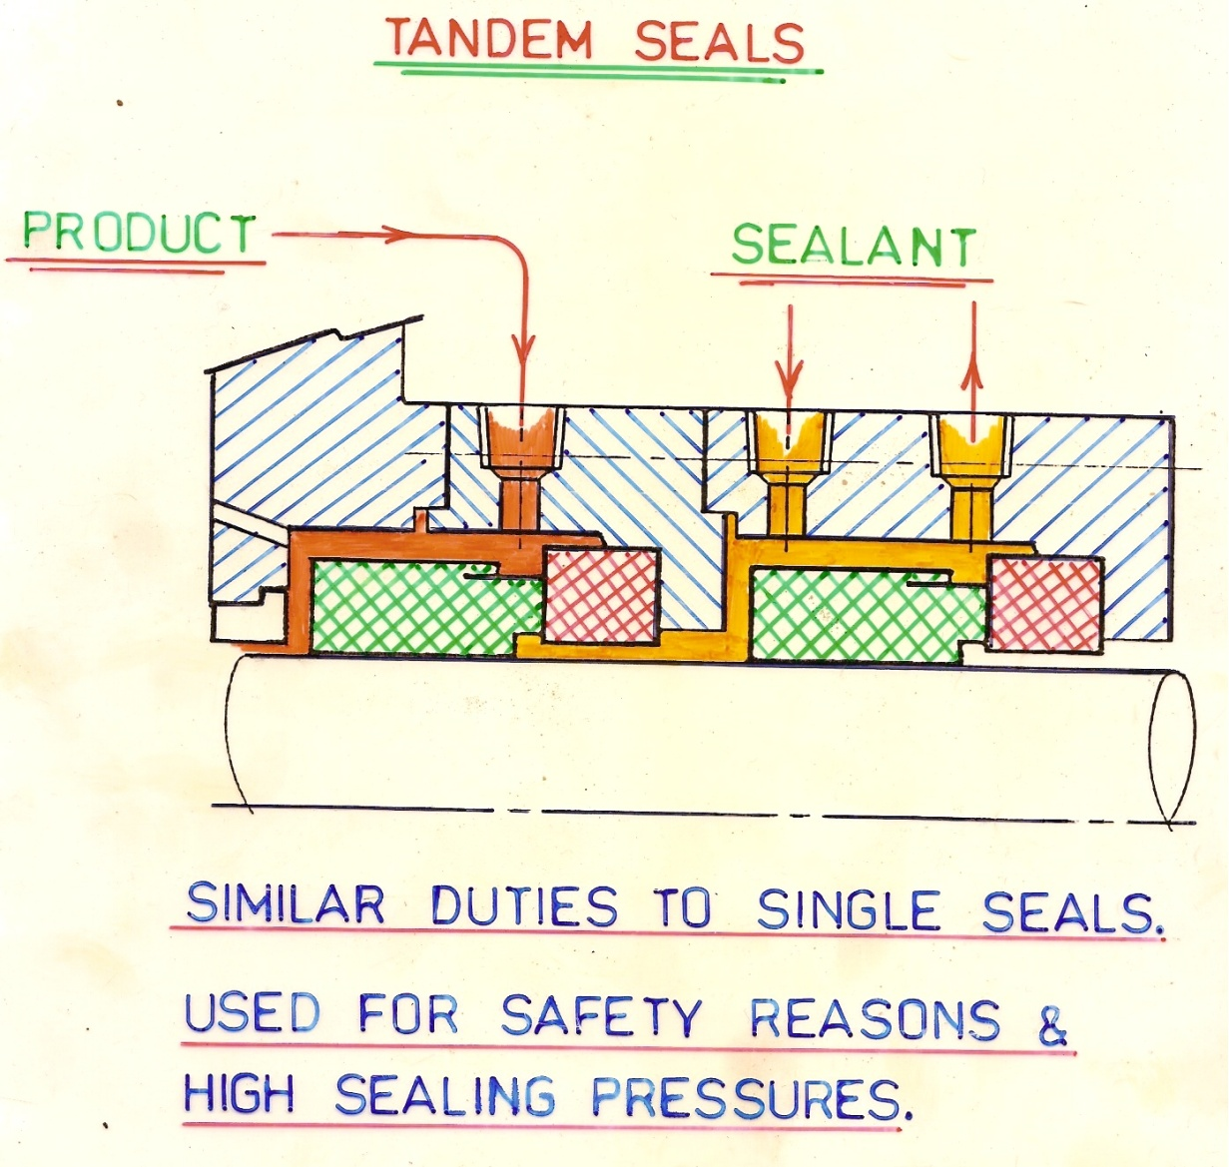

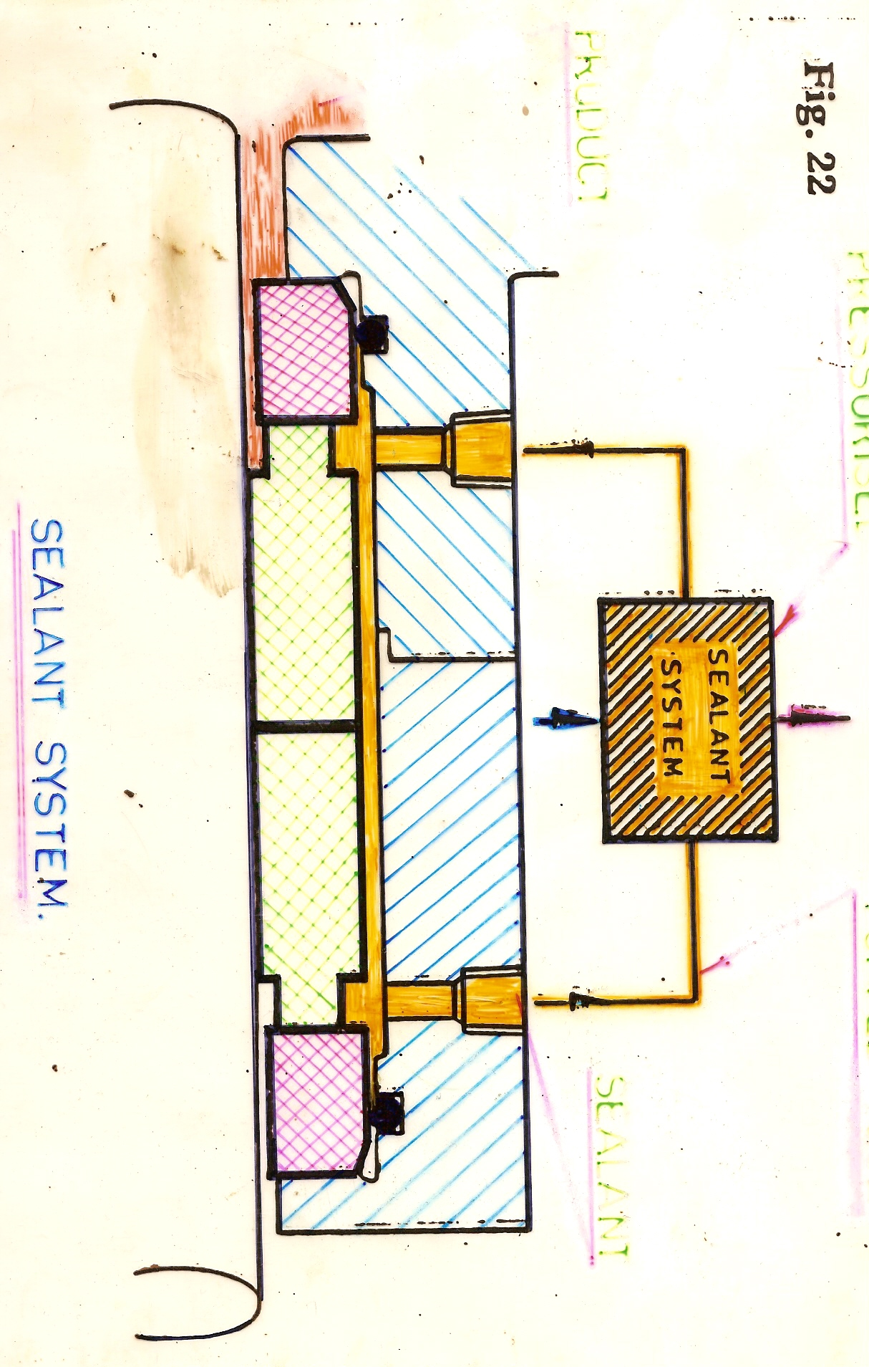

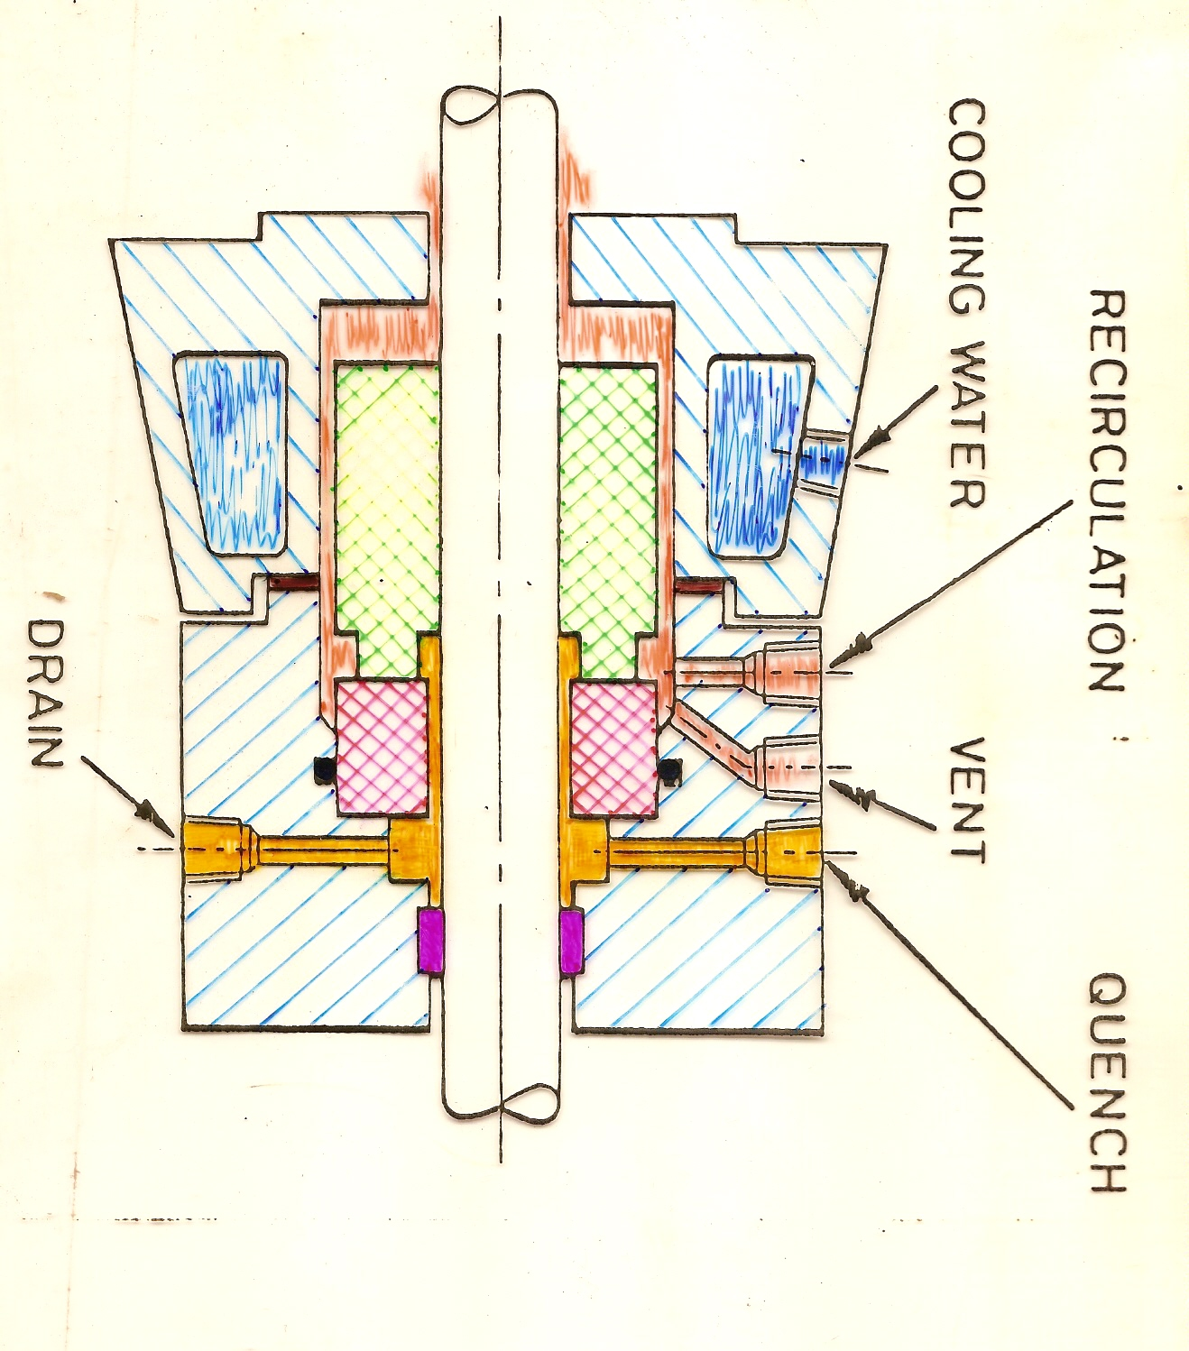

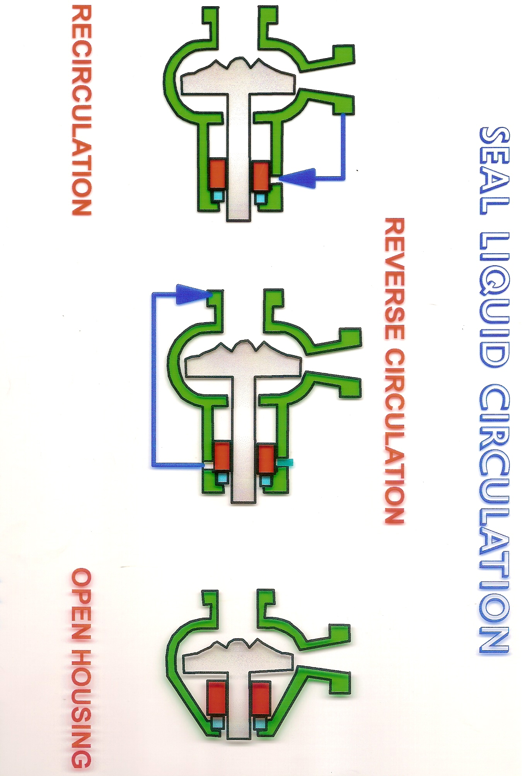
INSIDE SEALS

*ROTARY ACTION CLEANS ITSELF

PREVENTS ABRASIVES REACHING THE FACES

SECONDARY SEAL IS LUBRICATED BY THE PRODUCT

OUTSIDE SEALS

*EASY INSTALLATION

*SUITABLE FOR CORROSIVE FLUIDS (WORKING PARTS OUTSIDE)

FOOD PRODUCTS - EASY REMOVAL

LIMITED SEAL HOUSING ROOM

REASONS FOR SEAL FAILURE

INCORRECT SELECTION

INCORRECT INSTALLATION

CHANGES IN PRESSURE OR TEMPERATURE

LOSS OF SEALANT

VIBRATION DUE TO : BEARING FAILURE SHAFT MISALIGNMENT
RESONANCE

SEAL FAILURES

VAPOURISATION

RESULTS –Chipping, Radial Cracking.

REASON – Boiling Off liquid film, causing popping.

DRY RUNNING

RESULTS – Wear or grooves
REASONS – None or insufficient film.

ABRASIVES

RESULTS – Grooving
REASONS – Grinding Effect

SLUDGING

RESULTS – Pieces pulled off, light grooves.

REASONS – Sheer stresses of high viscosity liquids between faces.

BONDING

RESULTS – As sludging above.

REASONS – Crystallisation after pump has been left standing.

COKING

RESULTS – Jamming of rotary seal

REASONS – Carbonised particles on atmosphere side.

CRYSTALLISATION

RESULTS - Jamming of rotary seal.

REASONS – Crystallised particles on atmospheric side.

VIBRATION

RESULTS – Jamming of rotary seal

REASONS – Clearances reduced so causing rubbing of sleeve.

SPRING DISTORTION

RESULTS – Fracture, Cracks

REASONS – Incorrect spring handling, stress corrosion, fatigue.

