MECHANICAL SEALS CME 12 & 13
TEST PAPER

CANDIDATE NAME: ………………………………………….GROUP NO: …………..

PASS
Needs more training: DATE: …………………………..

ASSESSOR: …………………………..PRINT: ……………………………….SIGN

1 | Name and identify the location of the three sealing points on all mechanical seals.  ANSWER:-  PRIMARY – Contact area between the face and the seal, stationary and rotating faces giving fluid film sealing.  SECONDARY – The location between the mech seal and the shaft it is fixed to. A likely position for wear to occur.  TERTIARY - The seal fits into the housing and an “O” Ring is included.
2. | State three reasons why an outside seal is used instead of an inside seal.  ANSWER:-  - Out side seals are used where the product would corrode the springs within the seal.  - Used for food products, easy removal.  - Used where there is a limited space.

3. | Draw a back to back seal operating a sealant system and identify product and sealant flow throughout the seal.  ANSWER:- 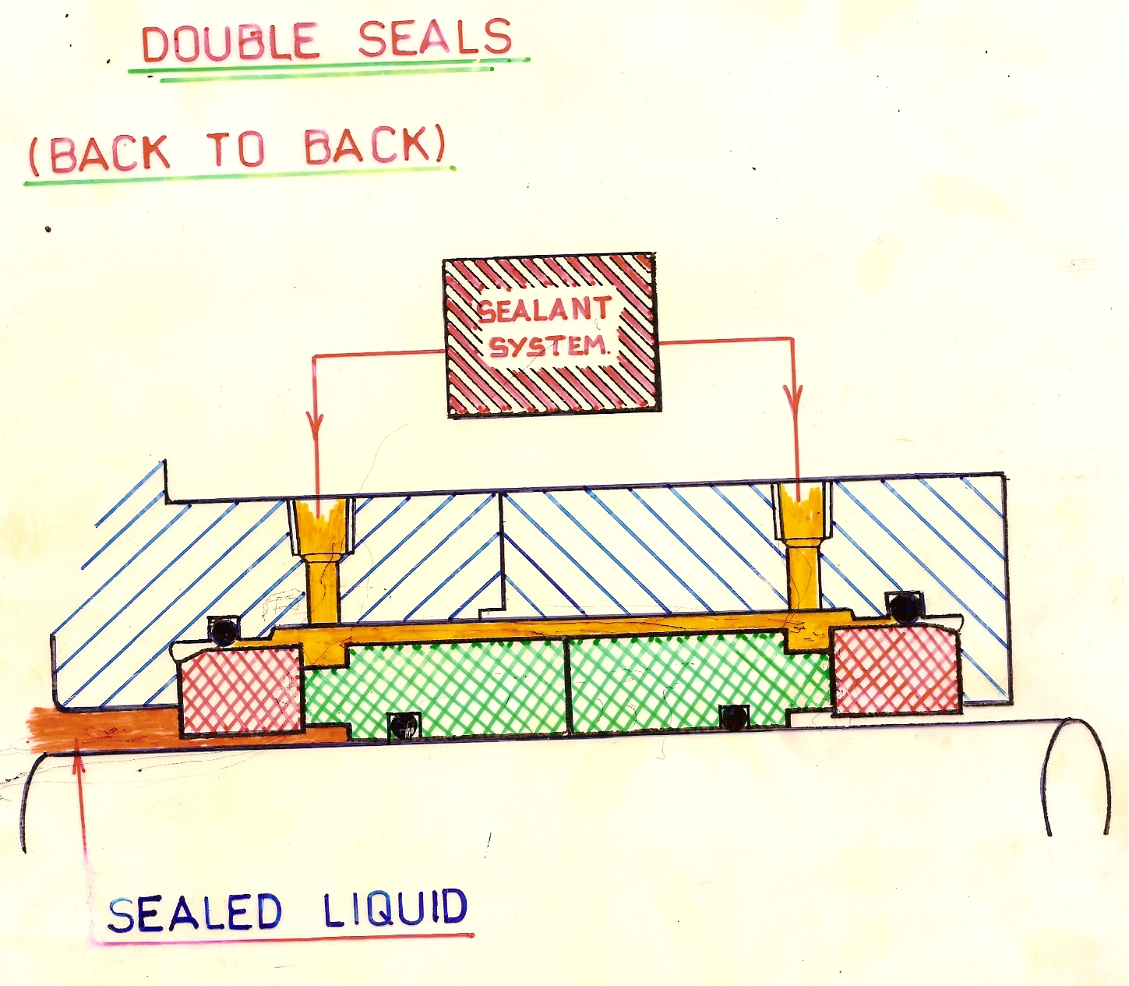
4. | On the mechanical seal, name three forms of secondary sealing that seal between the shaft and the rotating seal unit.  i) ”O” RINGS  ii) BELLOWS  iii) WEDGE RINGS
5. | State the three double seal arrangements.  ) TANDEM –Each seal faces the same way.  ii) FACE TO FACE  iii) BACK TO BACK
6. | Give 4 examples of and explain why two mechanical seals are used instead of one?  - Hazardous Product – Alarm system is placed after first seal but before second. If process leaks into the area between the two seals an alarm is activated to alert.  - In a product such as food stuffs, the area between the two seals is kept at a higher pressure than the product so that if the seal leaks the higher pressure (compatible) sealant is leaked into the product.  - One seal may not provide sufficient sealing within the space allowed.  - They cause less reduction in power than packed glands and are much easier to install, lasting longer than previous types.
7. | State and explain three reasons for using a mechanical seal instead of a packed gland.  i) They are easier to install/remove and therefore maintenance is quicker. There is no unpacking and re-packing.  ii) Lasts a lot longer than older methods – The sealing method is more efficient than packing.  iii) The amount of leakage is minimal (When the seal is set up correctly) so you can measure the quantity of drips over a certain period, alerting you to total losses.
8. | From the diagram of a 109 seal, label all the parts.  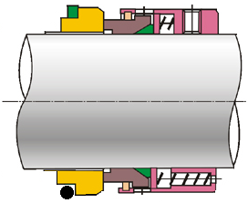  TERTIARY SEAL  STATIONARY FACE  SNAP RING  GRUB SCREW  SPRING  THRUST PLATE  ROTARY FACE  PTFE WEDGE  SECONDARY SEAL  CAGE  TERTIARY SEAL
9. | On double suction pumps serviced by two mechanical seals how and why are the seals handed when they use a single large spring for compression.  If the springs rotate in the wrong direction they will increase the sealing load on the seal faces and damage the seals. Therefore they are handed and must be fitted for the correct rotational direction.
10 | On a vertical pump arrangement fitted with a mechanical seal why is the venting of the seal face area important.  To remove any gas that has accumulated in the seal face area thus ensuring the seal faces do not run dry.
11 | When a mechanical seal in used on a centrifugal gas compressor how and why does the seal differ from a liquid sealing application  The seal faces have to be jacked apart using an inert gas before the equipment is started up thus ensuring the dry seal faces do not touch when they are moving.
12 | What are the permissible lubricant that can be applied between the stationary and the rotating seal faces  No lubricants are to be used.

