MECHANICAL SEALS CME 12 & 13
TEST PAPER

CANDIDATE NAME: ………………………………………….GROUP NO: …………..

PASS
Needs more training: DATE: …………………………..

ASSESSOR: …………………………..PRINT: ……………………………….SIGN

1 | Name and identify the location of the three sealing points on all mechanical seals.
2. | State three reasons why an externally mounted seal is used instead of an inside seal.

3. | Draw a back-to-back seal operating a sealant system and identify product and sealant flow throughout the seal.
4. | On the mechanical seal, name three forms of secondary sealing that seal between the shaft and the rotating seal unit.  i)  ii)  iii)
5. | State the three double seal arrangements.  i)  ii)  iii)
6. | Give three examples of and explain why two mechanical seals are used instead of one?
7. | State and explain three reasons for using a mechanical seal instead of a packed gland.  i)  ii)  iii)
8. | From the diagram of a 109 seal, label all the parts.  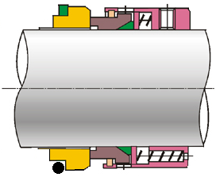
9. | On double suction pumps serviced by two mechanical seals how and why are the seals handed when they use a single large spring for compression.
10 | On a vertical pump arrangement fitted with a mechanical seal why is the venting of the seal face area important.
11 | When a mechanical seal in used on a centrifugal gas compressor how and why does the seal differ from a liquid sealing application
12 | What are the permissible lubricant that can be applied between the stationary and the rotating seal faces

