ALIGNMENT TEST (CME 15)

CANDIDATE NAME: …………………………………………GROUP NO: …………

RESULT PASS
Needs more training DATE: …………………

ASSESSOR: …………………………………PRINT:………………………………SIGN

1) What are the three most common methods of alignment?

i)

ii)

iii)

2) What is the formula used to determine the amount of shimming required to correct angular and off-set misalignment?

a

Indicate what each part of the formula represents.
b

3) What are the three forms of misalignment?

i)

ii)

iii)

4) In order of priority list the four steps of alignment (excluding soft foot).

i)

ii)

iii)

iv)

5) From the drawing, determine the amount of shimming required and show the calculations used to correct the angular in elevation misalignment and indicate where the shimming should be placed.
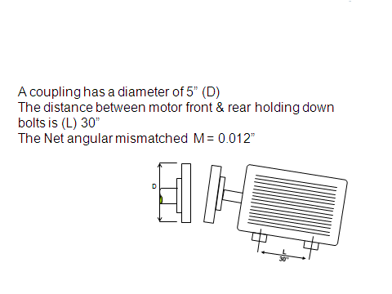

6) What is the maximum allowable pulley miss-alignment on a Vee belt pulley drive system per unit drive and driven shaft separation.

7) Sketch the correct Vee belt drive engagement between the pulley Vee and the Vee belt and say why is this important.

8) What is meant by the term SOFT FOOT when carrying out an alignment exercise.

9) What are the five measurements needed to enable a reverse clock alignment exercise to be carried out.

i)

ii)

iii)

iv)

v)

10) What are the main advantages of reverse clock or laser alignment over the face and rim method.

