CANDIDATE NAME: ……………………………………… GROUP NO: ……………

**CONDITION MONITORING HANDOUT**

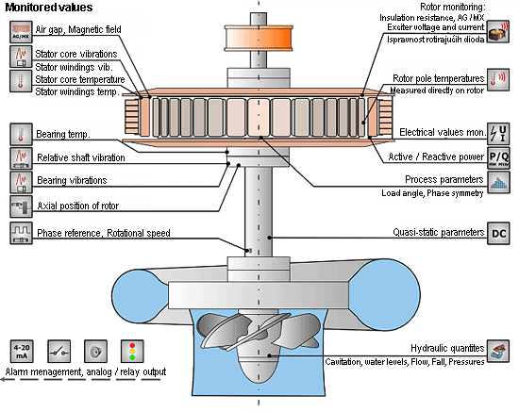

'**Condition monitoring**:

Is the process of monitoring all parameters of condition in machinery, such that a significant change is indicative of a developing failure. It is a major component of [predictive maintenance](http://en.wikipedia.org/wiki/Predictive_maintenance). The use of conditional monitoring allows maintenance to be scheduled, or other actions to be taken to avoid the consequences of failure, before the failure occurs. Nevertheless, a deviation from a reference value (e.g. temperature or vibration behavior) must occur to identify impeding damages. **Predictive Maintenance does not predict failure.**

**Rotating equipment**

The most commonly used method for rotating machines is called vibration analysis. Measurements can be taken on machine bearing casings with seismic or piezo-electric transducers to measure the casing vibrations, and on the vast majority of critical machines, with eddy current transducers that directly observe the rotating shafts to measure the radial (and axial) vibration of the shaft. The level of vibration can be compared with historical baseline values such as former start-ups and shutdowns, and in some cases established standards such as load changes, to assess the severity.

[](http://en.wikipedia.org/wiki/File:Sine_waves_different_frequencies.svg)

Fig 01.

Sinusoidal Wave of various frequencies; the bottom waves have higher frequencies than those above. The horizontal axis represents time.

Interpreting the vibration signal so obtained is a complex process that requires specialized training and experience. Exceptions are state-of-the-art technologies that provide the vast majority of data analysis automatically and provide information instead of data. One commonly employed technique is to examine the individual frequencies present in the signal. These frequencies correspond to certain mechanical components (for example, the various pieces that make up a rolling element [rolling-element bearing](http://en.wikipedia.org/wiki/Rolling-element_bearing)) or certain malfunctions (such as shaft unbalance or misalignment). By examining these frequencies and their harmonics, the analyst can often identify the location and type of problem, and sometimes the root cause as well. For example, high vibration at the frequency corresponding to the speed of rotation is most often due to residual imbalance and is corrected by balancing the machine. As another example, a degrading [rolling-element bearing](http://en.wikipedia.org/wiki/Rolling-element_bearing) will usually exhibit increasing vibration signals at specific frequencies as it wears. Special analysis instruments can detect this wear weeks or even months before failure, giving ample warning to schedule replacement before a failure which could cause a much longer down-time. Beside all sensors and data analysis it is important to keep in mind that more than 80% of all complex mechanical equipment fail accidentally and without any relation to their life-cycle period.

Fig 02.

Four-point-contact radial bearings

[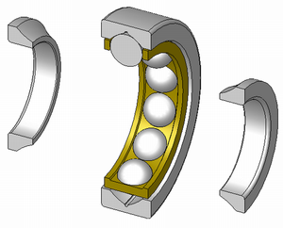](http://en.wikipedia.org/wiki/File:Four-point-contact-bearing_din628_type-qj_180-ex.png)

**Oil Analysis**

