RELIEF STREAMS TEST PAPER (CME18)

CANDIDATE NAME: ……………………………………… GROUP NO: …………….

PASS
Needs more training: Date: ………………………….

ASSESSOR: ……………………………….. PRINT ………………………………..SIGN

1 | What is a protective device?  A devices to protect plant from overpressure conditions.
2 | What is a pressure relief stream?  A relief device, and associated lines and process equipment to safely handle the material ejected
3 | What is the function of a safety valve?  Is a relief valve on a compressible fluid or gas filled vessel.
4 | When a safety valve is removed from plant, what precautions need to be implemented and explain why?  Both open ends must be blacked off, consider decontamination if it’s appropriate  Check the lift settings of the PRV before it is dismantled and ensure the valve is are returned to the plant protected from bumps and shocks and nozzles sealed.
5 | Explain the use of a combined pressure and vacuum relief valve.  To protect from both over pressure and vacuum conditions
6 | Draw a line diagram symbol for a relief valve.  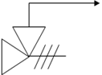
7 | Draw a line diagram symbol for a bursting disc.  
8 | What piece of equipment can be added to a relief stream in order to protect the relief valve from corrosive products?  Bursting disc
9 | Name the three items of equipment used on a multi-device system.  Relief valve  Pressure gauge  Bursting disc
10 | Draw a multi-device system (line diagram)  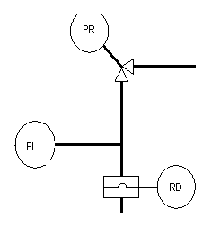
11 | What is the purpose of a duel system?  For switching from an active PRV to a standby PRV.
12 | Name two materials that bursting discs are made from.  Carbon Steel Stainless Steel
13 | What are the possible consequences of fitting a bursting disc incorrectly?  The disc and fail to operate above the pressure or fail at a lower pressure
14 | Why are vents used, what possible problems can arise when in service?
15 | Explain the use of lute pots; give a possible problem that can arise in service.
16 | Give two points to look for when inspecting each of the following:  VENTS:  LUTE POTS:
17 | Draw a line diagram of a single device system incorporating a safety valve.
18 | Draw a line diagram of a single device system involving a bursting disc.
19 | State the Type of Pressure relief vale shown below and Label the parts indicated on the drawing.  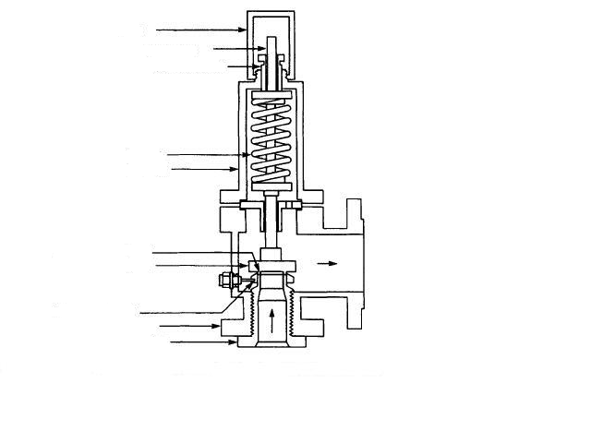

20 | Draw and label a duel system.

