RELIEF STREAMS TEST PAPER (CME18)

CANDIDATE NAME: ……………………………………… GROUP NO: …………….

PASS
Needs more training: Date: ………………………….

ASSESSOR: ……………………………….. PRINT ………………………………..SIGN

1 | What is a protective device?
2 | What is a pressure relief stream?
3 | What is the function of a safety valve?
4 | When a safety valve is removed from plant, what precautions need to be implemented and explain why?
5 | Explain the use of a combined pressure and vacuum relief valve.
6 | Draw a line diagram symbol for a relief valve.
7 | Draw a line diagram symbol for a bursting disc.
8 | What piece of equipment can be added to a relief stream in order to protect the relief valve from corrosive products?
9 | Name the three items of equipment used on a multi-device system.  i)  ii)  iii)
10 | Draw a multi-device system (line diagram)
11 | What is the purpose of a duel system?
12 | Name two materials that bursting discs are made from.
13 | What are the possible consequences of fitting a bursting disc incorrectly?
14 | Why are piped vents used, what possible problems can arise when in service?
15 | Explain the use of lute pots; give a possible problem that can arise in service.
16 | Give two points to look for when inspecting each of the following:  VENTS:  LUTE POTS:
17 | Draw a line diagram of a single device system incorporating a safety valve.
18 | Draw a line diagram of a single device system involving a bursting disc.
19 | State the Type of Pressure relief vale shown below and Label the parts indicated on the drawing.  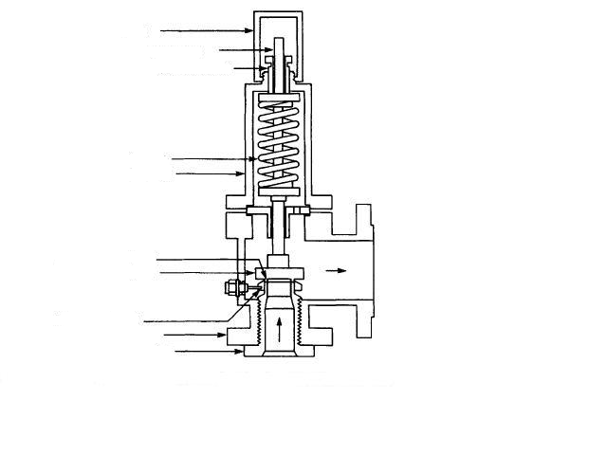

20 | What are the three main points an insurance inspector will check when witnessing a relief valve test.

