STEAM PRESSURE SYSTEMS

Steam cycle [ Rankine / Carnot ]

Indicator diagram : Steam admission
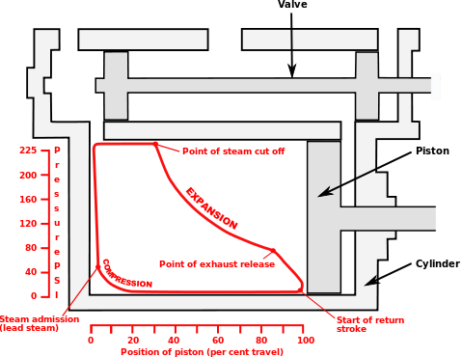

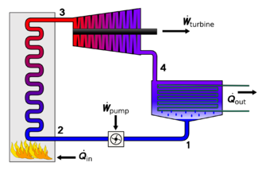

Flow diagram of the four main devices used in the Rankine cycle : 1). Feedwater pump 2). Boiler or steam generator 3). Turbine or engine 4). Condenser; where Q = heat and W = work. Most of the heat is rejected as waste.
The Rankine cycle is the fundamental thermodynamic underpinning of the steam engine. The cycle is an arrangement of components as is typically used for simple power production, and utilizes the phase change of water (boiling water producing steam, condensing exhaust steam, producing liquid water)) to provide a practical heat/power conversion system. The heat is supplied externally to a closed loop with some of the heat added being converted to work and the waste heat being removed in a condenser. The Rankine cycle is used in virtually all steam power production applications. In the 1990s, Rankine steam cycles generated about 90% of all electric power used throughout the world, including virtually all solar, biomass, coal and nuclear power plants. It is named after William John Macquorn Rankine, a Scottish polymath.
The Rankine cycle is sometimes referred to as a practical Carnot cycle because, when an efficient turbine is used, the TS ( Temperature / Entropy ) diagram begins to resemble the Carnot cycle. The main difference is that heat addition (in the boiler) and rejection (in the condenser) are isobaric (constant pressure) processes in the Rankine cycle and isothermal (constant temperature) processes in the theoretical Carnot cycle. In this cycle a pump is used to pressurize the working fluid which is received from the condenser as a liquid not as a gas. Pumping the working fluid in liquid form during the cycle requires a small fraction of the energy to transport it compared to the energy needed to compress the working fluid in gaseous form in a compressor (as in the Carnot cycle). The cycle of a reciprocating steam engine differs from that of turbines because of condensation and re-evaporation occurring in the cylinder or in the steam inlet passages.
The working fluid in a Rankine cycle can operate as a closed loop system, where the working fluid is recycled continuously, or may be an "open loop" system, where the exhaust steam is directly released to the atmosphere, and a separate source of water feeding the boiler is supplied. Normally water is the fluid of choice due to its favourable properties, such as non-toxic and unreactive chemistry, abundance, low cost, and its thermodynamic properties. Mercury is the working fluid in the mercury vapor turbine. Low boiling hydrocarbons can be used in a binary cycle.
The steam engine contributed much to the development of thermodynamic theory; however, the only applications of scientific theory that influenced the steam engine were the original concepts of harnessing the power of steam and atmospheric pressure and knowledge of properties of heat and steam. The experimental measurements made by Watt on a model steam engine led to the development of the separate condenser. Watt independently discovered latent heat, which was confirmed by the original discoverer Joseph Black, who also advised Watt on experimental procedures. Watt was also aware of the change in the boiling point of water with pressure. Otherwise, the improvements to the engine itself were more mechanical in nature. The thermodynamic concepts of the Rankine cycle did give engineers the understanding needed to calculate efficiency which aided the development of modern high pressure and temperature boilers and the steam turbine.

Efficiency
The efficiency of an engine can be calculated by dividing the energy output of mechanical work that the engine produces by the energy input to the engine by the burning fuel.
The historical measure of a steam engine's energy efficiency was its "duty". The concept of duty was first introduced by Watt in order to illustrate how much more efficient his engines were over the earlier Newcomen designs. Duty is the number of foot-pounds of work delivered by burning one bushel (94 pounds) of coal. The best examples of Newcomen designs had a duty of about 7 million, but most were closer to 5 million. Watt's original low-pressure designs were able to deliver duty as high as 25 million, but averaged about 17. This was a three-fold improvement over the average Newcomen design. Early Watt engines equipped with high-pressure steam improved this to 65 million.
No heat engine can be more efficient than the Carnot cycle, in which heat is moved from a high temperature reservoir to one at a low temperature, and the efficiency depends on the temperature difference. For the greatest efficiency, steam engines should be operated at the highest steam temperature possible (superheated steam), and release the waste heat at the lowest temperature possible.
The efficiency of a Rankine cycle is usually limited by the working fluid. Without the pressure reaching super critical levels for the working fluid, the temperature range the cycle can operate over is quite small; in steam turbines, turbine entry temperatures are typically 565 °C (the creep limit of stainless steel) and condenser temperatures are around 30 °C. This gives a theoretical Carnot efficiency of about 63% compared with an actual efficiency of 42% for a modern coal-fired power station. This low turbine entry temperature (compared with a gas turbine) is why the Rankine cycle is often used as a bottoming cycle in combined-cycle gas turbine power stations.
One of the principal advantages the Rankine cycle holds over others is that during the compression stage relatively little work is required to drive the pump, the working fluid being in its liquid phase at this point. By condensing the fluid, the work required by the pump consumes only 1% to 3% of the turbine power and contributes to a much higher efficiency for a real cycle. The benefit of this is lost somewhat due to the lower heat addition temperature. Gas turbines, for instance, have turbine entry temperatures approaching 1500 °C. Nonetheless, the efficiencies of actual large steam cycles and large modern gas turbines are fairly well matched.
In practice, a steam engine exhausting the steam to atmosphere will typically have an efficiency (including the boiler) in the range of 1-10%, but with the addition of a condenser and multiple expansion, and high steam pressure/temperature, it may be greatly improved, historically into the regime of 10-20%, and very rarely slightly higher.
A modern large electrical power station (producing several hundred megawatts of electrical output) with steam reheat, economizer etc. will achieve efficiency in the mid 40% range, with the most efficient units approaching 50% thermal efficiency.
It is also possible to capture the waste heat using cogeneration in which the waste heat is used for heating a lower boiling point working fluid or as a heat source for district heating via saturated low pressure steam.
See also: Thermodynamics and Heat transfer

( Malc. W May 2014 )

