Design and Construction of a Compact

Plate Heat Exchanger

A plate heat exchanger or PHE is quite common in almost all industries. How does a compact plate heat exchanger work? How is a PHE constructed? Let's find out.
- Here is what a typical plate heat exchanger looks like:

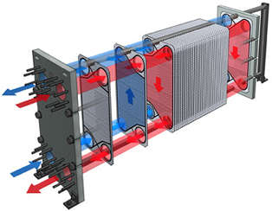

- Corrugated plates and gaskets are the key elements of a plate heat exchanger (PHE).
- The plates and gaskets, along with the front and back plates, are joined and held together by bolts and nuts. The function of the front and back plates is providing rigidity to the whole plate heat exchanger assembly.
- Gaskets ensure leak-proof joining of the plates and guide the fluids properly.

How Does a Compact Flat Plate Heat Exchanger Works?
- Plates are corrugated in such a way that the fluids get space to flow through the corrugation of the plates.
- Gaskets are designed and placed in between two plates to direct same fluid between alternate plates (please refer to image above). So, if fluid-2 is there between first and second plate then fluid-1 will be there in between second and third plate, and so on.
- In this way, Hot and cold fluids (Fluid-1 &2) are separated by a thin metal plate. The fluids thus have large surface areas for exchanging heat.
- Also, turbulent flow of the fluids is ensured by the design of the corrugated plates. This further increases the heat transfer efficiency of the PHE.
- A plate heat exchanger can have an approach temperature as low as 1 degree centigrade.

Advantage of Plate Heat Exchanger
- The separating wall between hot and cold fluid is very thin sheet metal plate in plate heat exchangers, gives higher convection heat transfer. Altogether, heat transfer efficiency for plate heat exchanger is quite high.
- A plate heat exchanger is more compact in comparison with a shell hence higher conduction heat transfer is facilitated. Also, turbulent fluid flow between the plates and tube heat exchanger of the same capacity.
- The assembly and dismantling of a PHE is easier.
- The capacity of a plate heat exchanger can be increased or decreased easily by increasing or decreasing the number of plates.

Applications for Plate Heat Exchangers
Plate heat exchanger finds applications in following conditions:
- For mainly clean liquids that contain no or very small suspended solids
- For low pressure applications.
- Where frequent changes of fluids are not involved.

Conclusion
Plate heat exchangers find many industrial applications because of their compactness and ease of maintenance. As of now, it should be clear how a plate heat exchanger works for two fluids. Heat transfers among more than two fluids are also possible in a PHE just by changing the design of the plates.

