HEAT EXCHANGERS – TEST PAPER (CME 20)

CANDIDATE NAME: ……………………………………… GROUP NO: ……………

PASS
Needs more training: DATE: ………………………..

ASSESSOR: ………………………………PRINT ....................................................SIGN

1 | Define the term Heat Exchanger.
2 | Neatly draw a section view of a single and a double- pass shell and tube exchangers and indicate the path through the tubes and the shell with baffles.

3 | Give three methods of sealing the exchanger tubes to the tube sheet and explain why they are used  i)  ii)  iii)
4 | State the two main reasons for using a two pass instead of a single pass tube exchanger.  i)  ii)
5 | Give two reasons where heat exchangers are used in industry.  i)  ii)
6 | In a shell and tube exchanger which gasket is deemed to be the most difficult to replace and why.
7 | From the drawing and the figures given, explain what could be the reason for the change in pressures in the inlet and outlet nozzles of the unit and how this would affect the efficiency of the exchanger?  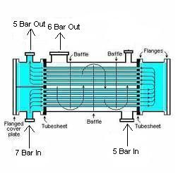

8 | Neatly draw a surface air condenser fan cooling system and indicate the air coolant path through the exchanger. What are the disadvantages of these systems in the summer months
9 | What are the main advantages of a plate heat exchanger over the shell and tube design, and what could be a disadvantage of these units.
10 | How are the baffle plates held in place in a tube bundle and explain why they have to be held securely
11 | Explain why some heat exchangers have flexible bellows arrangement or a packed gland in the shell between the two tube sheets
12 | If a heat exchanger is fitted with a flexible bellows in the shell what precautions must be taken before lifting the unit and what precautions when replacing the unit before in goes into service

