PROCESS VALVES

INTRODUCTION

Where pipework is a means of transporting solids, liquids and gases valves are incorporated in the pipework to facilitate the starting, stopping and diverting of the transportation. Valves are also situated in linework such as steam lines, air lines and water lines, which serve plants and installations with the utilities they require in their operations.

GENERAL PRINCIPLES

Consider the different type of liquids and gases that flow around plant pipelines. High pressure, low pressure, corrosive, non-corrosive, low and high viscosities and volatilities. If we understand this, then we can see why so many different types and sizes of valves are in use.

Valves are manufactured from forges steel, alloys, cast steel, cast iron, brass, plastics etc., the properties of which limit or determine the service for which they are designed.

Most manufacturers have certain standards developed for the design, manufacture and testing of all types of valves, but the basic dimensional standards, such as face to face length, flange and bolt circle dimensions, etc., are those of the A.P.I or Americal Petroleum Institute and this has made it possible to interchange various manufacturers valves.

VALVE CLASSIFICATION

The various types of valve can be sub-divided into the following groups:

- Isolation values (ball, plug, butterfly, gate)
- Regulating valves (globe and needle diaphragm)
- Check valves or non-return valves
- Relief valves

DIAPHRAGM VALVE

Diaphragm valves were first developed for compressed air duty but nowadays have a very wide and important range of duties for the control of fluids. The diaphragm isolates the operating mechanism in the bonnet assembly from the fluid being handled. This isolation preserves the lubricated part from possible damage by abrasive or corrosive fluids and is equally effective in preventing contamination of pipe contents. Diaphragm valve bodies and diaphragms are available in a very wide range of material to list any or more than 700 fluids.

Diaphragm valves are made in different designs for different types of service and can be equally effective for liquids, slurries, pulps or fluids containing solid matter in suspension. Diaphragms are manufactured to suit temperature conditions ranging from
-85˚ F to 392 ˚ F (-65˚ C to 200˚ C). Diaphragm valves find a wide use in chemical engineering.

Diaphragm valves consist of a mechanism which enables a diaphragm to be screwed down onto a seat by means of a compressor.
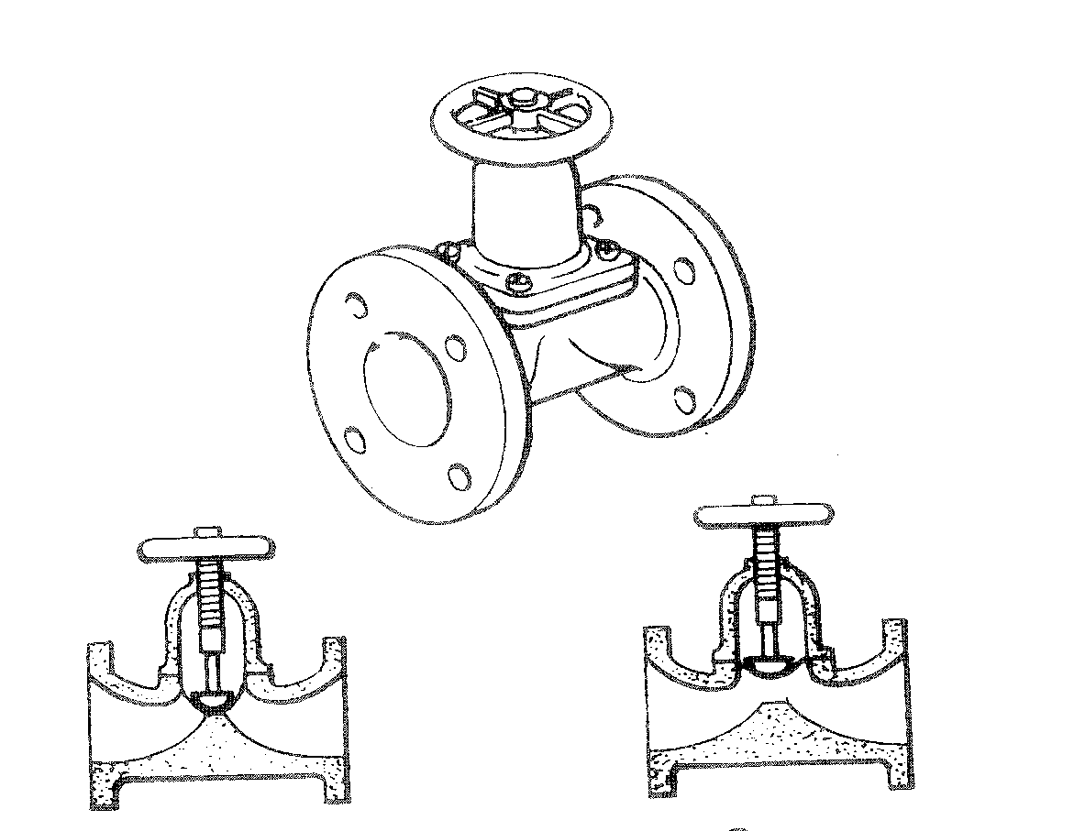

Closed Open

Diaphragm Valves

A. Weir-type B. Straightaway-type

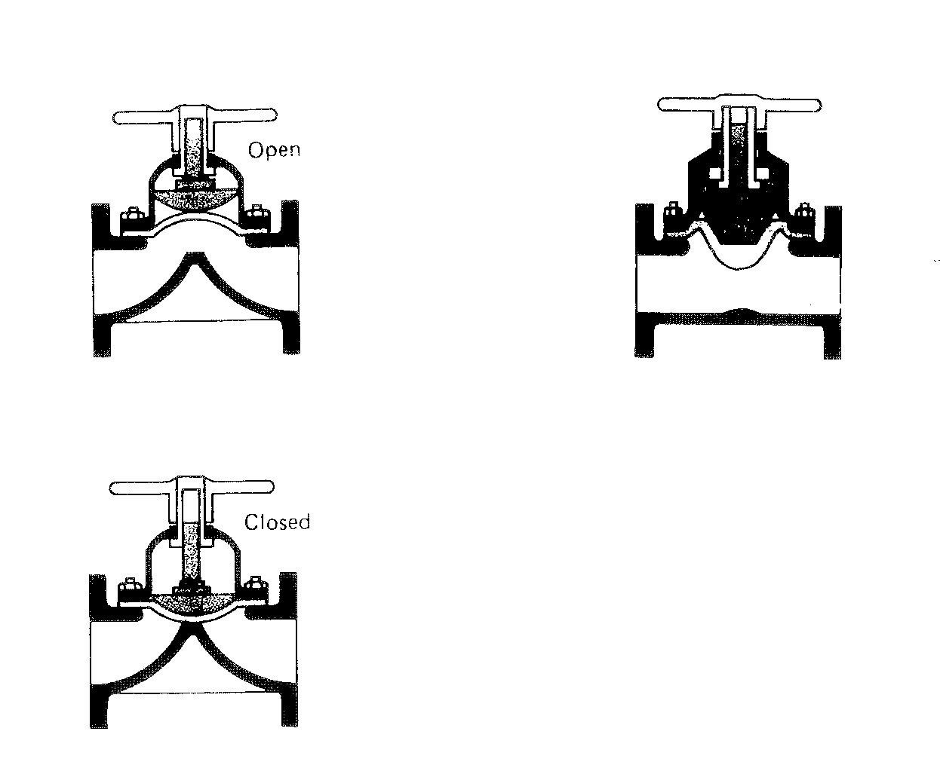

Exploded view of a diaphragm valve

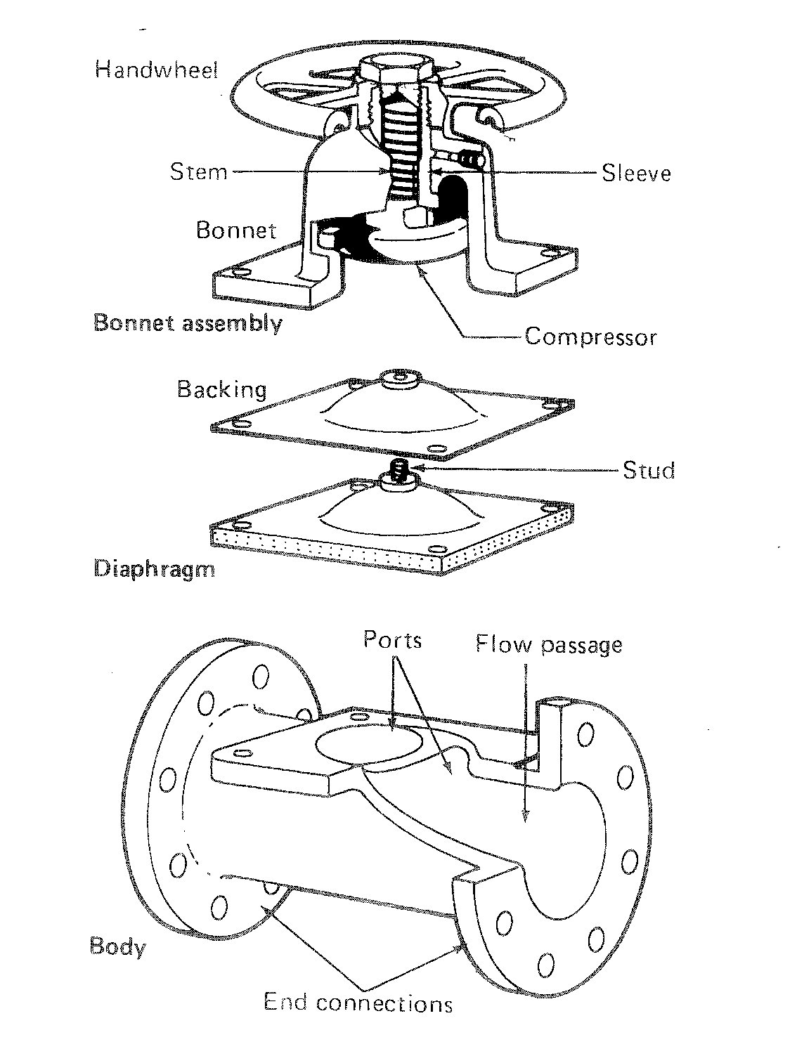
The flexible diaphragm isolates the operating mechanisms from the liquid flowing through the valve and therefore there is no gland.

Until recently only one diaphragm was fitted on these valves, now to diaphragms are used and the most common ones used on the chemical plants are teflon and rubber.

The outer portion of the diaphragms also form the body to bonnet joint, thus sealing off the fluid from the moving parts. Teflon is normally the diaphragm in contact with the fluid, the rubber being topside of this against the compressor.

Operation

The stem action of these valves is normally inside screw, non-rising stem, where the hand-wheel is attached to a non-rising stem, which is attached to a finger plate mounted in the valve for guidance of the compressor, the compressor and diaphragm rising on the stem where the valve is opened.

The operation of this valve is simple;- the hand-wheel is rotated to close the valve, this forces the compressor to which the diaphragm are attached on to the weir at the base of the valve, thus sealing off the fluid.

Summarising the diaphragm valves have the following features:

a) Flexible diaphragm
b) Absence of gland
c) Operating mechanisms insulated from fluid stream
d) a streamline flow

The bodies of these valves can be made from a variety of materials.

Finally, it is easy to line the valve internally in order to increase chemical or abrasion resistance materials such as glass, rubber, plastics can be used to line the body of the valve.

Minimum Maintenance

The seats are self-acting and pressure energised, thus requiring no adjustment or attention in service. The valve requires no lubrication and only infrequent attention to the gland.

Very compact size

It requires very little head-room and can be sited at any angle.

Round bore straight-through flow

Produces exceptionally low pressure drop with almost negligible turbulence.
DIAPHRAGMS

Typical applications are:

GRADE | MATERIAL | USE | GRADE | MATERIAL | USE
AA  B  C  HT  Q  W/WF  215/  215F  226 | Natural rubber  Butyl  Nitrile  Polychloropene  Natural/synthetic rubber  White natural rubber  White Butyl  Vilon | Abrasive fluids  Gases, Acids, Alkalis  Oils, fats  Radioactive materials,  Oils, fats, air  Water, salts, acids, foods, pharmaceuticals  Foods  Aromatics, chlorine sulphuric acid | 237  300  325  286  303  214  C (F)  326 | Hypalon  Butyl  Ethylene  Propylene  Fire resistant  Hypalon base  Virgin Pile  White nitrile  White ethylene  propylene | Potable Water  Potable Water  Pharmaceuticals  Steam sterilisation  Steam sterilisation  Hot water, pharmaceuticals, steam sterilisation, radioactive materials  Fire mains  Fire mains  Foods, chemicals  Foods, pharmaceuticals  Foods, pharmaceuticals steam sterilisation

BALL VALVES

The basic concept of the ball valve is the use of spherical ball-plug held between two lip seal seats. The seats are made from a choice of various synthetic materials such as ptfe, filled ptfe, butadiene – acrylonitrile rubber and a special nylon variant. The inside diameter lip is always slightly larger than the ball-port so that no ‘growth’ of the seal occurs to prevent operation. Tolerances are controlled so that a pre-determined deflection of the lip seal occurs during assembly, thus giving intimate contact, irrespective of line pressure. The metal ball closure member is usually hard chrome-plated, both to resist abrasion and to give long life.

Ball valves are usually manufactured in sizes of ¼″ to 8″. Materials of construction of the main valve assembly are chosen for design duty of the valve, such as cast iron, ductile iron, bronze, aluminium, carbon, stainless steel, titanium, zirconium, tantalum, and many corrosion resisting alloys and plastics.

Pressure ratings are as high as 7,500 psi and temperatures ordinarily up to 575˚F.

Operation of ball valves

The Ball Valve has always been considered one of the most efficient type of valves because it provides an unrestricted throughway, ease of operation, and minimum weight.
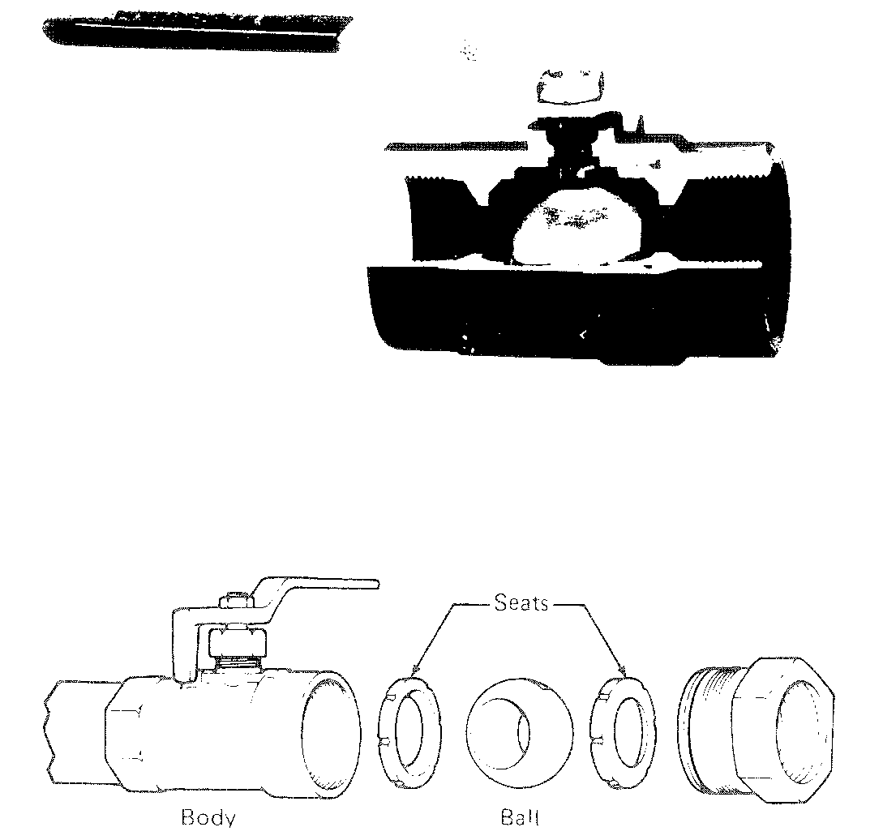
Ball Valve

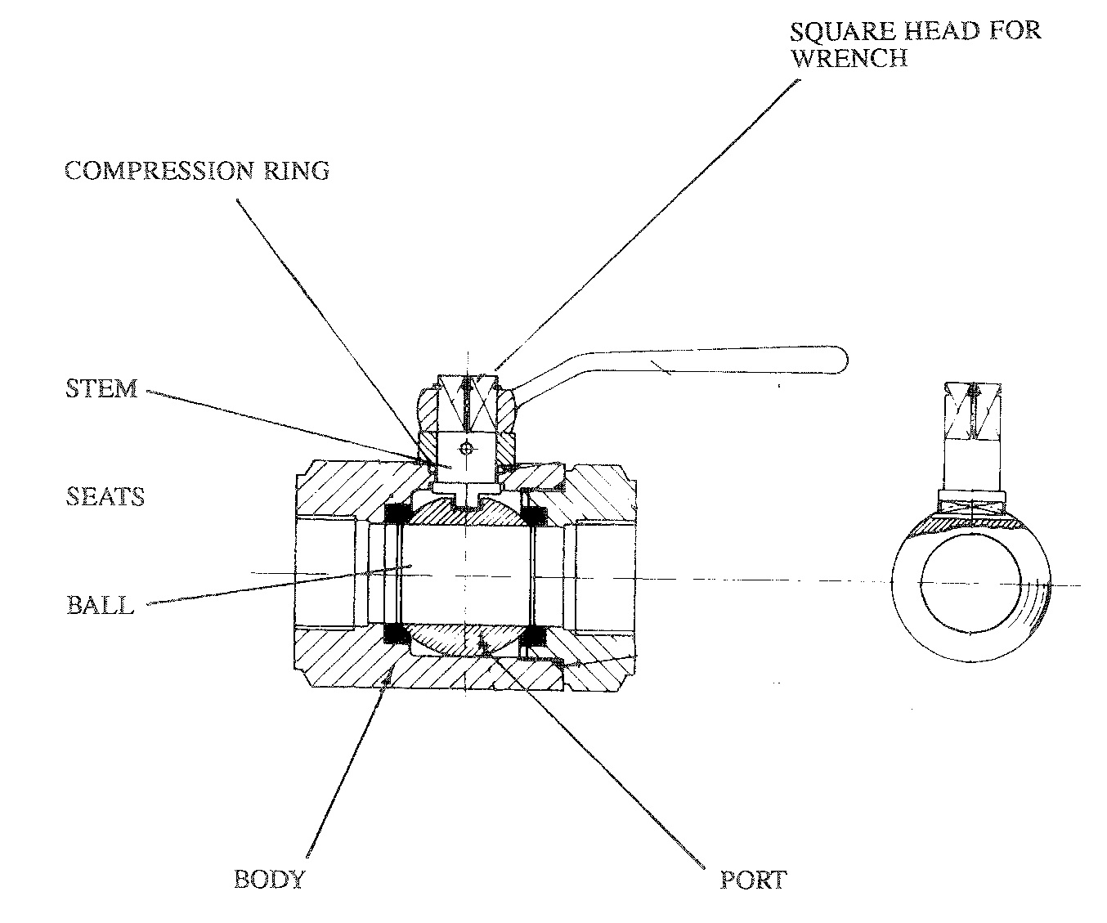
Operating is by means of a shouldered stem which engages in a slot in the ball.

By operating the lever, the ball plug is rotated so that its port is in line with the body ports or at right angles to body ports, i.e. closing them off and preventing any flow.

90˚ Operation

From closed to open or vice versa the valve only requires 90˚ rotation of the stem of the Worcester valve compared with several turns on the other valves. This also enables a reliable indication of whether the valve is open or closed, and the valve is designed so that the handle lies along the line of flow when the valve is opened and across it when the valve is closed.

Some of the outstanding features of the double seal ball valve are as follows:

Two-way sealing

The design of the seat is such that line pressure forces the upstream seat on the ball and the ball on to the downstream seat, thus providing a “Double Seal” ball valve.

Complete shut-off

The well designed lip seals on the flexible seats deflect under pressure and follow the contour of the ball in the absence of the pressure, ensuring a dead tight seal in both directions of flow.

Wedge-gate sluice valve, a typical arrangement.
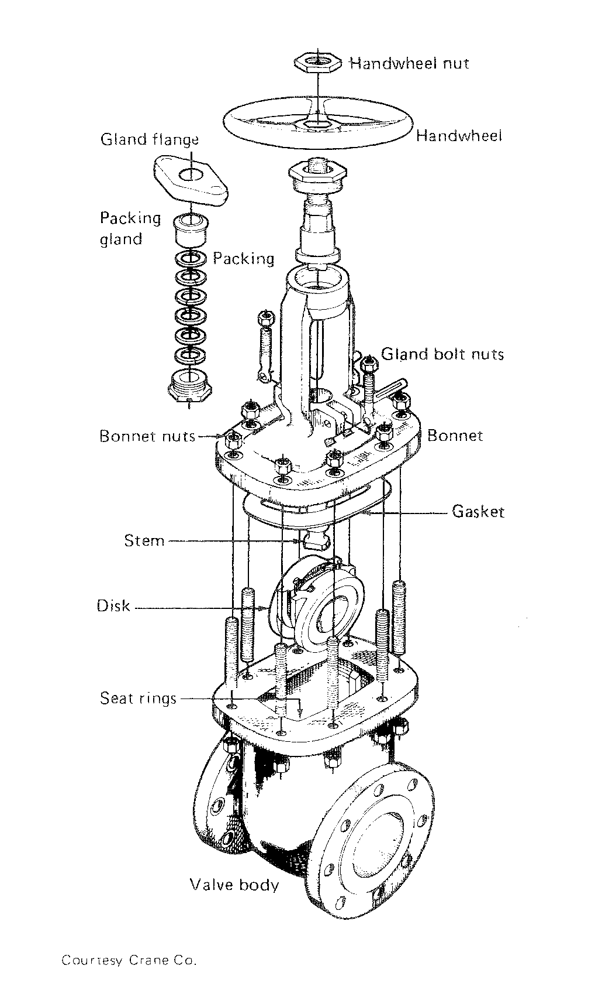
TYPES OF GATE VALVE

WEDGE GATE VALVE

A valve in which closure, i.e. affected by the wedge action between the gate and body seats. Wedge gate valve may take the following forms:

a) Solid wedge - in which the gate is in one piece, either solid or cored.

b) Split wedge - in which the gate is in two pieces.

The solid wedge disc has the advantage of strength and being a single part, is not liable to vibrate or chatter in service, thereby reducing wear to a miniumum. Solid wedge gate valve can be installed in any position without danger of the disc jamming due to misalignment of parts.

Soft seals can be installed in solid wedge gate valves, these comprise of non-metallic rings which are fitted in the body seats, or in the wedge, giving tight closure backed by contract of metal-to-metal surfaces for searching and corrosive fluids.

Gate valves are widely used where uninterrupted flow is required and are suitable for general purposes on services such as steam, water, oil, gas and many other fluids. They are not generally recommended for throttling service and should be used fully open or fully closed.

HOPKINSONS PARALLEL SLIDE VALVE

The merits of parallel slide valves have been recognised as a general purpose stop valve and for conditions where the flow through the valve may be in either direction. It is usually used as an isolating valve on steam service.

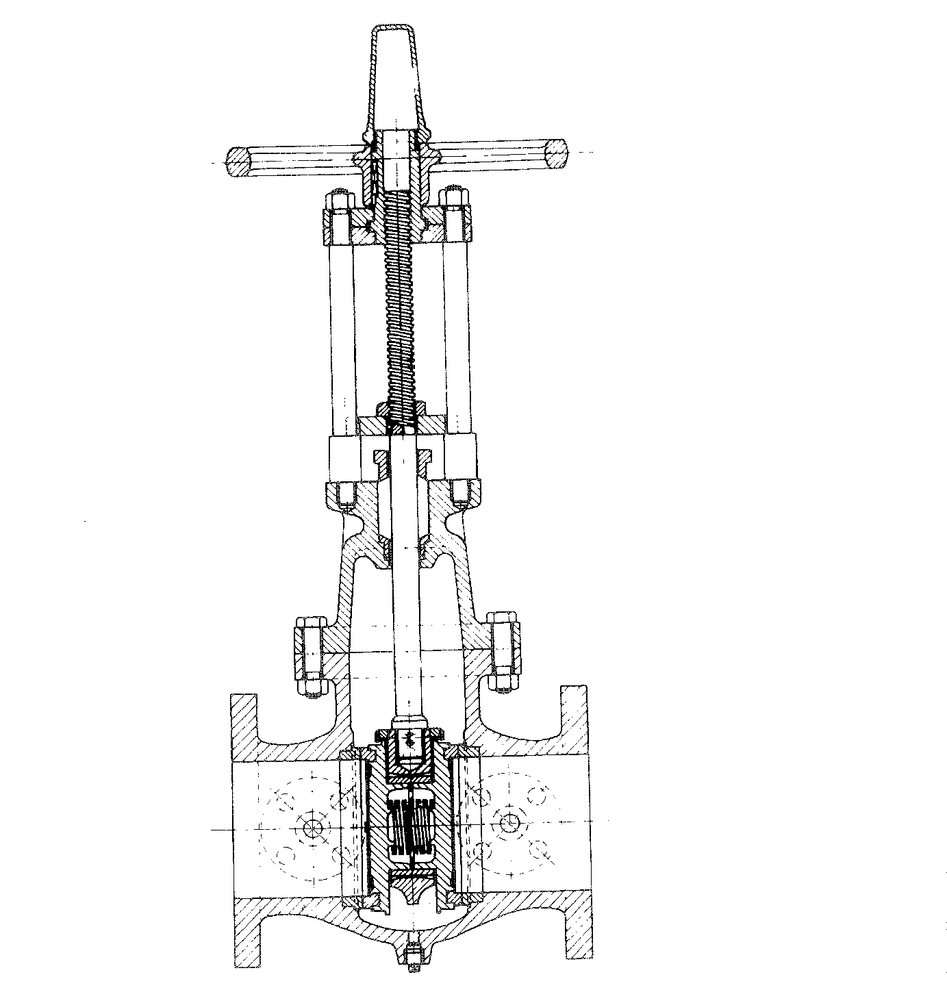
DOUBLE DISC GATE VALVE

A valve in which the gate consists of two discs which are forced apart by a spreading mechanism at the point of closure against both parallel body seats, thus ensuring an effective sealing of the valve without the assistance of the fluid pressure.

A light spring keeps the disc in close contact with the seats when the valve is not under pressure.

When the valve is being opened, the discs slide over the seat faces until completely clear of the bore, thus giving an unobstructed passage through the valve and reducing pressure drop to a minimum. The slide valve action also removes any dirt and foreign matter from the faces.

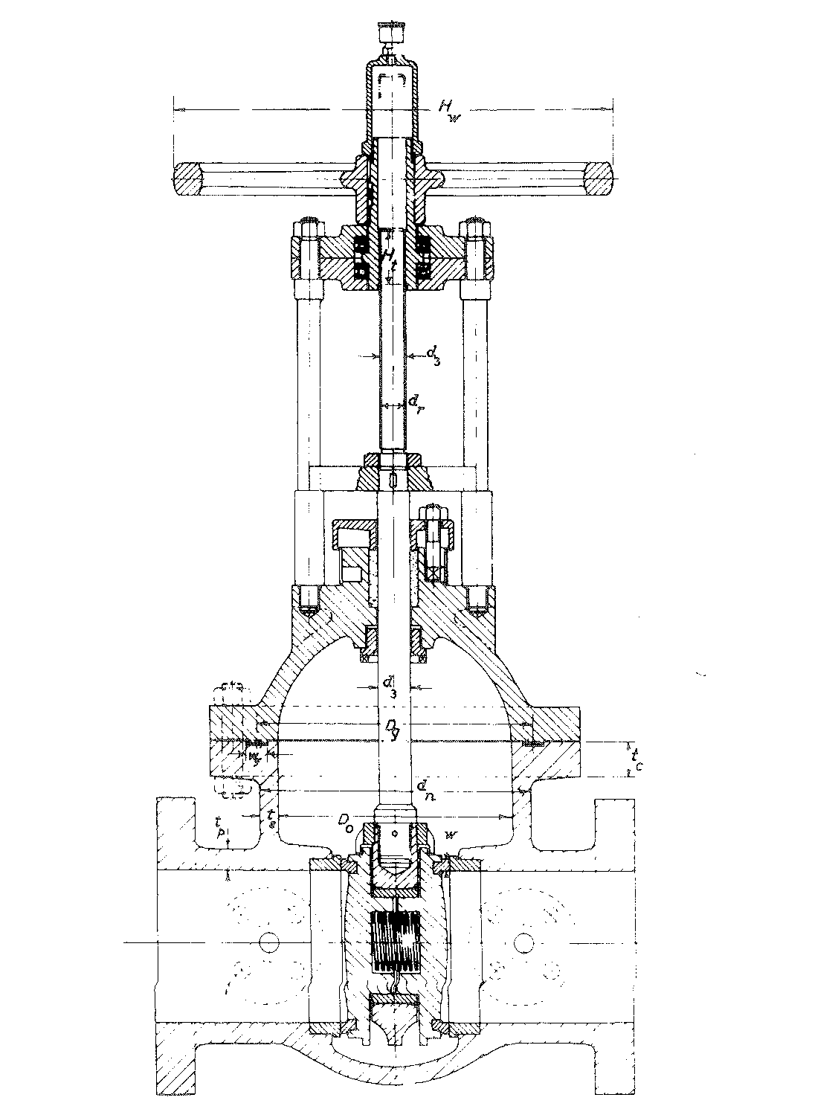
CHECK OR NON-RETURN VALVES

A check valve or NRV is one which prevents reversal of flow by means of a check mechanism, the valve being opened by the flow of fluid and closed by the weight of the check mechanism when the flow ceases, or by the back pressure and is a form of safety valve. They are usually installed in pump discharge lines so that if the pump stops, all the pressure in the line will now return to the pump. They will permit flow in one direction only.

For instance, suppose a centrifugal pump is taking suction from a tank having a working pressure of only 3.5 kg/cm², and discharging into a column at 35 kg/cm². If the power to the pump should fail and there is no non-return valve in the line between the column and the tank, the tank pressure could raise to 35 kg/cm².

Never depend on a non-return valve to do what a gate valve or plug valve is supposed to do. If there is a plug valve in the line along the non-return valve, close the manually operated valve also. This is a good insurance in case the non-return valve does not close completely.

TYPES OF CHECK VALVE

SWING TYPE

A check valve in which the check mechanism incorporates a disk which swings on a hinge.

The swing check type is commonly used in pipeline, conveying liquid by gravity or pumping. The selection of the most suitable pattern and size is determined by a number of parameters, working pressure and temperature, velocity of liquid, permissible friction losses, possibility of rapid reflux condition in the system, etc. Various forms of swing check valves are used from the single hinged pattern in pipelines of a few inches in bore, to the large multi-door patterns used in pipe systems of several feet in bore to the large multi-door used in pipe systems of several feet in bore, and their careful selection can result in low friction losses and trouble free functioning. Can be installed in the vertical or horizontal position.
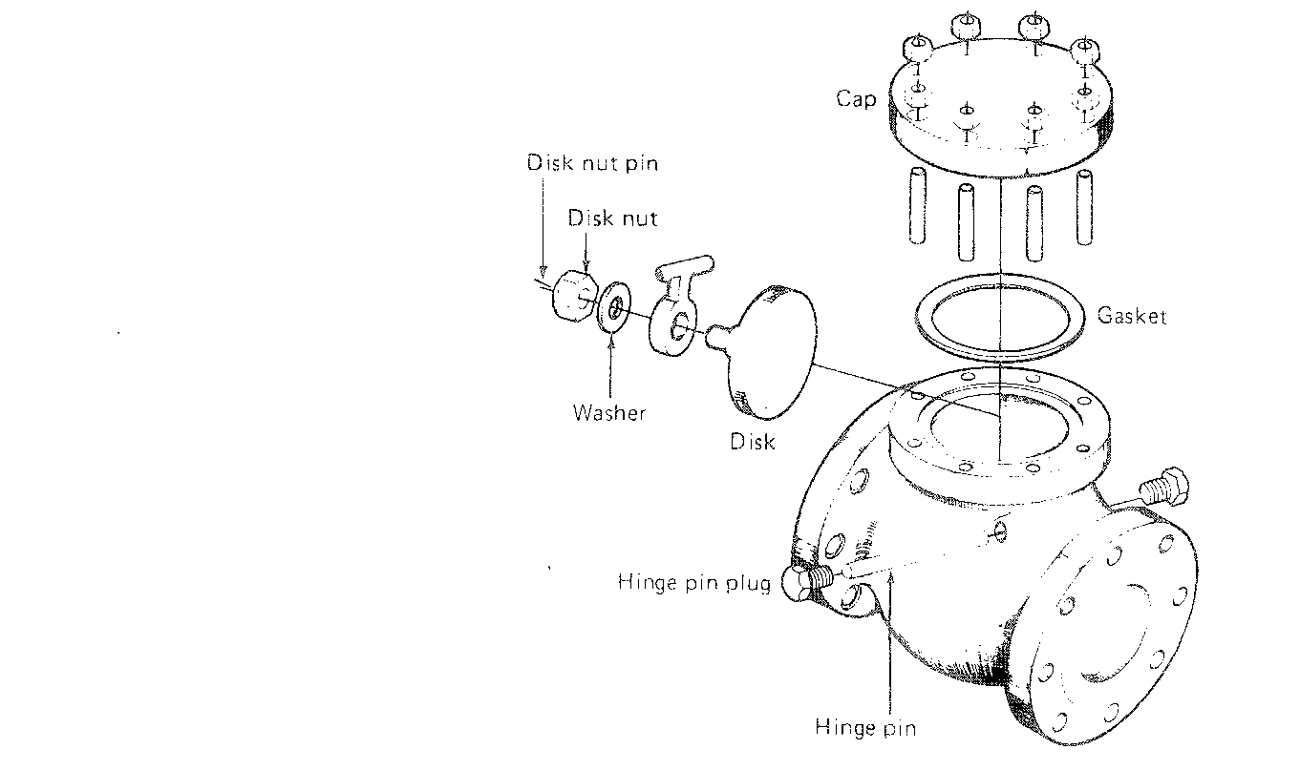
Horizontal lift check valve

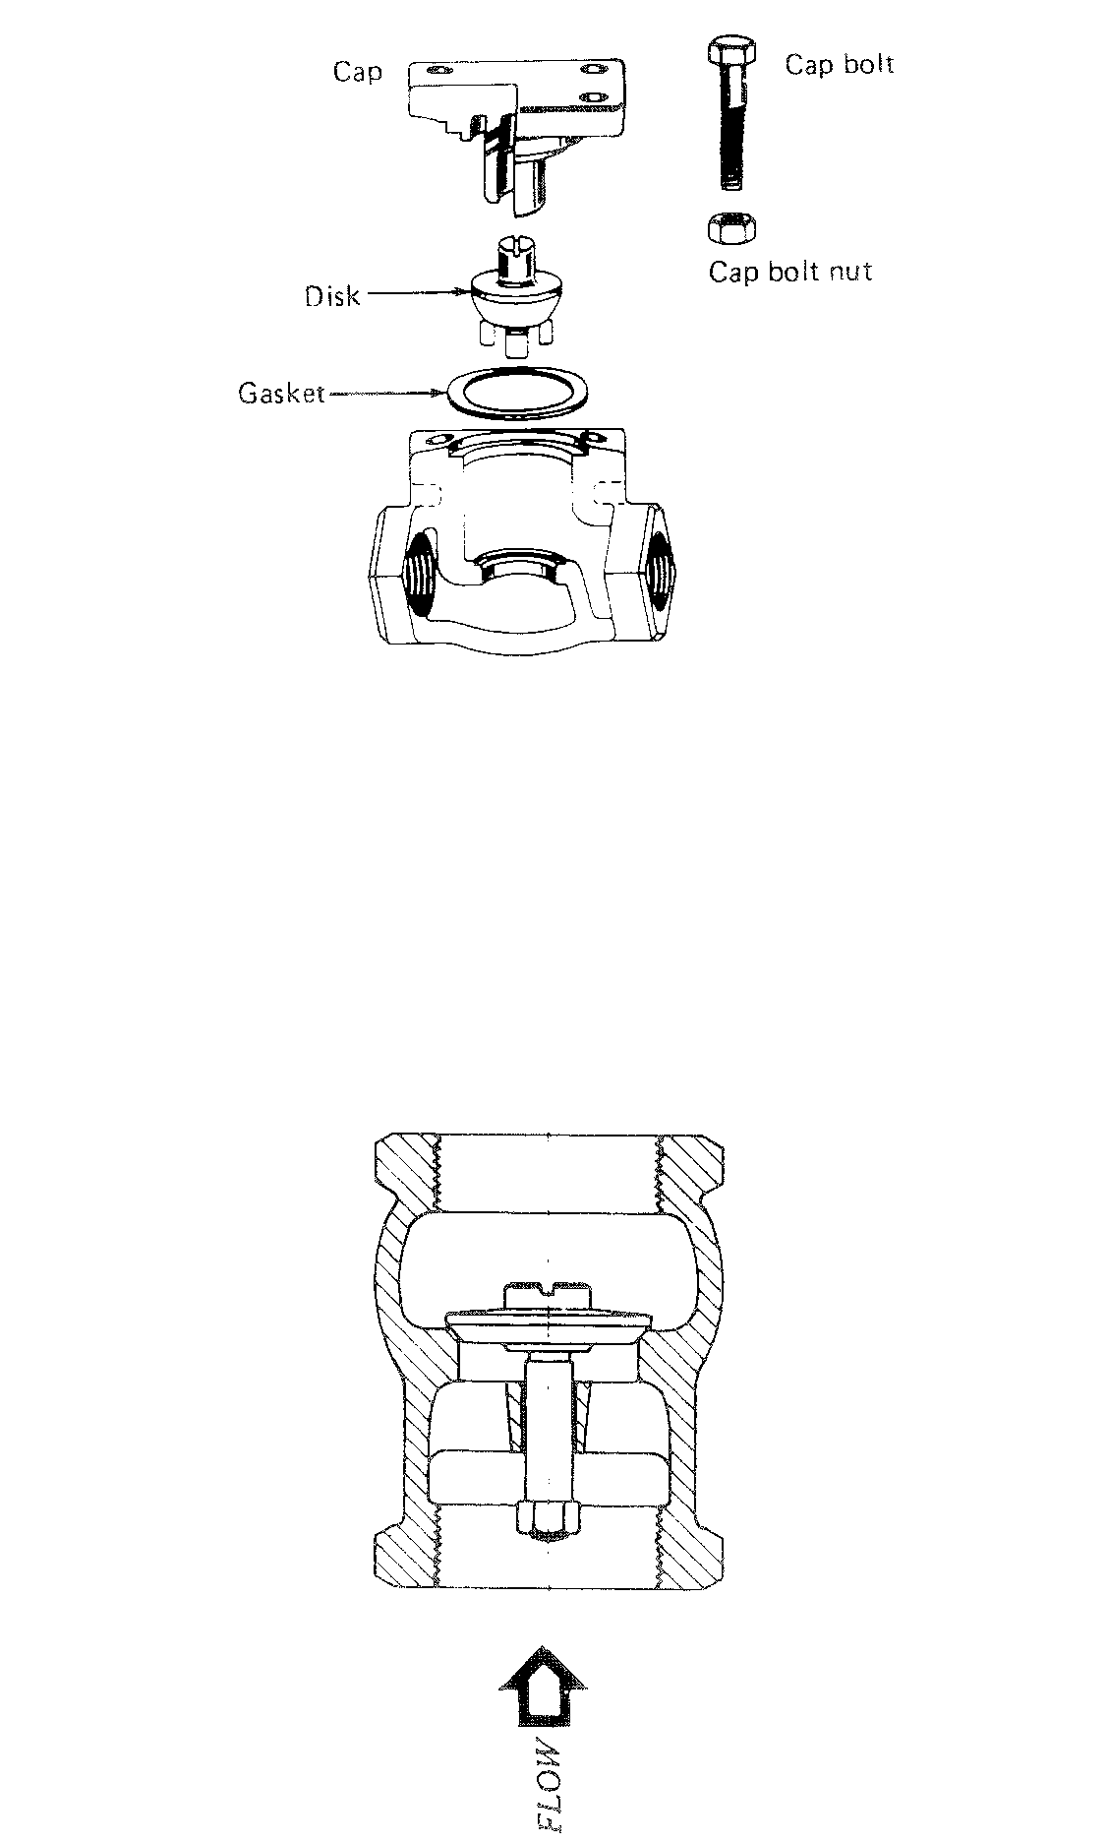
Non-return valves

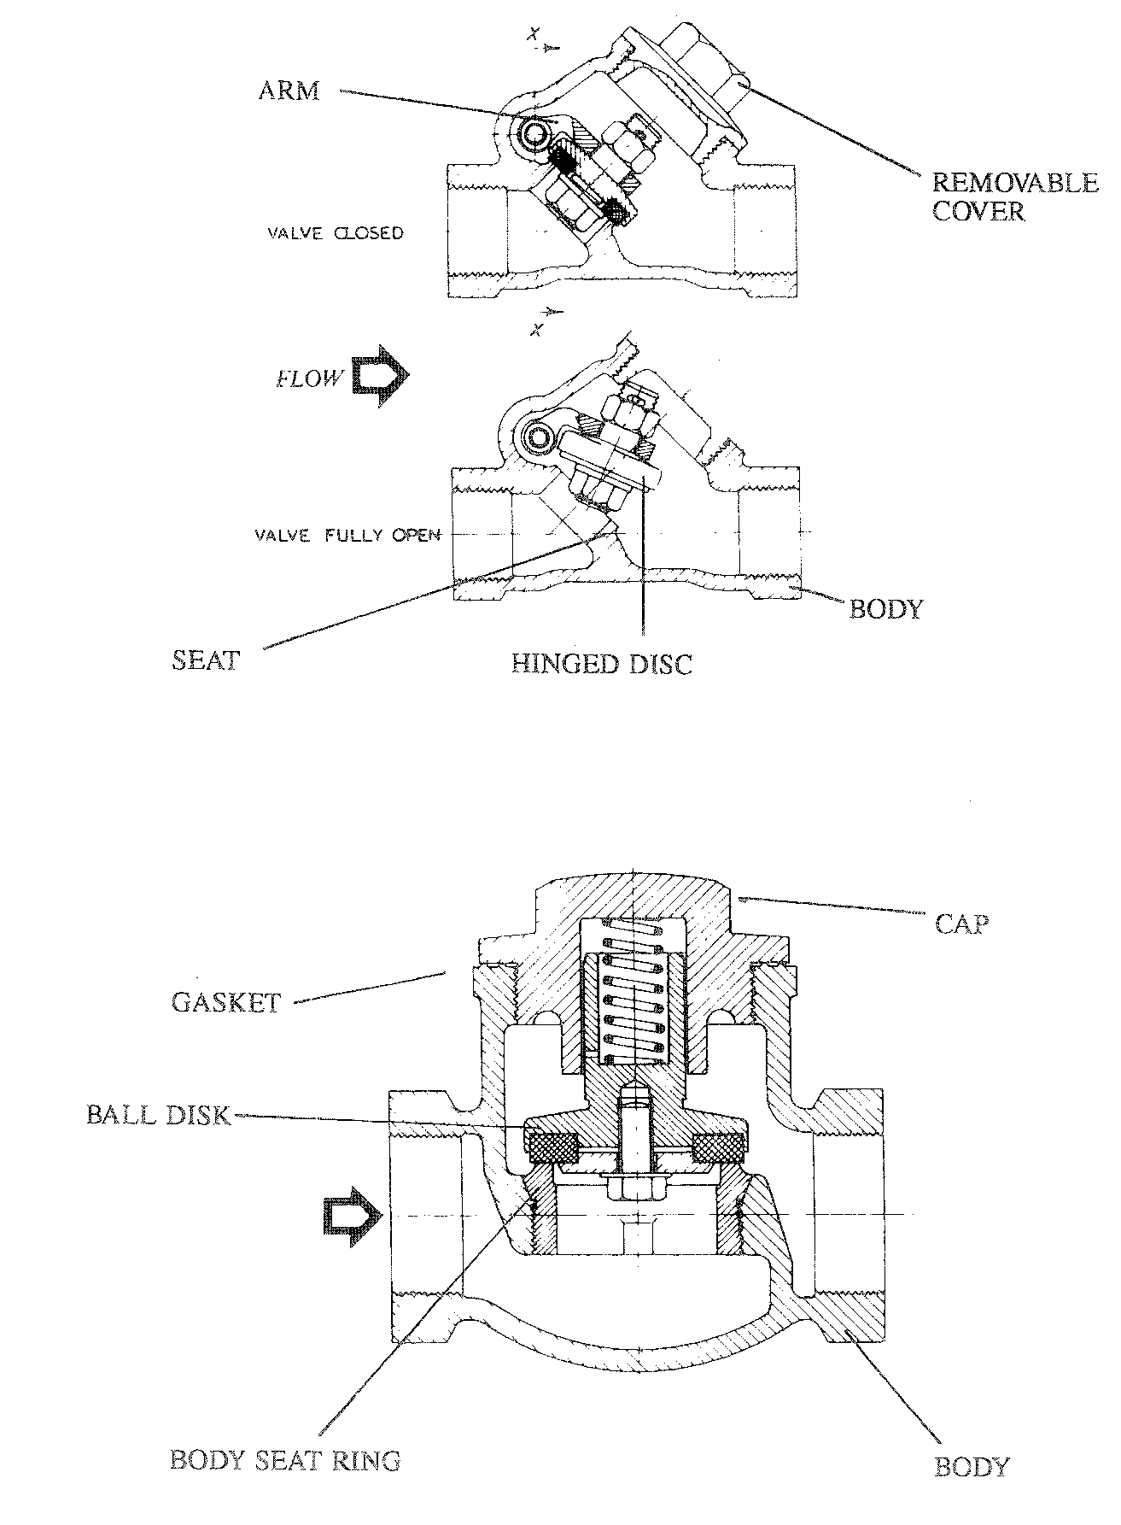
BUTTERFLY VALVES

A butterfly valve consists of a housing in which a shaft passes through. On this shaft the vane and valve plate are connected.

The top of the housing can adapt various types of shaft actuators, both power or manually operated. Power, lever and handwheel actuators are interchangeable without additional parts.

The actuator is connected on the end of the shaft. The valve is in the fully open or closed position by turning the actuator 90 angular degrees.

To prevent deflection there are bearings built-in at both sides of the shaft.

When the valve is in the wide open position, there is a straight-through flow with only the small area of the edge-wise surface of the plate and vane causing an obstruction.

A lever actuator valve for manual operation has a scale for indicating the vane position and an integral stop at each end of the scale. A plate-plunger pin located on a squeeze type level assembly engages the plate which is notched for on-off operation.

The packing at both ends of a one-piece shaft eliminates unbalanced forces on shaft due to static pressure and resultant vane mis-alignment problems.

A grease asbestos type of packing is normally used to seal-off leakage through the gland.

Butterfly valves are multi-purpose valves and are applicable to rather low pressures, say up to 10 kg/cm². They are characterised by their large capacity and are less expensive than plug or globe types.
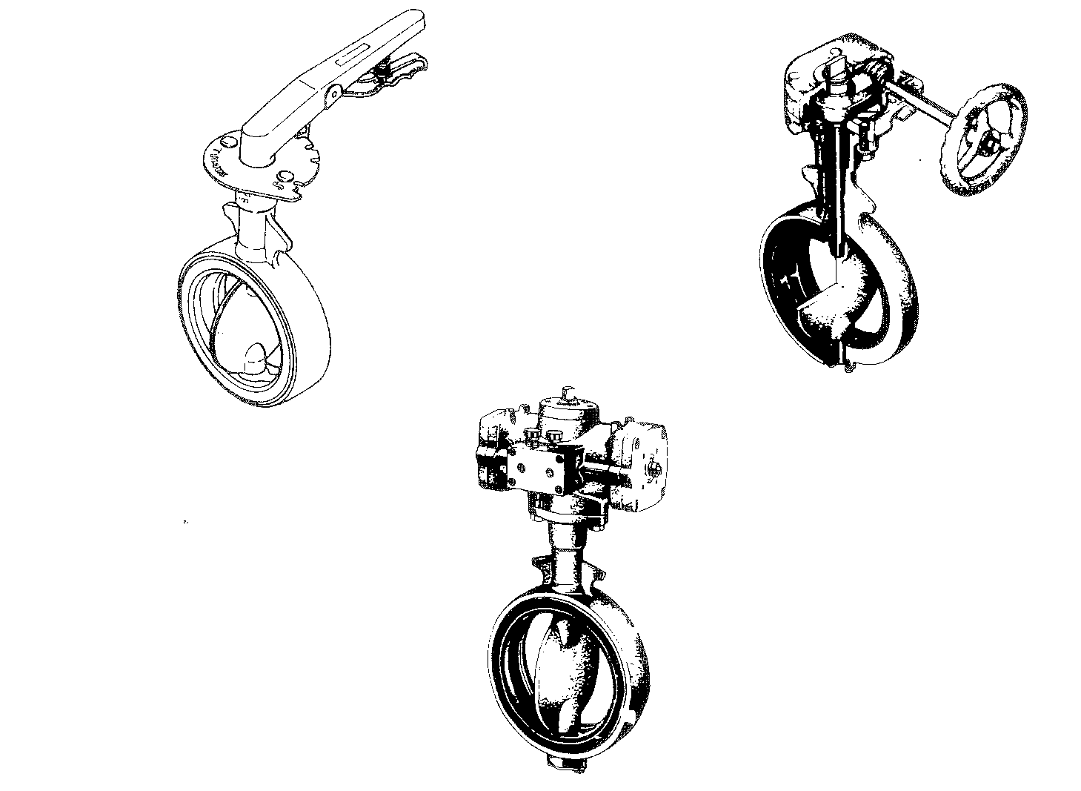
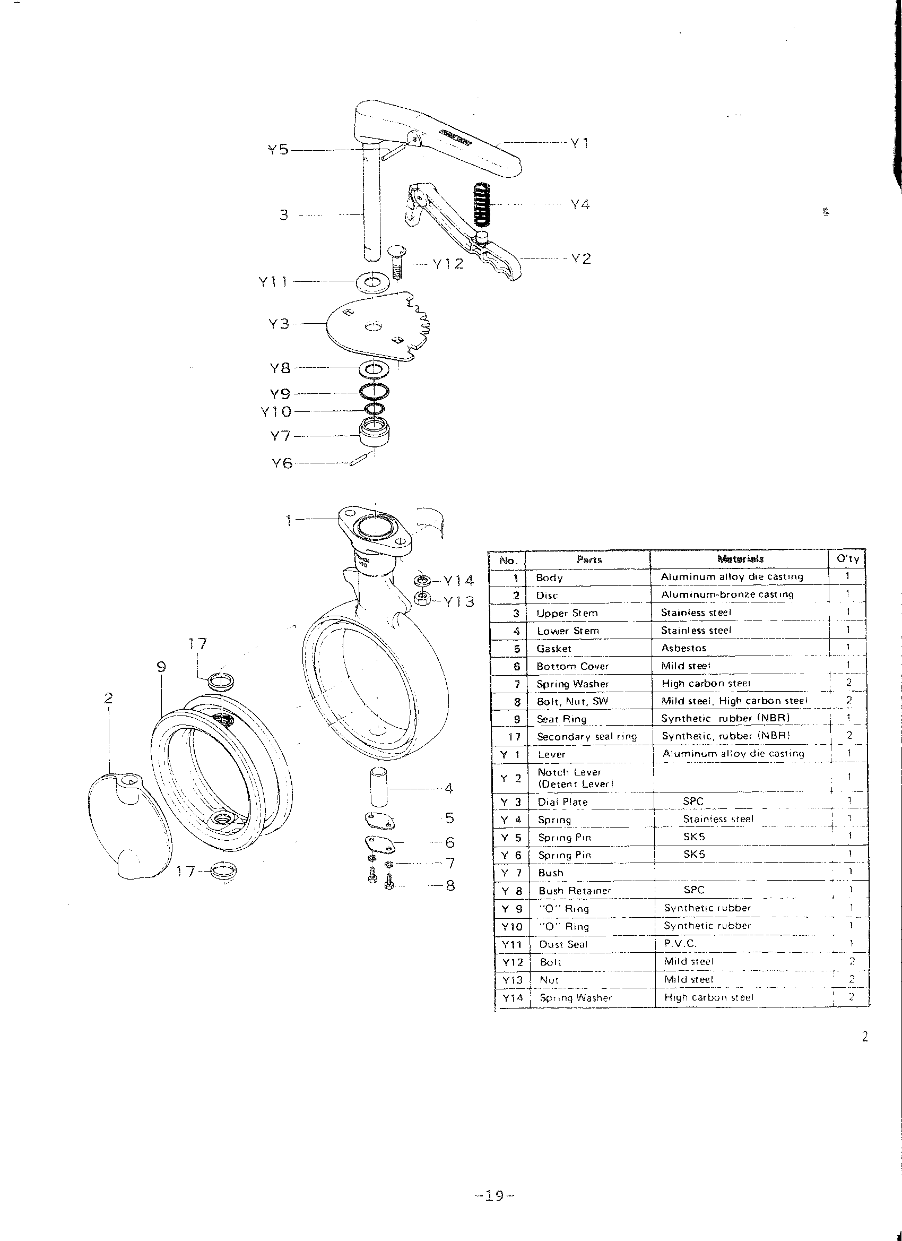

No. | Parts | Materials | Qty
1 | Body | Aluminium alloy die casting | 1
2 | Disc | Aluminium-bronze casting | 1
3 | Upper Stern | Stainless Steel | 1
4 | Lower Stern | Stainless Steel | 1
5 | Gasket | Asbestos | 1
6 | Bottom cover | Mild Steel | 1
7 | Spring washer | High Carbon Steel | 2
8 | Bolt, Nut, SW | Mild Steel, High Carbon Steel | 2
9 | Seat Ring | Synthetic rubber (NBR) | 1
17 | Secondary seal ring | Synthetic rubber (NBR) | 2
Y1 | Lever | Aluminium alloy die casting | 1
Y2 | Notch Lever  (Detent Lever) |  | 1
Y3 | Diap Plate | SPC | 1
Y4 | Spring | Stainless Steel | 1
Y5 | Spring Pin | SK5 | 1
Y6 | Spring Pin | SK5 | 1
Y7 | Bush |  | 1
Y8 | Bush Retainer | SPC | 1
Y9 | “O” Ring | Synthetic rubber | 1
Y10 | “O” Ring | Synthetic rubber | 1
Y11 | Dust Seal | P.V.C. | 1
Y12 | Bolt | Mild Steel | 2
Y13 | Nut | Mild Steel | 2
Y14 | Spring Washer | High Carbon Steel | 2

NEEDLE VALVES

Needle valves consist of a housing in which a sharp pointed needle passes through the gland and can be screwed down on its seat.

A screw type of gland may be applied to screw the Teflon or asbestos packing into the gland stuffing box. This is to seal off leakage of gas or liquid along the spindle.

A screw cap is used to prevent dirt getting into the thread of the gland.

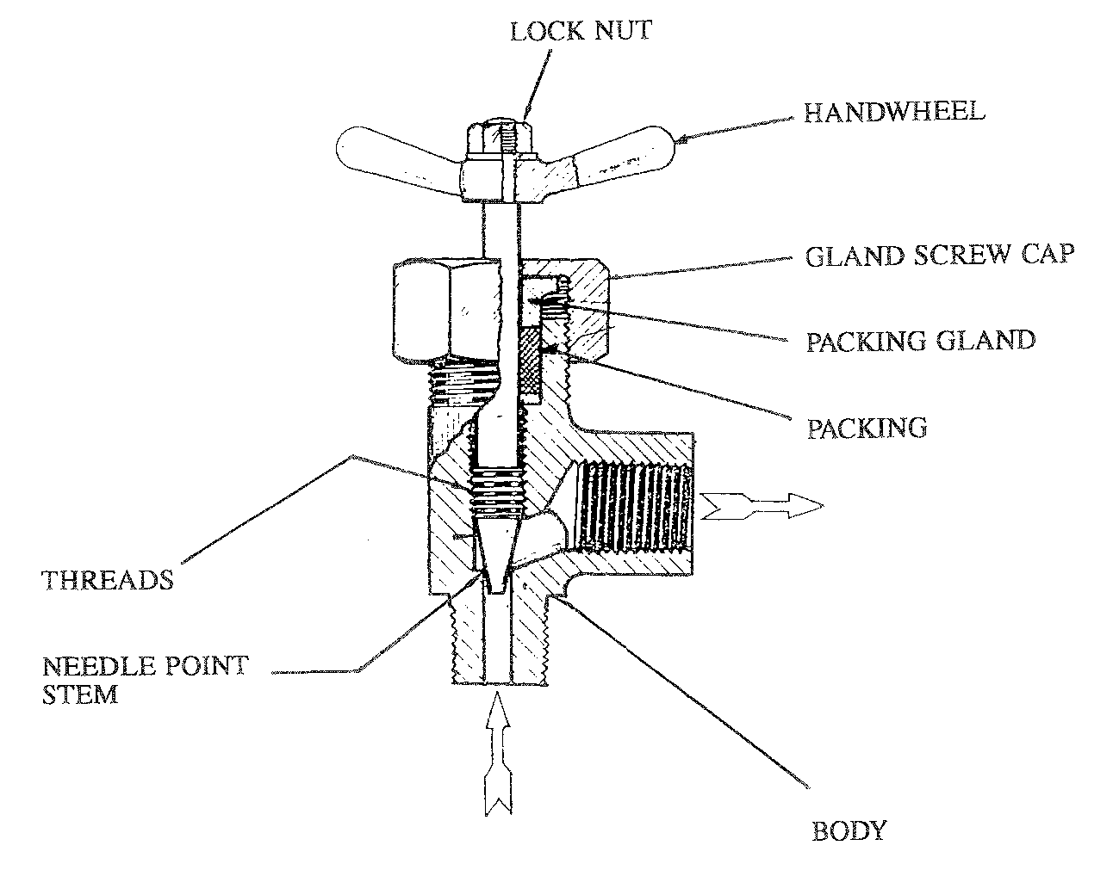
A needle valve has the same principle characteristics as the globe valve and is mainly used to control small amounts of gas or liquid flows through the valve. It has a perfect shut-off position and operates under high pressure. It is normally used on gas sample cylinders and also on bypasses of gas or chemical injection pumps. This valve is seldom operated in fully-open position, but basically only for throttling purposes. These are normally used where the flow has to be controlled at fine limits.

There are two types of needle valve:

i) Straight through flow
- process control

ii) 90˚ Angle Type
- generally used on gas cylinders for sampling gas/liquid streams
PLUG VALVES

A form of shut-off devise, having a plug either parallel, taper or spherical in shape, which can be turned to move its port or ports relative to the body seal ports to control the flow of fluid and which incorporates design features which reduce friction between the plug face and the body seat during the turning of the plug and/or seal them against leakage.

The plug is a refinement of the simple cock, suitable for high pressure and temperatures. A ¼ turn opens or closes the valve. Flow through the valve is smooth, straight and uninterrupted. Pressure drop across the valve is therefore low. Seating surfaces are fully protected from the line fluid. In addition to straightaway designs, multipart and steamjacket types are available.

Lubricated plug valves

Single gland Bolted gland Screwed gland
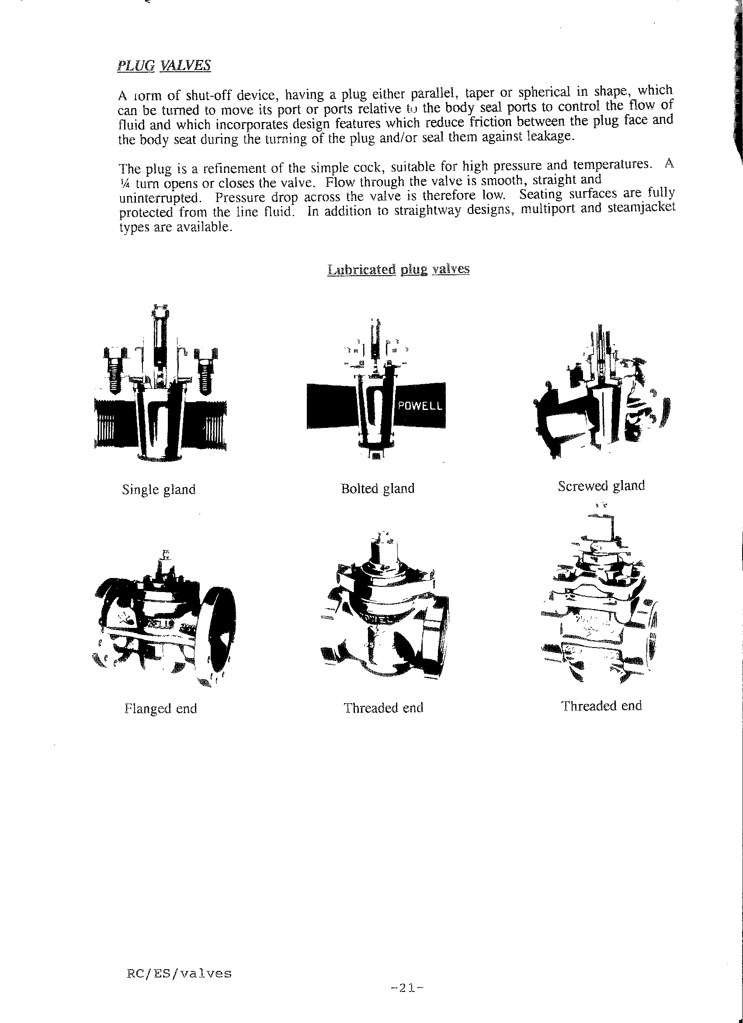

Flanged end Threaded end Threaded end

Lubricated plug valves

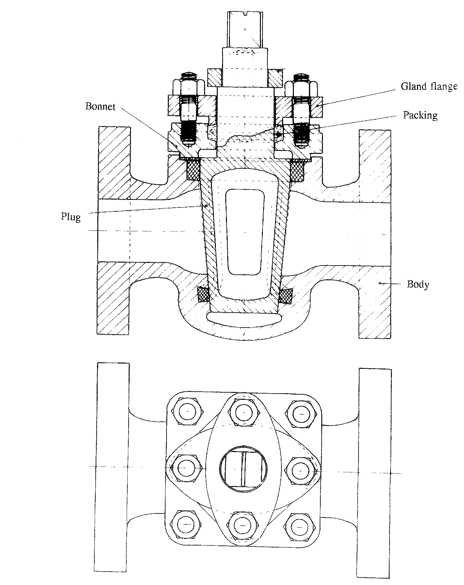

In lubricated plug valves, the seating surfaces of the plug and its enveloping barrel or body are lubricated, the lubricant being in stick or cartridge form and introduced into the head of the plug and forced through appropriately located ducts and grooves which eventually communicate with the seating surfaces of the valve. The lubricant is forced through these ducts with the agency of a screw or gun operation in conjunction with a small ball check valve to prevent return flow. This pressure lubrication performs four important functions:

i) it provides a jacking action
ii) it seals the valve
iii) it minimises friction and weat
iv) it protects the seating surface from corrosion and erosion

TYPES OF PLUG VALVE

Lubricated plug valve - A plug valve which incorporates design features whereby lubricant is injected under pressure between the plug face and body seats.

Non-lubricated plug valves - A plug valve which incorporates mechanical design features to reduce the friction between the plug face and body seat during turning off the plug.

GLOBE VALVES

Quite a common valve used in industry and is more expensive than the gate valve. Globe valves are used to stop or regulate flow of a liquid or gas and are operated by means of a screw and nut mechanism, actuated manually through the medium of a handwheel. They may incorporate a globe type body for insertion in a continuous straight pipeline or have an angled body for convenience or insertion in two converging pipelines arranged at angles to one another.

Spindle Action

a) Inside Screw - Where the actuating thread of the stem is engaged within the bonnet.

Outside Screw - Where the actuating thread of the stem is exterior to the bonnet.

Operation

A globe valve has a more ore less spherical housing in which a disc is pressed onto a circular seat. This disc can be screwed up and down by a spindle. The liquid enters the valve under the seat and passes out over the seat; this means that when the valve is closed, there is no pressure on the gland. Glove valves give a better control on the amount of flow than gate and plug valves, and are also placed there when good mixing is required.

The globe valve is used primarily for throttling or controlling specified flow through the valve. This valve should always be installed with the pressure underneath the seat, so that the valve steam packing maintenance is kept to a minimum. The flow of liquid or gas through this valve contacts all sides of the disc or needle, which results in an even wear. This allows a better leak-tight shut-off even on a worn valve. Conversely, if a gate valve was used, the flow would contact only the bottom edge of the disc, causing uneven wear, and leakage when shut-off.

Glove valves are called “slow opening valves”, because it takes several turns of the spindle to open it. They are similar in appearance from the outside to gate valves. They control the flow of the product when close control by a motor valve is not necessary. The maintenance and upkeep are the same as for a gate valve. The globe valves are very expensive
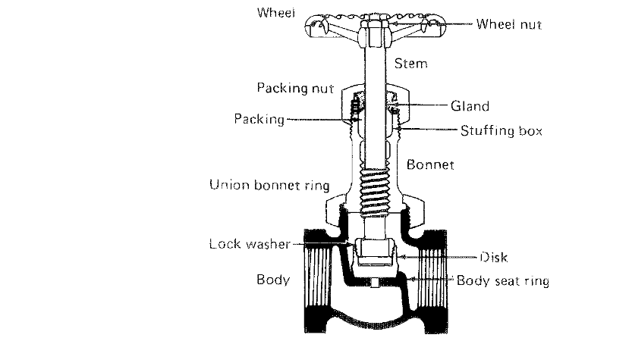
Globe Valve

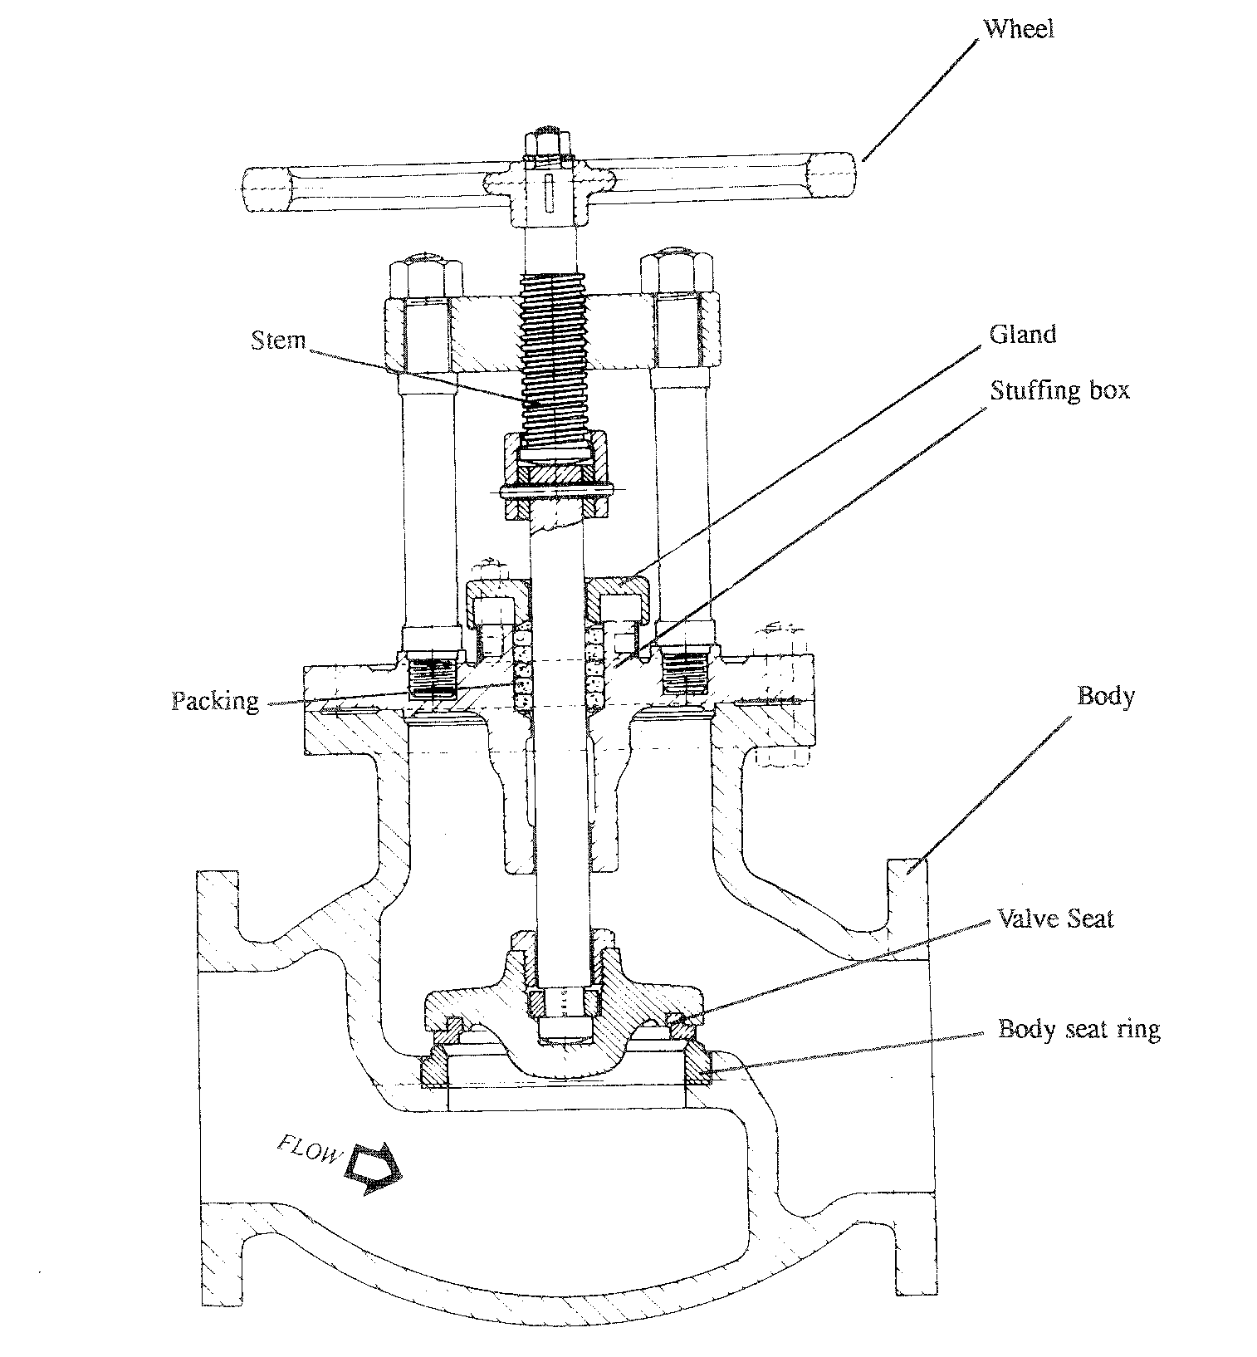

RELIEF VALVES

High pressure air, gas and steam systems require some means of protection against excessive pressures. Relief valves perform this function by opening quickly and allowing the pressure to drop to safe levels. The basic function of a relief valve is to maintain a constant pressure at its inlet. When the inlet pressure is too high, the valve opens, allowing fluid to pass to atmosphere or to a lower pressure outlet.

Relief valves are used on systems that carry liquids and gases in applications ranging from small air systems to large steam generating plants. Many sizes and types of relief valves are available, some are built into system components such as pumps.

Standard relief valve body materials include carbon steel, stainless steel, cast iron and bronze. Seats are often made of stainless steel. While springs may be of carbon steel or cadium plated steel.

Operation

A spring keeps the valve closed until the preset pressure level is reached, pressure above the set point overcomes the resistance of the spring and forces the valve off the seat allowing the excess pressure to be released. Adjustments can be made to change the pressure at which the valve will open, these adjustments are normally limited to a 10% increase or decrease. A greater increase requires the use of different spring or possibly a new valve. Adjustments are made by turning the adjusting screw, tightening it compresses the spring increasing the inlet pressure needed to open the valve.

There are strict codes of practice that cover the relief valve and these codes of practice must be met by law. Only trained and certified personnel should attempt to inspect or repair these valves.

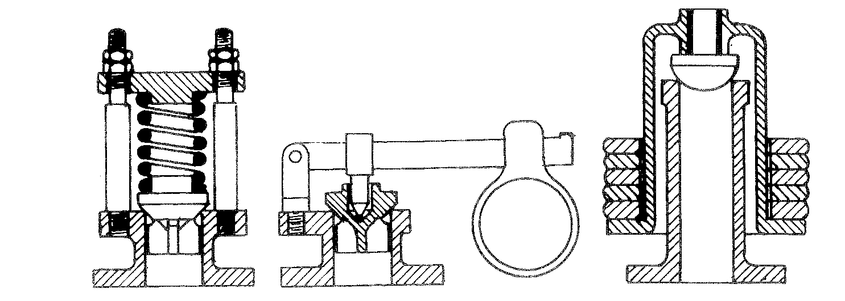

Spring safety or relief valve Lever safety or relief valve Dead-weight safety
or relief valve

RELIEF VALVES
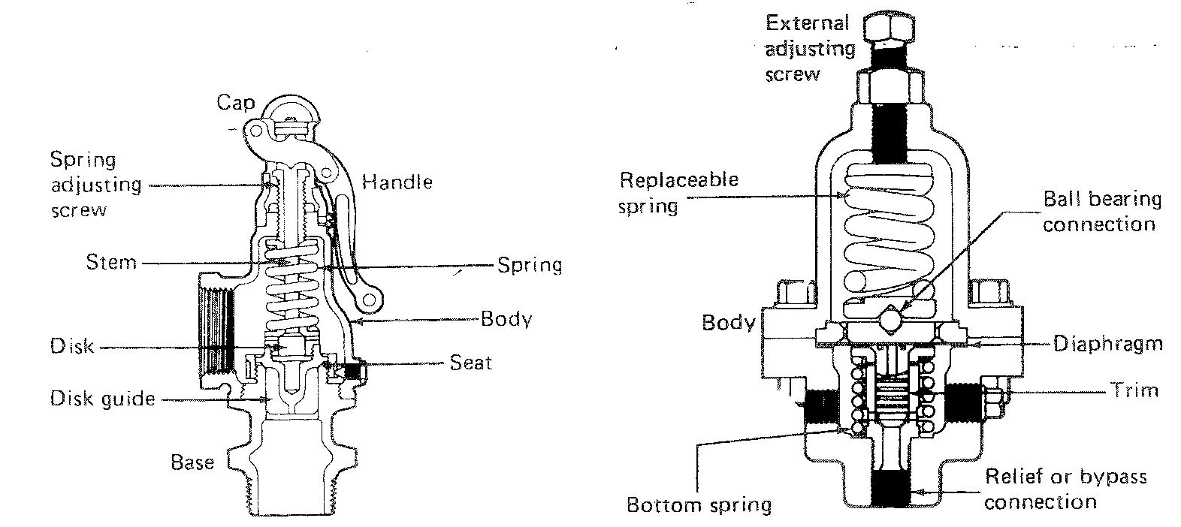

Applications

Small hot water boilers.

Low pressure steam boilers.

Fuel oil ring main, pump relief and by-pass valves.

Protection of low pressure equipment after pressure reducing valves.

Protection of vessels and pipelines liable to damage from over-pressure.

Protection of vessels where contents are liable to thermal expansion.

Outstanding features

Precision lapped metal to metal seating surfaces.

Adequate guiding of the valve disc.

Accurate setting fro correct blow-off pressure.

Individually tested by compressed air.

Sizes from ½ ″ to 4 ″ nominal bore.

Screwed or flanged connections.

Test lever can be rotated through 360˚.

Precision cadmium plated springs ensure peak performance at all set pressures.
ROTARY VALVES

Rotary Valves are designed for use in gravity and pressure systems. They are suitable for metering a wide range of Dry Solids, Granular, Pelleted and Powdered type materials from the outlets of Silos, Hoppers, Cyclones, Mixers, Weighers etc.

Rotary Valves have to perform under a wide range of conditions and duties and since no single type of Rotary Valve can economically perform all duties, Bush and Wilton have developed to Rotary Valve types. These are the Tapered Rotor range suitable for most applications where differential pressure are not greater than 0.7 bar (10 1bf/in²) and the Parallel Rotor Heavy Duty range suitable for differential purposes up to 1.4 bar (20 1bf/in²).

This brochure is devoted entirely to the Tapered Rotor range.

Materials on construction include Cast Iron, Stainless Steel, Aluminium and Mild Steel.

Two rotor options are available:

The standard taper rotor is of the closed-end type (with matching bore in the valve body). This is suitable for handling the majority of dry powdered and granular type materials in its standard room. The radial runner clearances between rotor and body are simple to adjust and can therefore be set to suit the product to be metered. When there is a differential pressure across the valve, such as in pneumatic conveying systems, gas losses through the valve can be minimised. When the product being metered is at a higher or lower temperature than ambient, clearances can be set to compensate differential expansion between the valve body and rotor. Re-assembly after routine maintenance is simple since the rotor need only be pushed into the valve body; the end covers and seals are then fitted. Radial clearances are set by withdrawing the rotor using the locking collars. These collars are tightened each side of the relevant outboard bearing once the setting has been achieved.

The Parallel rotor is particularly suitable when replaceable tips (steel, brass, rubber or polymers) are required. Rotor blades can be back-relieved to minimise product resistance.
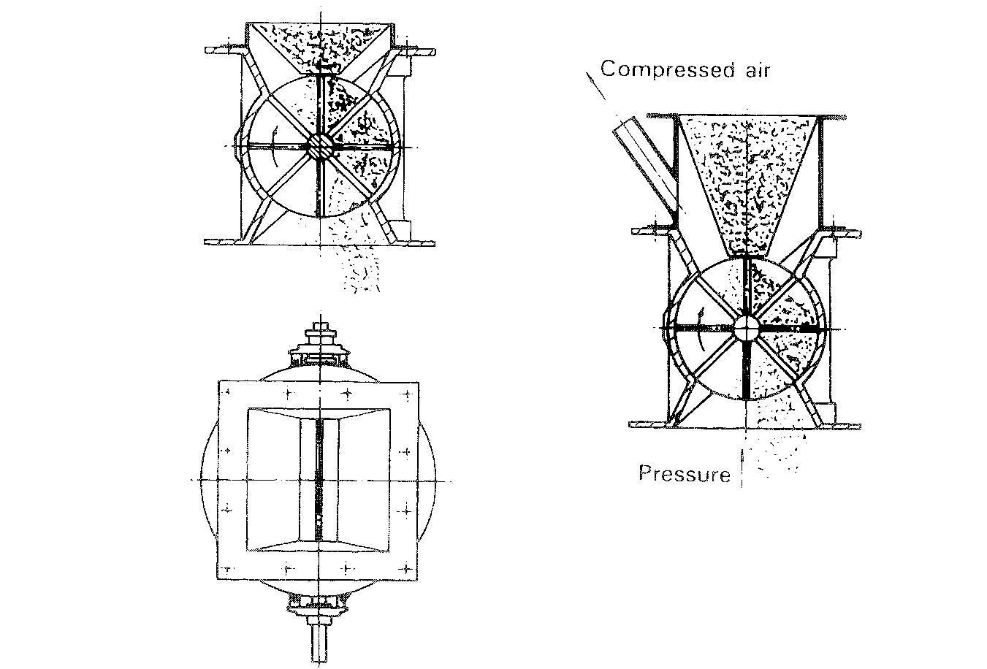
DESIGN DETAILS

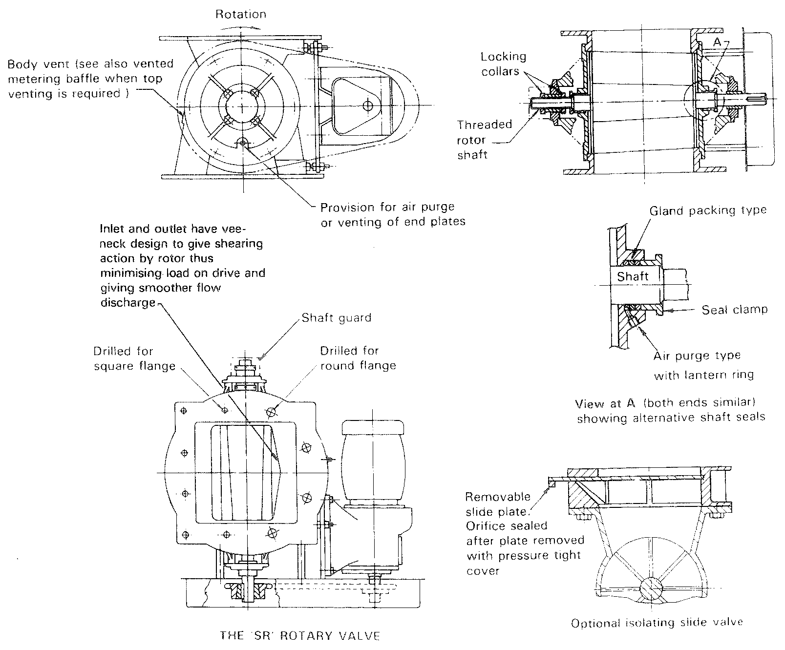
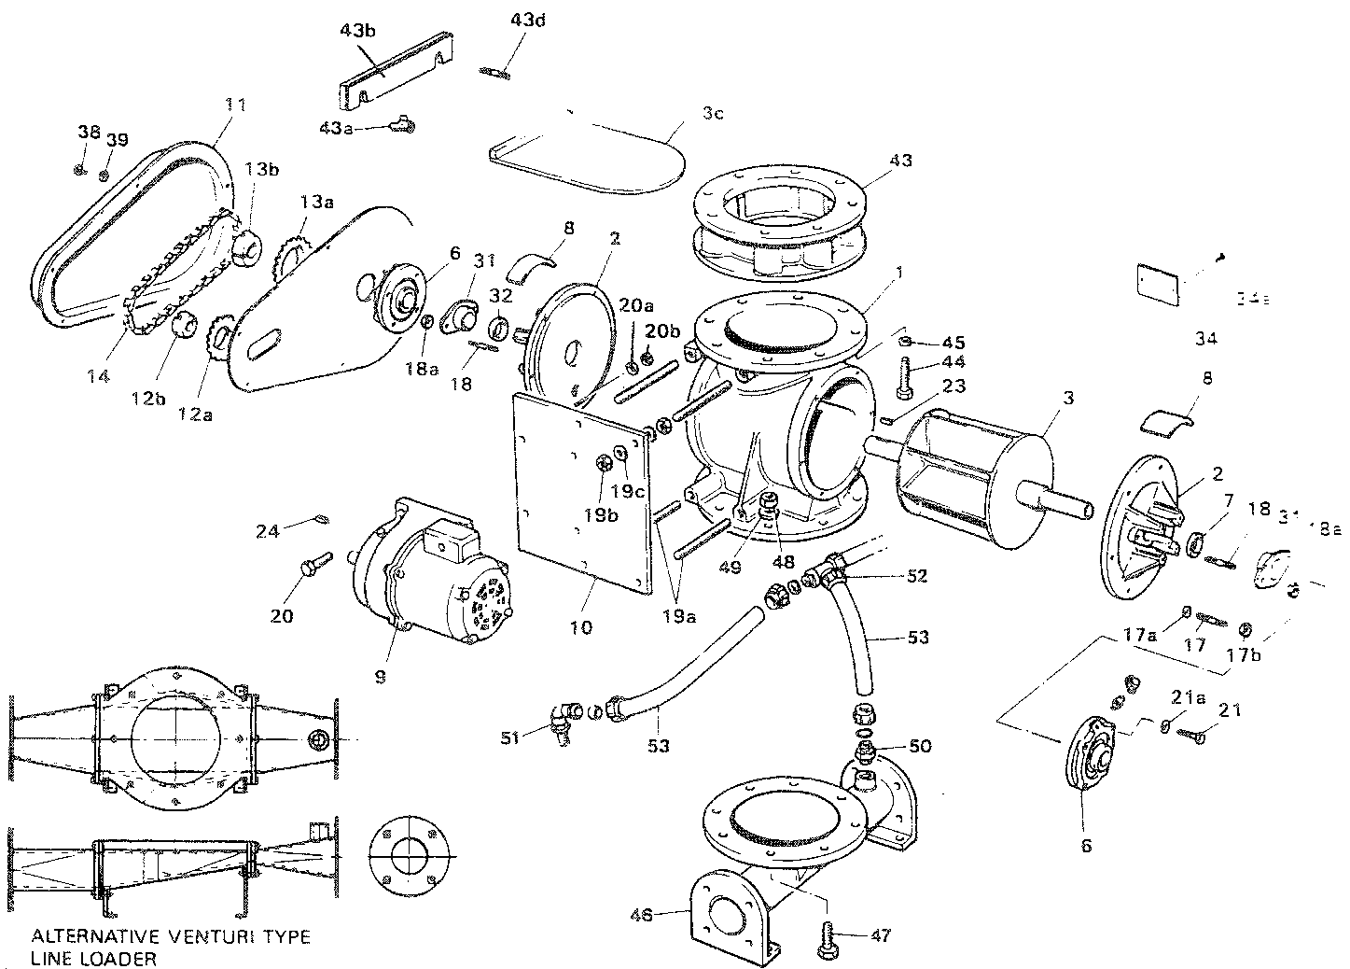

SPARES LIST

(This is a general list – certified spares lists for every valve are available on application to B & W V Ltd)

Part No. | DETAIL | No. Off Per Unit | Part No. | DETAIL | No. Off Per Unit | Part No. | DETAIL | No. Off Per Unit
1 | BODY | 1 | 17a | HEX NUT | 16 | 34a | DRIVE SCREW | 2
2 | END COVER | 2 | 17b | WASHER | 16 | 38 | HEX BOLT | 5
3 | ROTAR | 1 | 18 | STUD | 4 | 39 | HEX NUT | 5
6 | BEARING | 2 | 18a | HEX NUT | 4 | 43 | EMERGENCY SLIDE VALVE | 1
7 | GLAND PACKING RINGS | 6 | 19 | C/SK SCREW | 4 | 43a | WING NUT | 2
8 | END COVER GUARD | 2 | 19a | STUDDING | 4 | 43b | SLIDE PLATE COVER | 1
9 | GEARED MOTOR UNIT | 1 | 19b | HEX NUT | 8 | 43c | SLIDE PLATE | 1
10 | MOTOR | 1 | 19c | WASHER | 8 | 43d | STUD | 2
11 | CHAIN GUARD | 1 | 20 | HEX BOLT | 4 | 44 | HEX BOLT | 8
12a | DRIVE SPROCKET | 1 | 20a | HEX NUT | 4 | 45 | WASHER | 8
12b | TAPERLOCK BUSH | 1 | 20b | WASHER | 4 | 46 | LINE LOADER | 1
13a | DRIVEN SPROCKET | 1 | 21 | HEX BOLT | 8 | 47 | HEX BOLT | 8
13b | TAPERLOCK BUSH | 1 | 21a | WASHER | 8 | 48 | HEX NUT | 8
14 | CHAIN | 1 | 23 | KEY | 1 | 49 | WASHER | 8
14b | JOCKEY SPROCKET | 1 | 24 | KEY | 1 | 50 | STRAIGHT COUPLING | 1
14c | JOCKEY SPINDLE | 1 | 31 | GLAND FOLLOWER | 2 | 51 | TAPER MALE STUD ELBOW | 2
14d | TEE BOLT AND NUT | 1 | 32 | LANTERN RING | 2 | 52 | EQUAL TEE | 1
14e | JOCKEY SPROCKET BEARING | 1 | 34 | NAMEPLATE | 1 | 53 | POLYTHENE TUBE | 3
17 | STUD | 16

