VALVES TEST PAPER

CANDIDATE NAME: GROUP NO:

RESULT: PASS

Needs more training: DATE:

ASSESSOR: PRINT SIGN

1 | List four factors that are taken into account when selecting a valve for a given duty.  1) 2)  3) 4)
2 | Explain how the seats in a parallel slide isolation valve differ from the gate valve, and what is the purpose of the stem guide bridge stop.
3 | When commissioning large high pressure steam main systems, explain how the main isolation valve should be protected from damage and how that protection system should be set-up.
4 | Identify this type valve and label its components. Explain one of the main advantages and disadvantage for the valve, only one advantage and disadvantage can be used for each valve.  Name:_ .  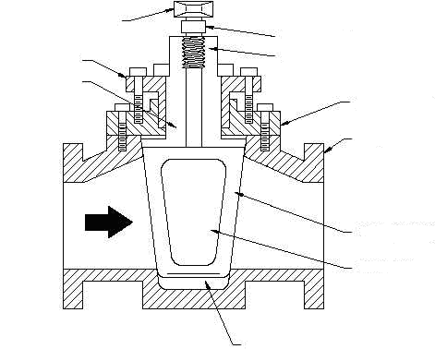  - _____________________  - _____________________  - _____________________  - _____________________  - _____________________  - _____________________  - _____________________  - _____________________  - _____________________  - _____________________  I  A  J  B  C  H  G  E  D  F  ADVANTAGE DISADVANTAGE
5 | Identify this type valve and label its components. Explain one of the main advantages and disadvantage for the valve, only one advantage and disadvantage can be used for each valve.  Name:_ .  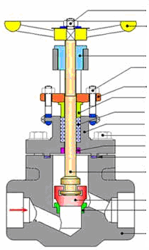  A  B  D  E  F  G  H  C  A. ____________ B ____________ C____________ D ____________ E. ____________ F ____________  G. ____________ H ____________ I. ____________ J ____________ K ____________ L ____________  M ____________ N ____________ O ____________  I  J  K  L  O  M  N  ADVANTAGE DISADVANTAGE
6 | Identify this type valve and label its components. Explain one of the main advantages and disadvantage for the valve, only one advantage and disadvantage can be used for each valve.  Name:_ .  E  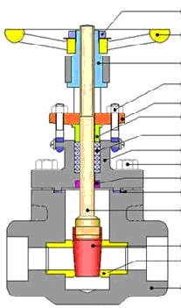  A  B  D  E  C  G  F  A. ____________ B ____________ C ____________ D ____________ E. ____________ F ____________  G. ____________ H ____________ I. ____________ J ____________ K ____________ L ____________  M ____________ N ____________ O ____________  H  I  O  J  N  K  M  L  ADVANTAGE DISADVANTAGE
7 | Identify this type valve and label its components. Explain one of the main advantages and disadvantage for the valve, only one advantage and disadvantage can be used for each valve.  Name:_ .  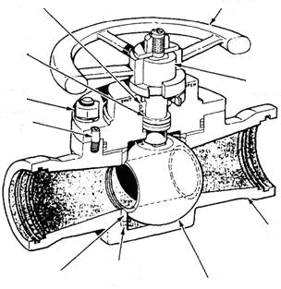  ADVANTAGE DISADVANTAGE
8 | When removing a tapper plug or a ball valve from a process system explain the possible dangers that may be present and what needs to be down before removing the valve from the plant.
9 | Explain why there is a direction of flow requirement on globe valves and what the requirement is.
10 | What sort of globe or gate valve should be used if a leak from the spindle gland is not permissible.

