**TTE Logo.jpg**

**Shaft, Keys, Keyways**

**and Splines.**

**Shaft and Hub Keyway and Key Sizes**

Keys connecting shafts to pulley hubs are commonly used to achieve reliable no-slip power transmission in belt drive systems. This handout will explain the uses of keys and keyways in pulleys and bushings, and present current industry standards for key and keyway component sizing.

**What is a Key, Keyseat, and Keyway?**

Key: A demountable machinery part, which when assembled into keyseats, provides a positive means for transmitting torque between a shaft and a hub or bushing.

Keyseat: An axially located rectangular groove in a shaft, hub or bushing. This may also be referred to as shaft keyseat or hub keyseat or bushing keyseat when describing an exact application. The hub or bushing keyseat can be referred to as a keyway.

**Keys and Keyways: The Basics**

In order to lock a hub or bushing and shaft together, and prevent the shaft from rotating in the bore, a key is commonly inserted into a keyway that is machined in both the bore and shaft. The key is responsible for preventing rotation between the shaft and the bore, and carries a portion of the torque load. Improperly fitted keys and keyways- either too tight or too loose – can result in mechanical failures. Therefore, to ensure appropriate fit, the width and height dimensions of standard key and keyways must be held to recommended tolerances. Industry standards for key sizes in various bores exist for both English and Metric systems. A common standard available from the Mechanical Power Transmission Association is MPTA-B1-2003. Another useful industry standard is ANSI Standard B17.1 for Keys and Keyseats.

**Shallow Keys**

Shallow keys are sometimes used when the shaft diameter approaches the maximum bushing or hub bore range. In order to accommodate the large shaft, the bore keyway depth is reduced. The power transmission capability of this arrangement is not reduced, but may not be as robust as a standard key and keyseat. Dimensional standards for ‘shallow key’ sizes do not exist, so manufacturers generally furnish these special keys with their pulleys or bushings.

**Plain Bore Style Pulleys**

In larger plain bore style pulleys, a keyway must be machined into the bore with the correct tolerances. The fit between a finished pully bore and its mating shaft must not allow relative movement when the pully is subjected to belt tension and torque loads. This is accomplished with the use of set screws, and by controlling the fit or clearance between the bore and the mating shaft. Set screws do push shafts to one side of the bores causing eccentricity or radial run-out, resulting in belt tension excursion and vibration. In order to minimize these potentially negative results, Gates publishes recommended shaft to bore fit tolerances for a range of shaft sizes. If cyclical or pulsating loads with be transmitted, an interference type fit is required. Interference fit tolerances for a range of shaft sizes are also published by Gates. Tables containing these recommended fit tolerances are available in any of the Gates Synchronous Belt Drive Design Manuals.

In smaller minimum plain bore style pullys, keys are not used. Set screws, along with the press fit interaction between the bore and shaft, are relied upon to secure the hub to the shaft. This type of arrangement is generally sufficient for very light loads. In these cases, designers should evaluate the design loads to be sure the set screw holding torque is sufficient.

**Pullys with Bushings**

In order to achieve better concentricity as well as versatility in fitting numerous standard shaft sizes, tapered bushings are commonly used in pulleys. The most common bushing types used in industrial power transmission applications are QD (Quick Disconnect – flanged type) and TL (Taper-Lock – Flangeless Type). Each system has its own merits and benefits.

In most QD type bushings, a setscrew in the flange tightens against the key to prevent key loss in applications subject to vibrating or pulsating loads, and in vertical shaft applications. Some bushing types are manufactured with an integral key that is formed as part of the bore. This also prevents potential key loss. Both types of bushings are popular in vertical shaft installations.

**Keyless Bushings**

Besides keyed bushings, several types of keyless locking devices using a tapered wedge principle are available. These keyless bushings convert clamping action between inner and outer tapered rings into radial pressure that locks the device to the shaft and pulley. Keyless bushings exert significantly greater radial hub loads compared to conventional tapered and keyed bushings. This requires that hubs be sufficiently sized to handle the increased hoop stress loads. Keyless bushings transmit high torque loads while maintaining excellent concentricity (minimal radial run out and belt tension excursion). However, they are available in a limited number of bore sizes and tend to cost more than conventional tapered and keyed bushings.

**Standard Key and Keyway Sizing**

Figure 1 describes the dimensions used when specifying English and Metric keys and keyways.

**English Dimensions:**

Keyway W x T1

Key: W x T

**Metric Dimensions:**

Keyway: W x H

Key: W x T

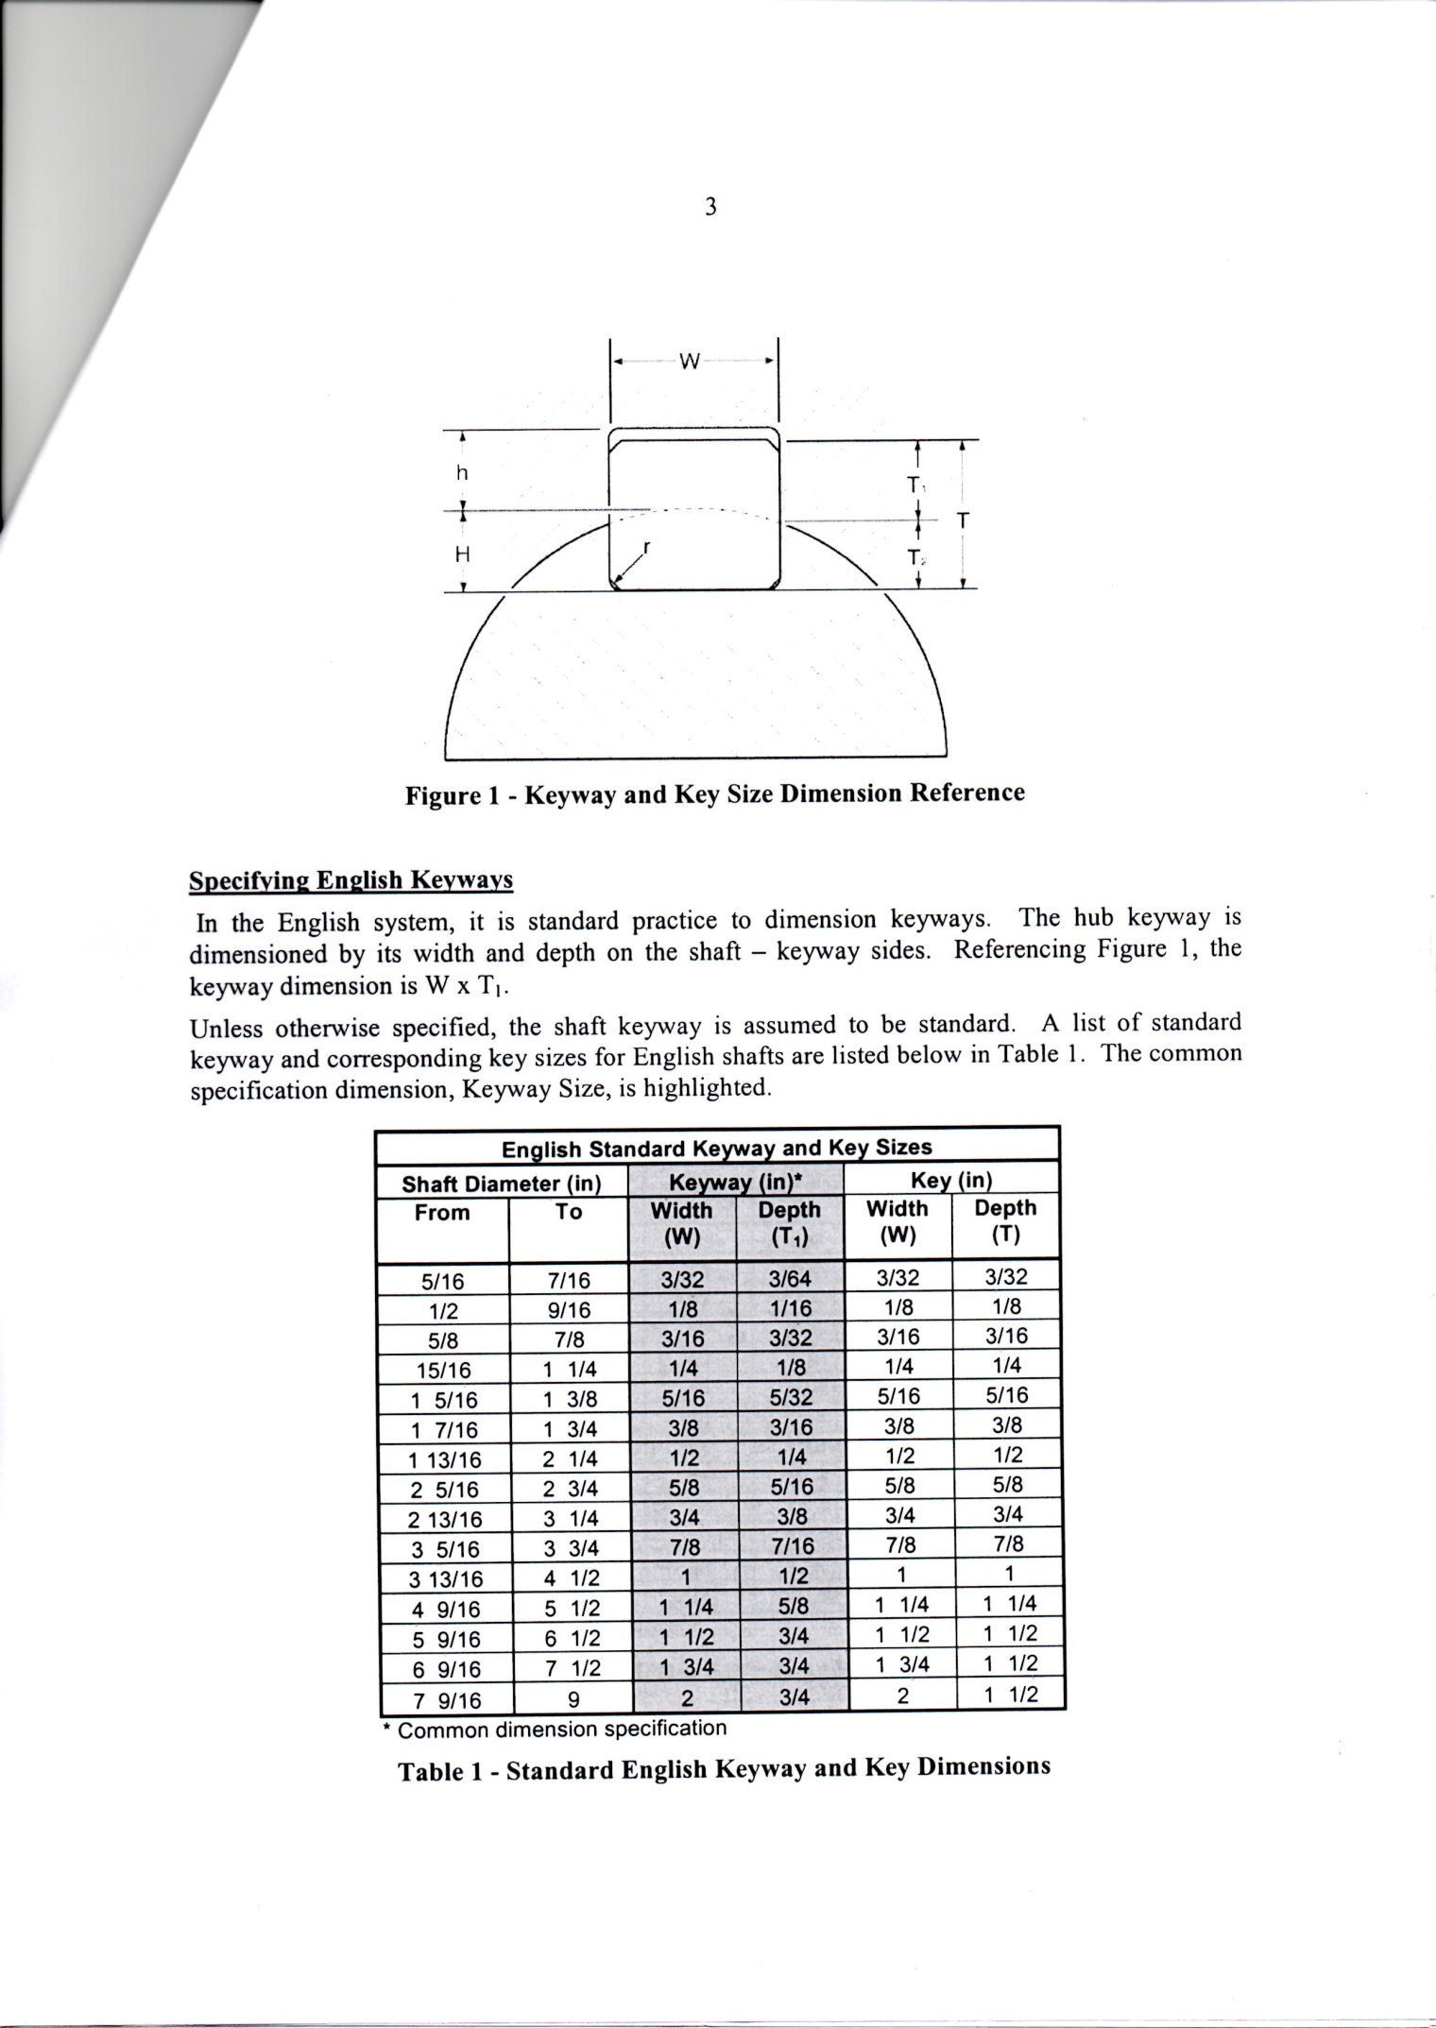

**Specifying English Keyways**

In the English system, it is standard practice to dimension keyways. The hub keyway is dimensioned by its width and depth on the shaft – keyway sides. Referencing Figure 1, the keyway dimension is W x T1.

Unless otherwise specified, the shaft keyway is assumed to be standard. A list of standard keyway and corresponding key sizes for English shafts are listed below in Table 1. The common specification dimension, Keyway Size, are highlighted.

|  |  |  |  |  |  |
| --- | --- | --- | --- | --- | --- |
| **English Standard Keyway and Key Sizes** | | | | | |
| Shaft Diameter (in) | | Keyway (in)* | | Key (in) | |
| From | To | Width  (W) | Depth  (T1) | Width  (W) | Depth  (T) |
| 5/16 | 7/16 | 3/32 | 3/64 | 3/32 | 3/32 |
| ½ | 9/16 | 1/8 | 1/16 | 1/8 | 1/8 |
| 5/8 | 7/8 | 3/16 | 3/32 | 3/16 | 3/16 |
| 15/16 | 1 ¼ | ¼ | 1/8 | ¼ | ¼ |
| 1 5/16 | 1 3/8 | 5/16 | 5/32 | 5/16 | 5/16 |
| 1 7/16 | 1 ¾ | 3/8 | 3/16 | 3/8 | 3/8 |
| 1 13/16 | 2 ¼ | ½ | ¼ | ½ | ½ |
| 2 5/16 | 2 ¾ | 5/8 | 5/16 | 5/8 | 5/8 |
| 2 13/16 | 3 ¼ | ¾ | 3/8 | ¾ | ¾ |
| 3 5/16 | 3 ¾ | 7/8 | 7/16 | 7/8 | 7/8 |
| 3 13/16 | 4 ½ | 1 | ½ | 1 | 1 |
| 4 9/16 | 5 ½ | 1 ¼ | 5/8 | 1 ¼ | 1 ¼ |
| 5 9/16 | 6 ½ | 1 ½ | ¾ | 1 ½ | 1 ½ |
| 6 9/16 | 7 ½ | 1 3/4 | 3/4 | 1 ¾ | 1 ½ |
| 7 9/16 | 9 | 2 | 3/4 | 2 | 1 ½ |

*Common dimension specification

**Table 1 – Standard English Keyway and Key Dimensions**

The second list of standard keyway and corresponding key sizes for Metric shafts are listed below in Table 2. The common specification dimension, Keyway Size, are highlighted.

|  |  |  |  |  |  |
| --- | --- | --- | --- | --- | --- |
| Metric Standard Parallel Keyway and Key Sizes | | | | | |
| Shaft Diameter (mm) | | Keyway (mm) | | Key (mm)* | |
| From | To | Width  (W) | Depth  (h) | Width  (W) | Depth  (T) |
| 6 | 8 | 2 | 1.0 | 2 | 2 |
| 9 | 10 | 3 | 1.4 | 3 | 3 |
| 11 | 12 | 4 | 1.8 | 4 | 4 |
| 13 | 17 | 5 | 2.3 | 5 | 5 |
| 18 | 22 | 6 | 2.8 | 6 | 6 |
| 23 | 30 | 8 | 3.3 | 8 | 7 |
| 31 | 38 | 10 | 3.3 | 10 | 8 |
| 39 | 44 | 12 | 3.3 | 12 | 8 |
| 45 | 50 | 14 | 3.8 | 14 | 9 |
| 51 | 58 | 16 | 4.3 | 16 | 10 |
| 59 | 65 | 18 | 4.4 | 18 | 11 |
| 66 | 75 | 20 | 4.9 | 20 | 12 |
| 76 | 86 | 22 | 5.4 | 22 | 14 |
| 86 | 96 | 25 | 5.4 | 25 | 14 |
| 96 | 110 | 28 | 6.4 | 28 | 16 |
| 111 | 130 | 32 | 7.4 | 32 | 18 |
| 131 | 150 | 36 | 8.4 | 36 | 20 |
| 151 | 170 | 40 | 9.4 | 40 | 22 |
| 171 | 200 | 45 | 10.4 | 45 | 25 |
| 201 | 230 | 50 | 11.4 | 50 | 28 |
| 231 | 260 | 56 | 12.4 | 56 | 32 |
| 261 | 290 | 63 | 12.4 | 63 | 32 |
| 291 | 330 | 70 | 14.4 | 70 | 36 |
| 331 | 380 | 80 | 15.4 | 80 | 40 |
| 381 | 440 | 90 | 17.4 | 90 | 45 |
| 441 | 500 | 100 | 19.5 | 100 | 50 |

*Common dimension specification

**Table 2 – Standard Metric Keyway and Key Dimensions**

In general, increasing the length of keys produces an increase in the bearing surface and hence permissible driving torque, also different types of keyways in shafts are used to suit different designs and drive requirements.

**Type of Common Keyways and Secure Drives**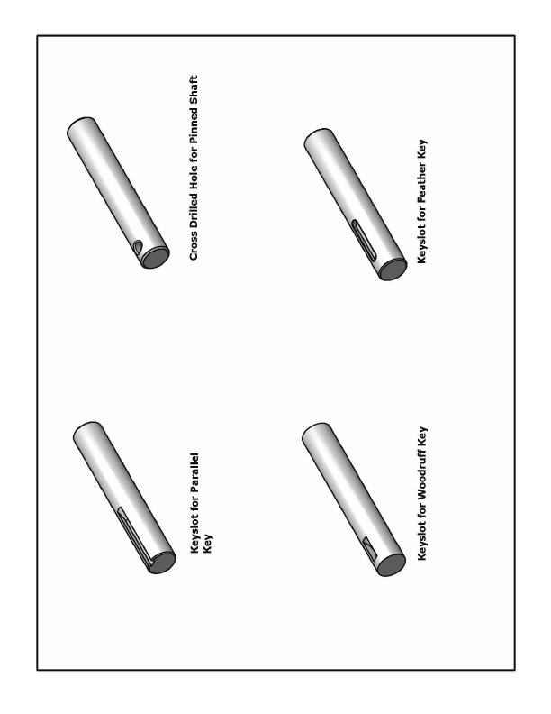

**Sunk or Boxed Key**

This is a very common type of key of rectangular section and engages in a keyway in the shaft and wheel.

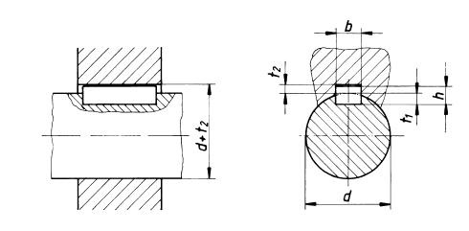

**SOFT METAL DRIFTS ONLY SHOULD BE USED TO REMOVE KEYS**

This is a sunken key which is parallel and with radiused corners to allow wheels to be slid onto shafts with the key in position. This key is often screwed on to a shaft by countersunk screws.

**Feather Key**

This type of key of rectangular section and engages in a keyway in the shaft and hub and is used for axial displacement along the shaft of the hub.

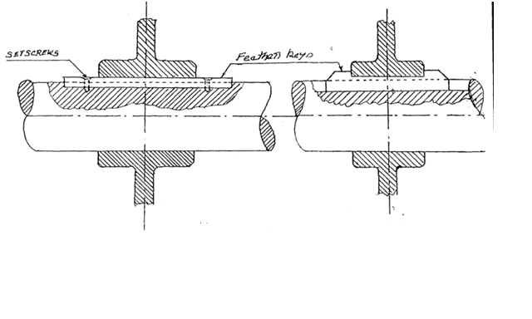

**Gib Head Key**

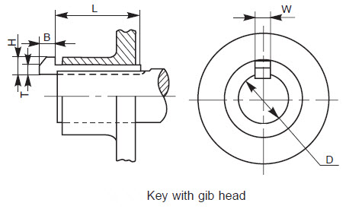

This is a tapered key and is fitted into a corresponding tapered keyway in the hub and is used were axial positioning of the hub needs to be adjusted and then locked into place.

**Woodruff Key**

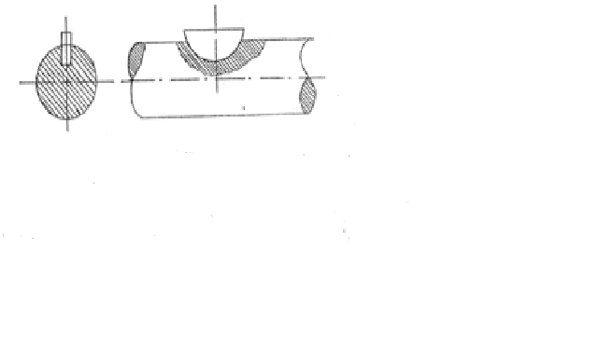

The main advantage of the Woodruff key is that it eliminates milling a keyway near shaft shoulders, which already have [stress concentrations](http://en.wikipedia.org/wiki/Stress_concentration).[[](http://en.wikipedia.org/wiki/Key_(engineering)#cite_note-keyadvantages-4)

**Make sure that the correct corrosion preventive is used; it is quite likely that you will have to remove the key later.**

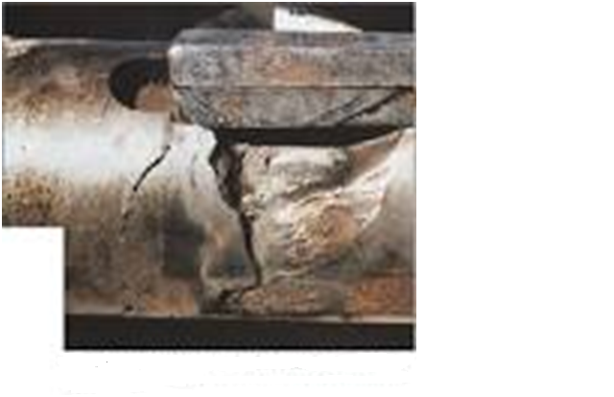

**Poorly Fitted Keys**

Poorly fitted keys will alway fail prematurely and when a key fails there is usually a lot of associated damage

**Splined Shafts and Hubs**

**Spline and Serrated Drives Shafts**

A spline shaft is a shaft with a number of keys cut on it which fit into a spline hub. Splined shafts have equally spaced splines situated around their outer periphery that engage with splined bore of the hub, the splines shapes may be involutes, straight sided or serrated.   
  
When axial movement is required, the hub is made a sliding fit on the shaft. Splines can transmit much greater force than keys.

Not only can heavy torques be transmitted through the spline shaft and hub but the shaft can be positioned laterally in the hub. A spline shaft and hub can be used to transmit motion between shaft and wheel or between shafts. Applications include the sliding plate of a friction clutch or the power drive.

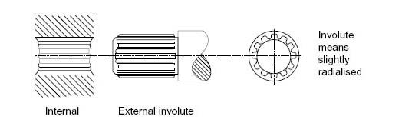

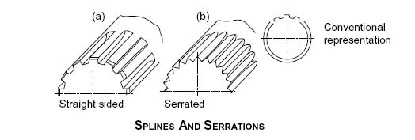

Before fitting; keys, splines or feathers should be examined, and if burred or distorted, renewed. Corrosion preventive must always be used and consideration must be given to working temperatures of parent companies.

It is vitally important that keys are a good fit in mating shafts and hubs. Keys which are slack lead to backlash and resultant wear, and keys which are too tight can cause damage to key seatings during fitting.

Some of the questions you must be able to answer:

1. Describe four types of keys and their uses.
2. What is a spline?
3. What is a feather?
4. What precautions must be taken before refitting keys, splines and feathers?
5. Why is it necessary to ensure keys are a good fit in mating hubs and shafts?

**THERE IS NO SUBSTITUTE FOR THE CORRECT KEY OR SPLINE FOR THE GIVEN APPLICATION**