Copper Pipe and Connectors.
Copper has a number of advantages over the iron and lead types:
- Copper is relatively non-toxic - unlike lead.
- Copper does not suffer corrosion - as iron does.
- Copper is relatively soft and easy to work with - unlike both iron and lead.
Copper pipe is available in a number of sizes commonly:
- 8 and 10 mm - for use microbore central heating systems
- 12 and 15 mm - generally for connections to individual taps, appliances etc.
- 22, 28 and 35 mm - generally for long runs where use of 15 mm piping would cause excessive pressure drop.
Copper pipework in older installations will probably be sized in imperial measurements - 1/2 inch, 3/4 inch, 1 inch etc. One point to bear in mind in the UK is that the measurement quoted for imperial sized pipe is the INNER diameter of the pipe whilst the measurement for metric pipes is the OUTER diameter - this means that the 1/2 inch pipe is very nearly identical to the 15 mm metric pipe. In fact these two sizes can generally be joined as if they were both 15 mm. The other imperial sizes do not have 'workable' equivalents metric sizes - joining these imperial to metric sized pipes require the use of connection specifically designed for the job - these connectors are no more expensive than metric to metric connectors, they are just designed for the job.
Copper pipe is normally available in various lengths depending upon the type of stockist. Trade outlets may only stock 3 and 4 metre lengths whist small DIY outlets may hold sizes ranging from 1.5 to 2 metre.
Connectors
Connectors are specific to the size of pipe being used, a number of differing styles are available which cater for almost all needs of a pipe run. The main styles are:
Straight connector | 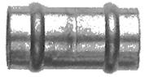
90 degree bend | 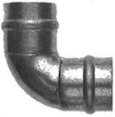
'T' connector | 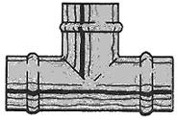
The above three fittings are known as Yorkshires. The recess shown has solder already installed. The alternative fittings are compression, as described below and end feed. End feed are the same as Yorkshire however the solder is applied when the joint is made and is not pre installed.
Most of these are available either to accept the same sized pipes at each end or to accept different sizes, this allows a change in pipe size to be achieved simply. Connectors are also available to connect modern metric sized pipes to imperial sized copper pipe or external screw threads such as used on iron pipes and accessories (such as sink taps etc.).
Two basic types of connectors are used for joining copper pipes:
- Compression Connections
Compression connectors use an internal ring (known as an olive) which is compressed onto the pipe as the end nut is tightened onto the body of the connector.
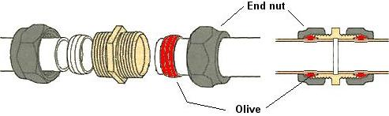
- Compression connectors can be dismantled and reassembled fairly easily. Alternatively, if a pipe run is to be rearranged, the end of the pipe can be cut to allow the end nut to be removed, and then the connector can be reused with a new olive (olives can be purchased in small quantities).
- Solder Connections
Solder connectors are sized to be a tight slide fit onto the copper pipe, the joint is then heated (normally by using a blowtorch or hot air gun) and the small gap between the pipe and connector is filled with solder by capillary action.
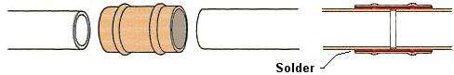
Some connectors incorporate a solder ring within the body (as indicated by the ring formed in the connector as shown above) while other connectors are plain copper and solder needs to be fed around the exposed gap after the connector/pipes has been heated.
Solder connectors are cheaper than the compression type but they are not reusable. With solder connectors it is very easy to get a water tight joint at the first attempt, but if they should leak, they can sometimes be problematic (but not impossible) to repair as they cannot be disassembled without heating and splitting the soldered joint.

