Hand Tool Safety Induction Training Worksheet

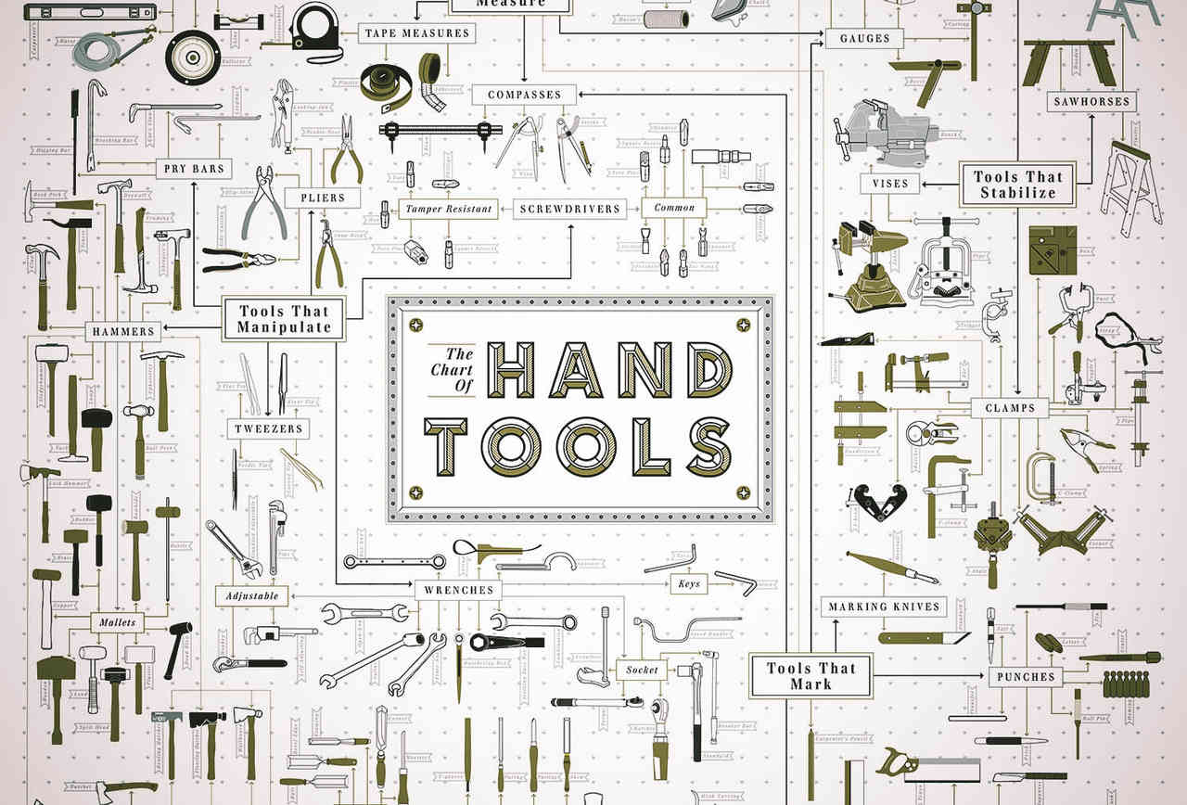

**Instructions.**

Study the given presentation and decide what the:

1. Name of the Tool is.
2. The Hazards associated with the tool – List as many as you can.
3. The Potential Injuries that may occur through misuse or lack of training.
4. The Control measures that can be put in place to eliminate or reduce the likelihood of hazardous event occurring (RISK).

|  |  |  |
| --- | --- | --- |
| **Name** | **Group** | **Date** |
|  |  |  |

|  |  |  |  |
| --- | --- | --- | --- |
| **Tool 1** | |  | |
|  | **Hazard** | **Potential Injury** | **Control Measure** |
| **1** |  |  |  |
| **2** |  |  |  |
| **3** |  |  |  |
| **4** |  |  |  |
| **5** |  |  |  |

|  |  |  |  |  |
| --- | --- | --- | --- | --- |
| **Tool 2** | | |  | |
|  | **Hazard** | **Potential Injury** | | **Control Measure** |
| **1** |  |  | |  |
| **2** |  |  | |  |
| **3** |  |  | |  |
| **4** |  |  | |  |
| **5** |  |  | |  |

|  |  |  |  |  |
| --- | --- | --- | --- | --- |
| **Tool 3** | | |  | |
|  | **Hazard** | **Potential Injury** | | **Control Measure** |
| **1** |  |  | |  |
| **2** |  |  | |  |
| **3** |  |  | |  |
| **4** |  |  | |  |
| **5** |  |  | |  |

|  |  |  |  |  |
| --- | --- | --- | --- | --- |
| **Tool 4** | | |  | |
|  | **Hazard** | **Potential Injury** | | **Control Measure** |
| **1** |  |  | |  |
| **2** |  |  | |  |
| **3** |  |  | |  |
| **4** |  |  | |  |
| **5** |  |  | |  |

|  |  |  |  |  |
| --- | --- | --- | --- | --- |
| **Tool 5** | | |  | |
|  | **Hazard** | **Potential Injury** | | **Control Measure** |
| **1** |  |  | |  |
| **2** |  |  | |  |
| **3** |  |  | |  |
| **4** |  |  | |  |
| **5** |  |  | |  |

|  |  |  |  |  |
| --- | --- | --- | --- | --- |
| **Tool 6** | | |  | |
|  | **Hazard** | **Potential Injury** | | **Control Measure** |
| **1** |  |  | |  |
| **2** |  |  | |  |
| **3** |  |  | |  |
| **4** |  |  | |  |
| **5** |  |  | |  |

|  |  |  |  |  |
| --- | --- | --- | --- | --- |
| **Tool 7** | | |  | |
|  | **Hazard** | **Potential Injury** | | **Control Measure** |
| **1** |  |  | |  |
| **2** |  |  | |  |
| **3** |  |  | |  |
| **4** |  |  | |  |
| **5** |  |  | |  |

|  |  |  |  |  |
| --- | --- | --- | --- | --- |
| **Tool 8** | | |  | |
|  | **Hazard** | **Potential Injury** | | **Control Measure** |
| **1** |  |  | |  |
| **2** |  |  | |  |
| **3** |  |  | |  |
| **4** |  |  | |  |
| **5** |  |  | |  |

|  |  |  |  |  |
| --- | --- | --- | --- | --- |
| **Tool 9** | | |  | |
|  | **Hazard** | **Potential Injury** | | **Control Measure** |
| **1** |  |  | |  |
| **2** |  |  | |  |
| **3** |  |  | |  |
| **4** |  |  | |  |
| **5** |  |  | |  |

|  |  |  |  |  |
| --- | --- | --- | --- | --- |
| **Tool 10** | | |  | |
|  | **Hazard** | **Potential Injury** | | **Control Measure** |
| **1** |  |  | |  |
| **2** |  |  | |  |
| **3** |  |  | |  |
| **4** |  |  | |  |
| **5** |  |  | |  |

|  |  |  |  |  |
| --- | --- | --- | --- | --- |
| **Tool 11** | | |  | |
|  | **Hazard** | **Potential Injury** | | **Control Measure** |
| **1** |  |  | |  |
| **2** |  |  | |  |
| **3** |  |  | |  |
| **4** |  |  | |  |
| **5** |  |  | |  |

|  |  |  |  |  |
| --- | --- | --- | --- | --- |
| **Tool 12** | | |  | |
|  | **Hazard** | **Potential Injury** | | **Control Measure** |
| **1** |  |  | |  |
| **2** |  |  | |  |
| **3** |  |  | |  |
| **4** |  |  | |  |
| **5** |  |  | |  |

|  |  |  |  |  |
| --- | --- | --- | --- | --- |
| **Tool 13** | | |  | |
|  | **Hazard** | **Potential Injury** | | **Control Measure** |
| **1** |  |  | |  |
| **2** |  |  | |  |
| **3** |  |  | |  |
| **4** |  |  | |  |
| **5** |  |  | |  |

|  |  |  |  |  |
| --- | --- | --- | --- | --- |
| **Tool 14** | | |  | |
|  | **Hazard** | **Potential Injury** | | **Control Measure** |
| **1** |  |  | |  |
| **2** |  |  | |  |
| **3** |  |  | |  |
| **4** |  |  | |  |
| **5** |  |  | |  |

|  |  |  |  |  |
| --- | --- | --- | --- | --- |
| **Tool 15** | | |  | |
|  | **Hazard** | **Potential Injury** | | **Control Measure** |
| **1** |  |  | |  |
| **2** |  |  | |  |
| **3** |  |  | |  |
| **4** |  |  | |  |
| **5** |  |  | |  |

|  |  |  |  |  |
| --- | --- | --- | --- | --- |
| **Tool 16** | | |  | |
|  | **Hazard** | **Potential Injury** | | **Control Measure** |
| **1** |  |  | |  |
| **2** |  |  | |  |
| **3** |  |  | |  |
| **4** |  |  | |  |
| **5** |  |  | |  |

|  |  |  |  |  |
| --- | --- | --- | --- | --- |
| **Tool 17** | | |  | |
|  | **Hazard** | **Potential Injury** | | **Control Measure** |
| **1** |  |  | |  |
| **2** |  |  | |  |
| **3** |  |  | |  |
| **4** |  |  | |  |
| **5** |  |  | |  |

|  |  |  |  |  |
| --- | --- | --- | --- | --- |
| **Tool 18** | | |  | |
|  | **Hazard** | **Potential Injury** | | **Control Measure** |
| **1** |  |  | |  |
| **2** |  |  | |  |
| **3** |  |  | |  |
| **4** |  |  | |  |
| **5** |  |  | |  |

|  |  |  |  |  |
| --- | --- | --- | --- | --- |
| **Tool 19** | | |  | |
|  | **Hazard** | **Potential Injury** | | **Control Measure** |
| **1** |  |  | |  |
| **2** |  |  | |  |
| **3** |  |  | |  |
| **4** |  |  | |  |
| **5** |  |  | |  |

|  |  |  |  |  |
| --- | --- | --- | --- | --- |
| **Tool 20** | | |  | |
|  | **Hazard** | **Potential Injury** | | **Control Measure** |
| **1** |  |  | |  |
| **2** |  |  | |  |
| **3** |  |  | |  |
| **4** |  |  | |  |
| **5** |  |  | |  |

|  |  |  |  |  |
| --- | --- | --- | --- | --- |
| **Tool 20** | | |  | |
|  | **Hazard** | **Potential Injury** | | **Control Measure** |
| **1** |  |  | |  |
| **2** |  |  | |  |
| **3** |  |  | |  |
| **4** |  |  | |  |
| **5** |  |  | |  |

|  |  |  |  |  |
| --- | --- | --- | --- | --- |
| **Tool 21** | | |  | |
|  | **Hazard** | **Potential Injury** | | **Control Measure** |
| **1** |  |  | |  |
| **2** |  |  | |  |
| **3** |  |  | |  |
| **4** |  |  | |  |
| **5** |  |  | |  |

|  |  |  |  |  |
| --- | --- | --- | --- | --- |
| **Tool 22** | | |  | |
|  | **Hazard** | **Potential Injury** | | **Control Measure** |
| **1** |  |  | |  |
| **2** |  |  | |  |
| **3** |  |  | |  |
| **4** |  |  | |  |
| **5** |  |  | |  |

|  |  |  |  |  |
| --- | --- | --- | --- | --- |
| **Tool 23** | | |  | |
|  | **Hazard** | **Potential Injury** | | **Control Measure** |
| **1** |  |  | |  |
| **2** |  |  | |  |
| **3** |  |  | |  |
| **4** |  |  | |  |
| **5** |  |  | |  |