MEASUREMENT TEST

TEST PAPER

CANDIDATE NAME: GROUP NO:

RESULT: PASS
Needs more training: DATE:

ASSESSOR: PRINT SIGN

- Label the parts of the micrometer below

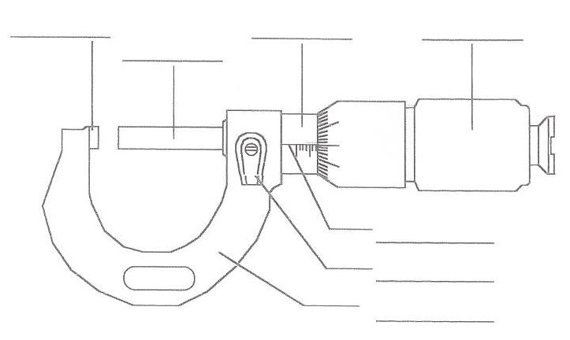

(10 marks)
2. What should be checked before using any micrometer?

(2 marks)
3. How many TPI has an imperial micrometer screw thread?

a) 20 b) 40 c) 60

(2 marks)
4. What is the pitch of a metric micrometer screw thread?

a) 1mm b) 0.5mm c) 2mm

(2 marks)
5. Why is a ratchet fitted to a micrometer?

6. Convert the following decimals to fractions

a) 0.3125

b) 0.9375

c) 0.625

d) 0.875

e) 1.3125

- What is 0.5m in millimeters

8. What must be done before using an internal micrometer for accurate work?

How is this done?

9. Name two other pieces of equipment that can be used to check internal measurements

a)

b)

10. What is unusual about the scale on a depth micrometer sleeve?

11. In which position should you never leave a 0-1” or 0-22mm external micrometer?

a) Open b) Closed c) Middle

12.
