**Reducing Fractions Exercise**

**Solve these problems. Show all work.**

**a. In 1 1 ⁄2 there are ______________ 16ths.**

**b. In 1 ⁄2 there are _______________ 16ths.**

**c. In 3 ⁄4 there are _____________ 8ths.**

**d. In 1 4 ⁄16 there are _______________ 8ths.**

**e. In 24 ⁄ 32 there are _______________ 4ths.**

**f. In 2 1 ⁄2 there are _______________ 16ths.**

**g. 12 ⁄16 reduced to its lowest terms is _______________.**

**h. 28 ⁄ 32 reduced to its lowest terms is _______________.**

**i. 48 ⁄ 64 reduced to its lowest terms is _______________.**

**j. 96 ⁄64 reduced to its lowest terms is _______________.**

**k. 19 ⁄32 reduced to its lowest terms is _______________.**

**l. In 1 40 ⁄64 there are _______________ 16ths.**

**m. In 1 ⁄8 there are _______________ 64ths.**

**n. In 1 5 ⁄16 there are _______________ 32nds.**

**o. In 3 ⁄4 there are __________________ 16ths.**

**p. 15 ⁄8 reduced to its lowest terms is __________.**

**! CHECK YOUR ANSWERS !**

**Rule Reading Exercise**

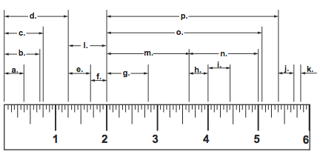

**! CHECK YOUR ANSWERS !**