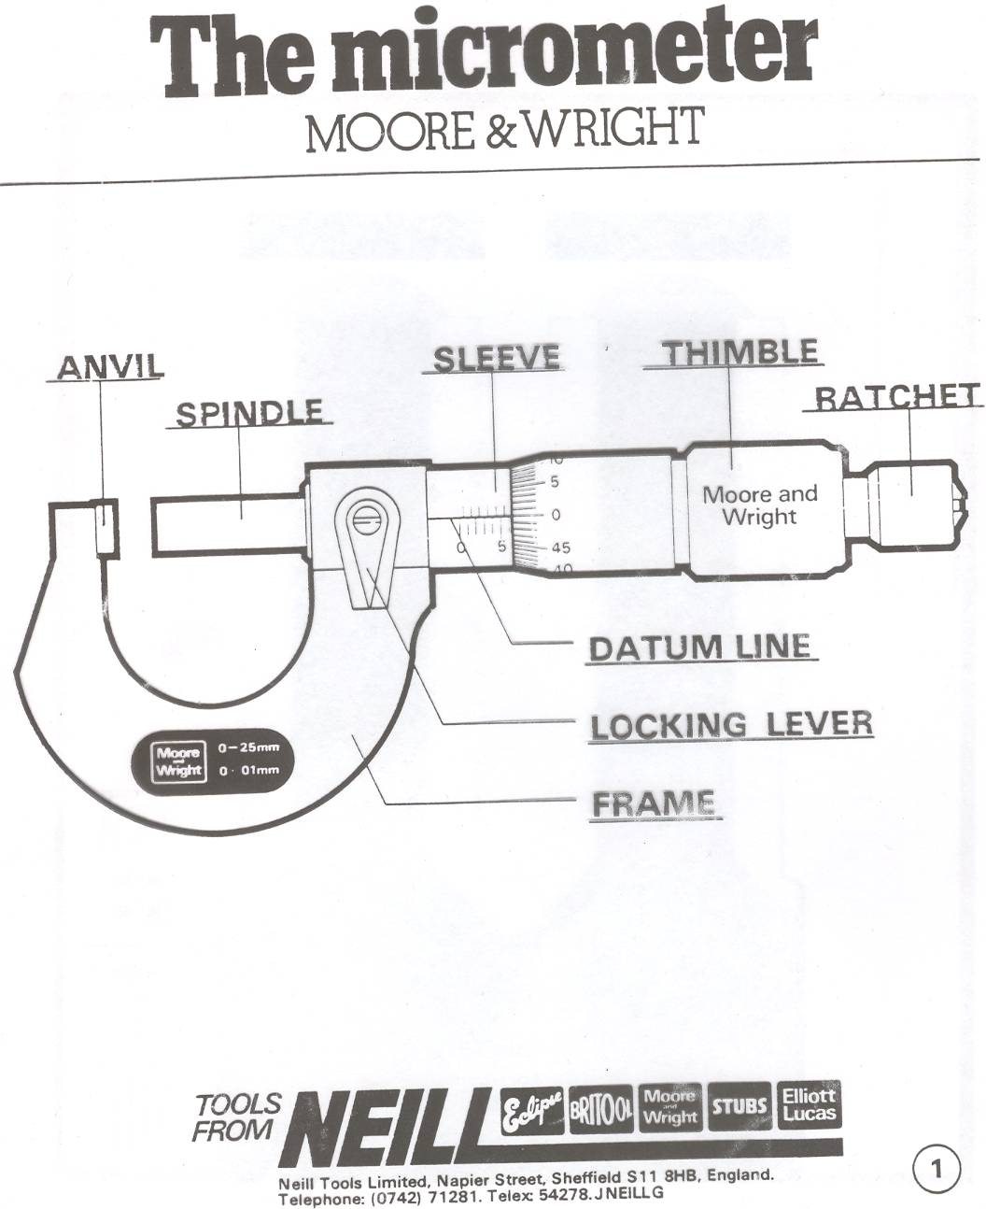

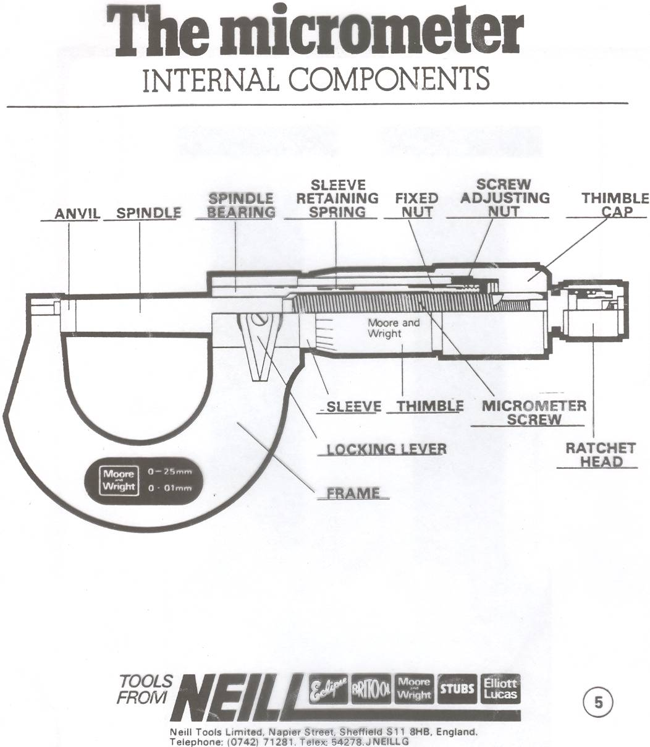

THE MICROMETER

The Micrometer is an instrument for measuring components to accuracy of 0.001” or 0.01mm.

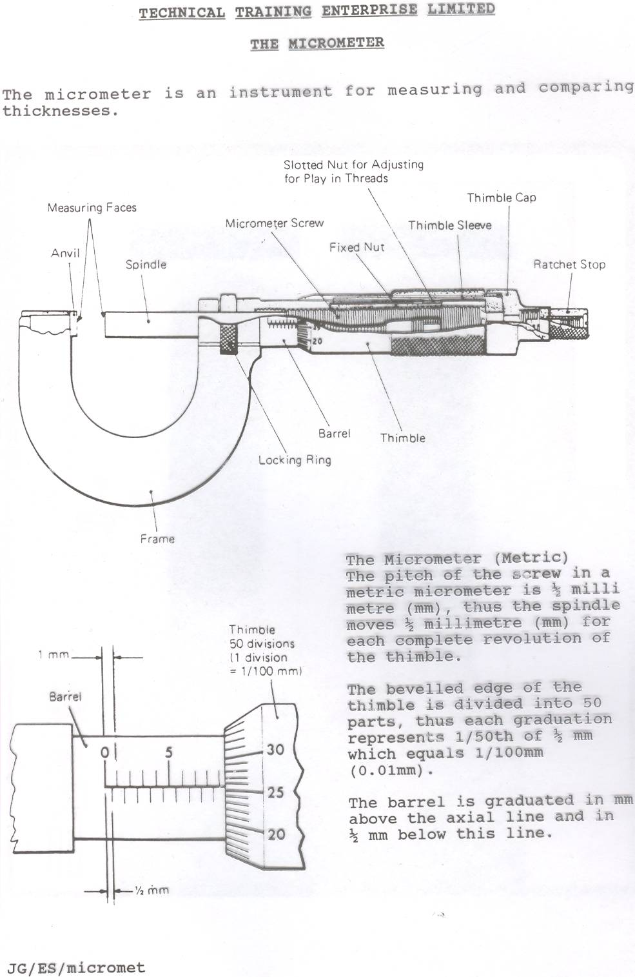
The Micrometer (Metric)
The pitch of the screw in a metric micrometer is ½ millimetre (mm), thus the spindle moves ½ millimetre (mm) for each complete revolution of the thimble.

The bevelled edge of the thimble is divided into 50 parts, thus each graduation represents 1/50th of ½ mm which equals 1/100mm (0.01mm).

The barrel is graduated in mm above the axial line and in ½ mm below this line.

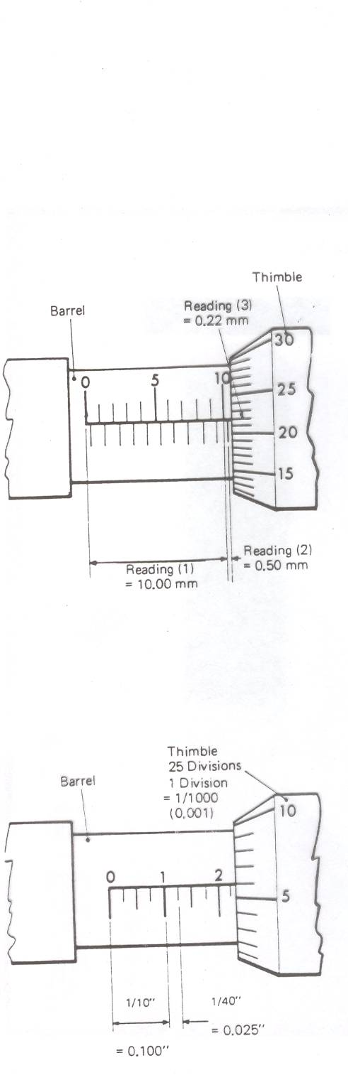
How to read a micrometer (Metric)

- Read the number of whole mm divisions visible on the barrel (above the axial line) and add to:

- The number of additional ½ mm divisions visible on the barrel (below the axial line) and add to:

- The line on the thimble which coincides with the axial line of the barrel.

Example:

  - Whole mm lines (upper) visible on barrel …………...10 = 10.00mm

  - Additional ½mm line (lower) visible on barrel ………...…...1 = 0.50mm

  - Line on thimble which coincides with axial line on barrel ………2 = 0.22mm

Total reading …… = 10.72mm

The Micrometer (Imperial)

The pitch of the screw in an Imperial Micrometer is 1/40th inch = 0.025 inch. Thus for one complete revolution of the thimble the spindle moves 0.025 inch.

The bevelled edge of the thimble is divided into 25 parts, thus each division represents 1/25th of 0.025 which equals 0.001 (one thousandth inch).

Every fourth vertical division on the barrel represents 0.100 inch (1/10th) and is marked 1, 2, 3 etc.

