Bolts, Nuts and Screw Threads

Screw Threads

There are several standards for screw threads used on bolts and fastenings. They all have a “VEE” formation. However, other than this basic shape the geometry for all the types varies, of the several types, three have become prominent within our sites, these are:

1. British Standard Screw Threads

This range of screw threads is the old standard devised around 1860 by an engineer named Whitworth. The standards were developed for the engineering industries to use instead of each individual company developing its own standards. All threads named “British Standard” have a thread form with an included angle of 55% and each diameter has a specific number of threads per inch. The most common BS thread is British Standard Whitworth or B.S.W for short. This is a general purpose thread.

The B.S.W thread is not perfectly suited to all duties and the first variation on this is the British Standard fine or B.S.F range of threads. This is a finer range of threads having more T.P.I than the corresponding B.S.W size. This thread type is used for duties subject to more adverse operating duties, ie. The higher number of T.P.I for each diameter means that the thread is not cut so deep, thus giving a longer cross sectional area of the bolt to carry stress therefore, this thread is suited to bolts and studs used on high pressure plant and machinery.

Over the years, various organisations have tried to establish standard thread forms throughout the world, Britain, America and Canada adopted the system of threads called “unified national” so that machinery produced by these countries would be easier to repair and overhaul due to the standardisation. It is the unified system of threads that was adopted. Consequently the use of B.S.W and B.S.F threads is restricted to older British made plant machinery.

- The unified thread system differs from the BS system primary due to having a thread angle of 60º rather than 55º and other slight changes to its form, as shown.

Unified Thread Form BS1580 Whitworth Thread Form BS 84
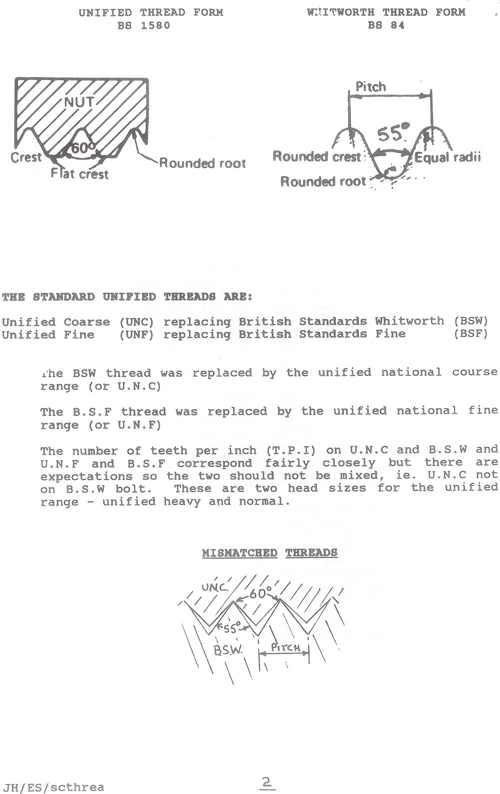

The Standard Unified Threads are:

Unified Coarse (UNC) replacing British Standards Whitworth (BSW)
Unified Fine (UNF) replacing British Standards Fine (BSF)

The BSW thread was replaced by the unified national course range (or U.N.C).

The BSF thread was replaced by the Unified national fine range (or U.N.F).

The number of teeth per inch (T.P.I) on U.N.C and B.S.W and U.N.F and B.S.F correspond fairly closely but there are expectations so the two should not be mixed, ie U.N.C not on B.S.W bolt. These are two head sizes for the unified range – unified heavy and normal.

Mismatched Threads

3. Metrication

In recent years and due to British pursuing a policy of metrication, the “The International Standardisation Organisation” (or I.S.O) range of metric screw threads is coming to the fore. For example, all the European machinery and Japanese machinery, as a rule, is fitted throughout with the metric range of screw threads. The metric threads have the same angle (60º) as the unified range but are not interchangeable. The general range is from 3mm DIA to 50mm DIA with both course and fine variants available. These are slowly becoming popular throughout.

Recognition of Unified BS and Metric Fastenings

With unified taking over from Whitworth from threads, industry agreed on the unified range of bolts, nuts etc, carrying some form of recognisable marking as a consequence the heads of all unified bolts have a circular recess cut into them on top and all unified nuts have a ring cut into the non-bearing face to aid recognition. Exceptionally small adjoining rings may be stamped on one of the flats of the bolt and nut as shown.

Identification Markings of Unified Bolts and Nuts Etc.

Bolts

The o of the recess is approximately equal to the nominal size of the bolt. The depth varies from 0.005″ – 0.018″.

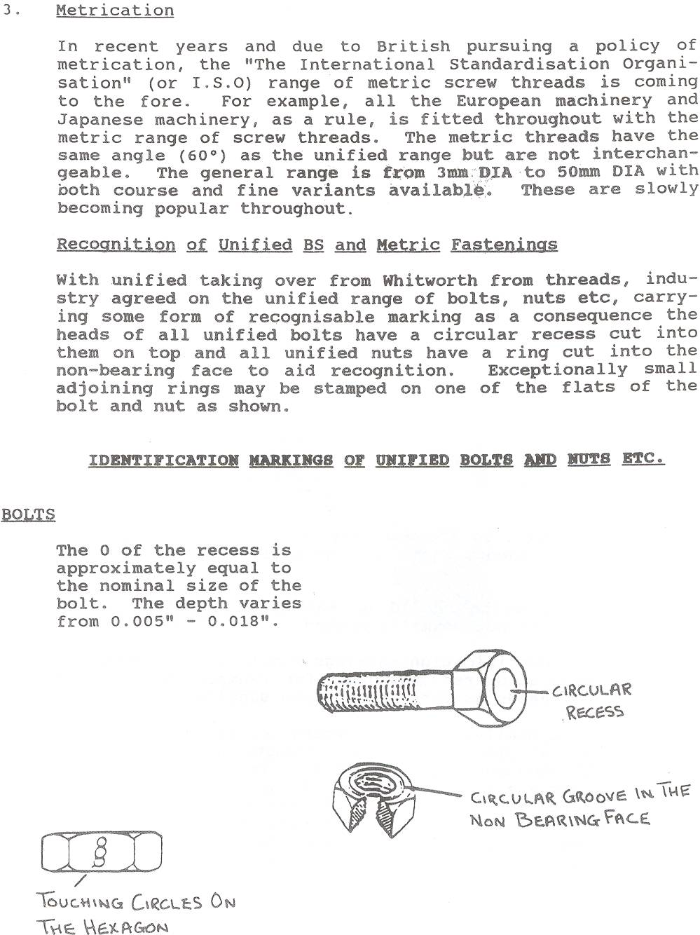

Unified studs have a raised flat end on them which is known as a flat dog point. The tapped hole into which the stud is screwed will usually have three adjoining rings stamped near to it to show a unified thread. If a tapped hole on machinery has got this identification, do not automatically assume that the hole is B.S.W or B.S.F because corrosion or dirt may have obscured the marking or it could be metric.

Studs
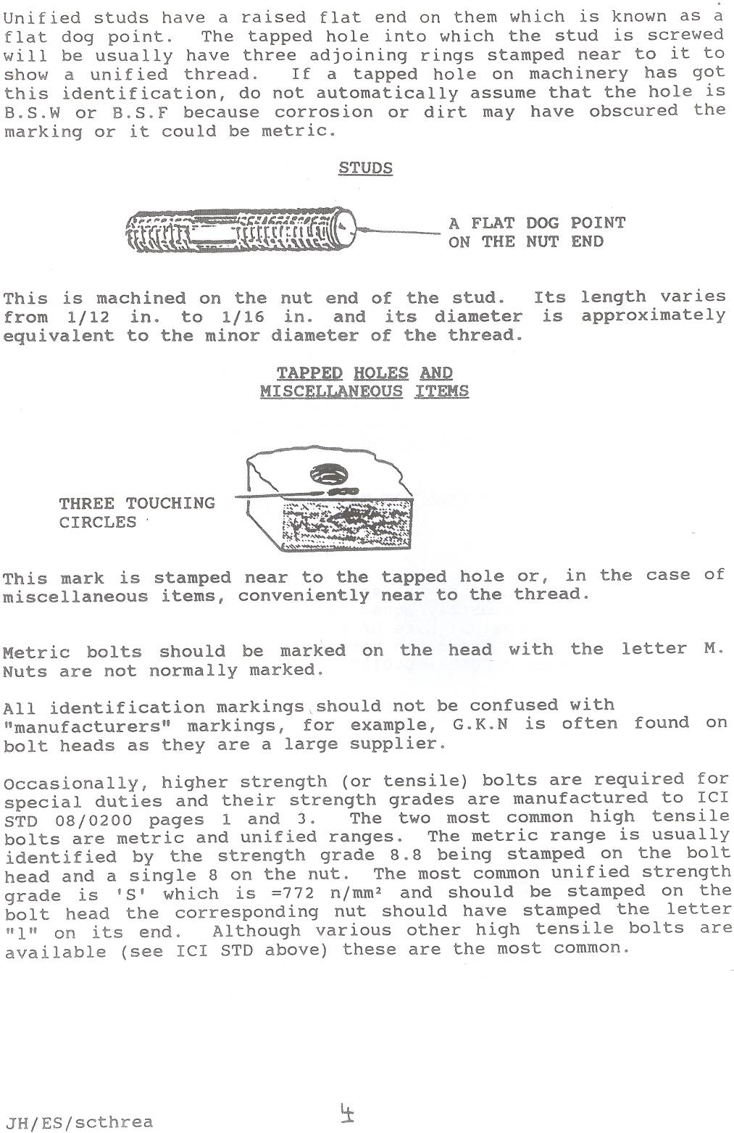

This is a machined on the nut end of stud. Its length varies from 1/12 in. to 1/16 in. and its diameter is approximately equivalent to the minor diameter of the thread.

Tapped Holes and Miscellaneous Items.

This mark is stamped near to the tapped hole or, in the case of miscellaneous items, conveniently near to the thread.

Metric bolts should be marked on the head with the letter M. Nuts are not normally marked.

All identification markings should not be confused with “manufacturers” markings, for example, G.K.N is often found on bolt heads as they are a large supplier.

Occasionally, higher strength (or tensile) bolts are required for special duties and their strength grades are manufactured to ICI STD 08/0200 pages 1 and 3. The two most common high tensile bolts are metric and unified ranges. The metric range is usually identified by the strength grade 8.8 being stamped on the bolt head and a single 8 n the nut. The most common unified strength grade is ‘S’ which is =772 n/mm²
And should be stamped on the bolt head the corresponding nut should have stamped the letter “1” on its end. Although various other high tensile bolts are available (see ICI STD above) these are the most common.

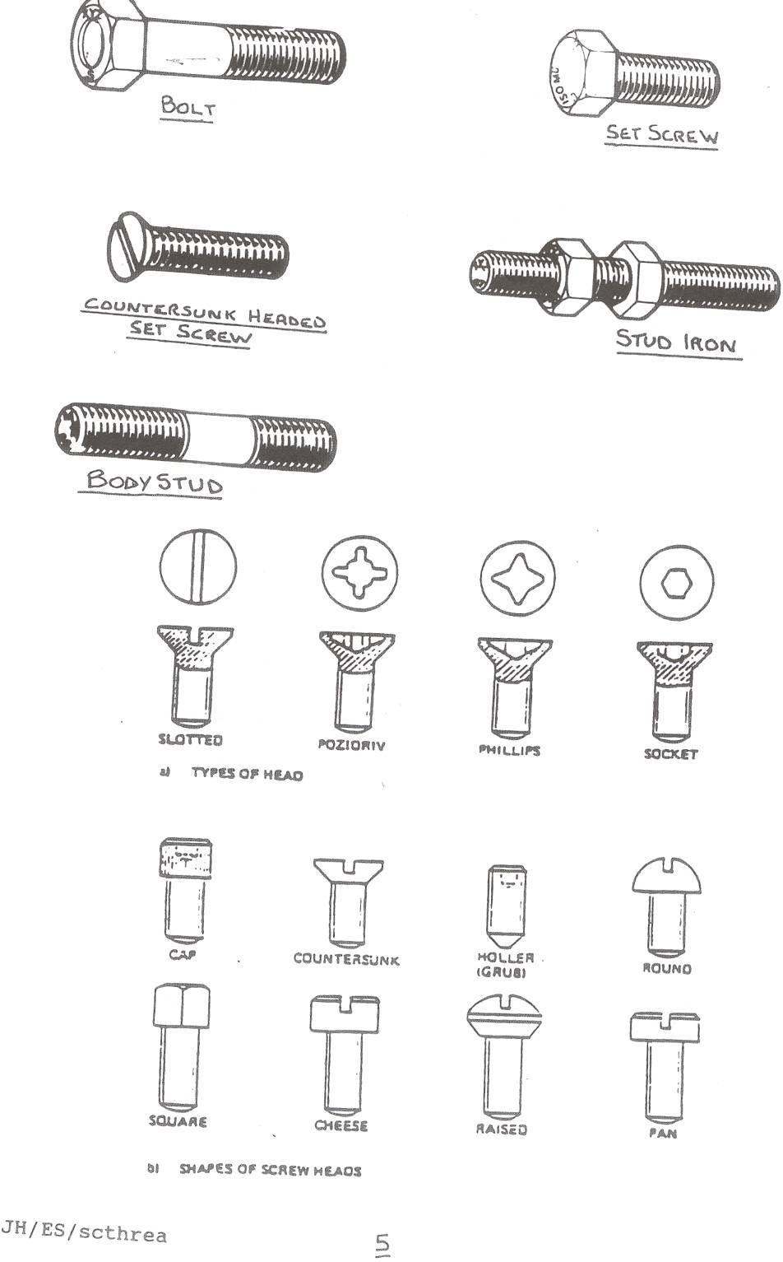

Special Duties

For extreme pressure and temperature and other hazardous conditions, a range of alloy steel stud bolts is available, the usual alloy is 1% chrome molybdenum, referred to by their grade numbers, the most common ones being B7 L7 and B16 and are stamped so on their ends all chrome moly studs should be used with the correct strength nuts, ie 2H/L4 as on ICI STD 08/0589 and 08/0551 (shown overleaf). The temperature range is -50 to -100ºC for L7 and -50 to +400ºC for B7 their uses would be specified in the pipeline specification sheets and they are of the unified course thread.

Hexagon Socket Screws

Hexagon socket screws are manufactured from high grade alloy steel and are hardened in oil and tempered. They should be free from defects in manufacture and have a blue/black finish after heat treatment. Socket hands may be plain in knurled and are proportional in size to the shank and socket. They are high tensile and are used mainly on machines.

Machine Screws and Fitted Bolts

Machine screws are threaded over their length and have various shaped heads, ie . round, countersunk, cheese etc. Fitted bolts of various threads are used on equipment to position as well as secure and are machined to close tolerances to be light transition fit in holes.

Thread Gauges

If any doubt exists as to the nature of a particular thread, by using preformed gauges known as thread gauges we can determine the angle of thread and the teeth per inch, and if the outside diameter of the thread is measured we can refer to reference charts (figs. 1, 2 and 3) to determine the correct size and type of thread.

To use thread gauges firstly ensure thread to be measured is clean, then by selecting various gauges by trial and error until the correct one is found and by holding up to the light the T.P.I and thread profile can be ascertained.

Locking Devices

There are various methods of ensuring nuts stay secured to their bolts, a list of which is shown below.

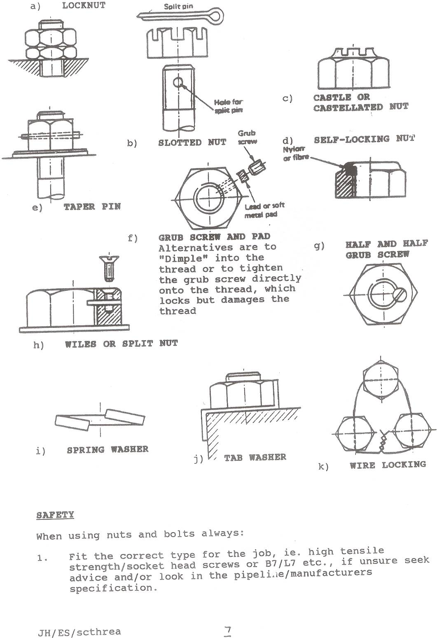
Safety

When using nuts and bolts always;

- Fit the correct type for the job, ie. high tensile strength/socket head screws or B7/L7 etc., if unsure seek advice and/or look in the pipeline/manufacturers specification.

- Fit the correct size and number off, ie. to ensure the correct diameter and bots are long enough to obtain at least a full nuts length.

General Safety

Always check bolts for wear, corrosion, fatigue, stretch etc. DO not over-tighten nuts. Always use correct size spanners! Although some threads may be interchangeable it is bad practice and should be avoided.

Fastening to Masonry etc.

The most common methods of fastening to concrete/brickwork are rawl plugs/rawl bolts, rang bolts and red heads.

Rawlplugs – usually made of either plastic or compressed fibre and inserted into like-sized holes for use with wood screws, as screw is inserted into plug it forces the buried plug to expand and grip the sides of the hole. Used for light securing work.
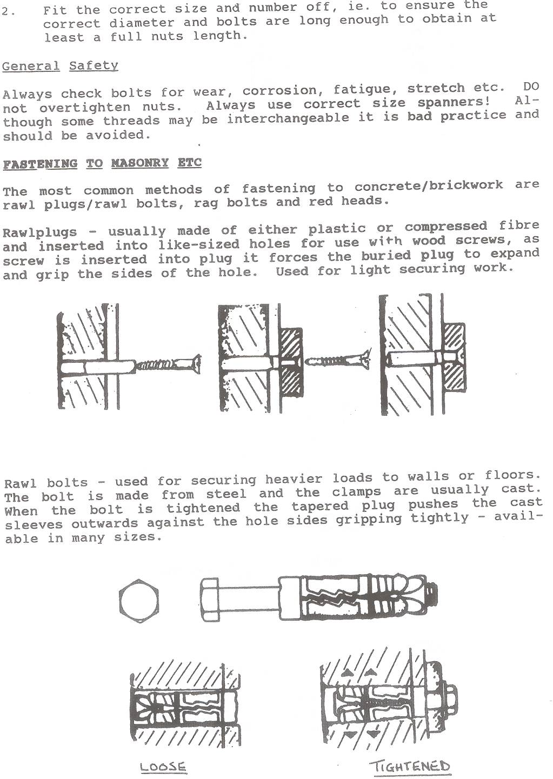
Rawl bolts – used for securing heavier loads to walls or floors. The bolt is made from steel and the clamps are usually cast. When the bolt is tightened, the tapered plug pushes the cast sleeves outwards against the hole sides gripping tightly – available in many sizes.
Rag Bolts

These are foundation bolts and when their final position is ascertained, they are grouted into their holes – usually with concrete. Are used on a vast array of plant machinery/vessels and supports for fixing firmly to the ground.

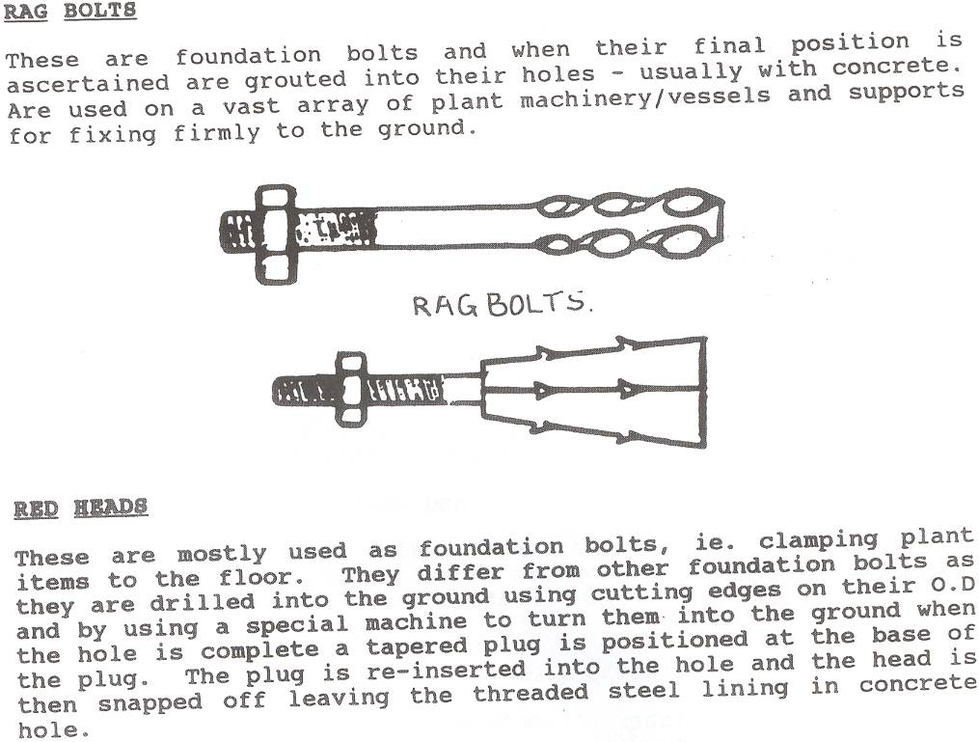

Red Heads

These are mostly used as foundation bolts, ie. clamping plant items to the floor. They differ from other foundation bolts as they are drilled into the found using cutting edges on their O.D and by using a special machine to turn them into the found when the hole is complete a tapered plug is positioned at the base of the plug. The plug is re-inserted into the hole and the head is then snapped off leaving the threaded steel lining in concrete hole.

Identification of Bolts and Nuts

Metric and Unified

General Notes

This standard has been prepared to assist in identifying various types of nuts and bolts in current use both metric and unified. It is important to replace like with like. The identification and marking of bolts, screws and nuts is not mandatory for all types, all sizes and al grades of material and this document explains the identification and marking that is recommended in appropriate British Standards for fasteners. For screwed items other than fasteners, see clause 5.

In the event of problems of identification not covered by this standard consult the Standards Section.

1. Metric Bolts, Screws and Nuts

The range of strength grades are as shown in the following tables. It should be noted that two drags of bolts only are stocked by manufacturers and are:

- Lower strength bolts to strength grade 4.6, the strength grade is not marked on;

- Higher strength bolts to strength grade 8.8; the strength grade is marked on.

Machine screws will not be marked but are to strength grade 4.8.

Strength Grade Designations of Steel Bolt and Screws

Strength Grade Designation | 4.6 | 4.8 | 5.6 | 5.8 | 6.6 | 6.8 | 6.9 | 8.8* | 10.9* | 12.9* | 14.9
Tensile Strength M/mm² | 400 | 400 | 500 | 500 | 600 | 600 | 600 | 800 | 1000 | 1200 | 1400
Yield Stress M/mm² | 240 | 320 | 300 | 400 | 360 | 480 | - | - | - | - | -
Stress at Permanent Set Limit M/mm² | - | - | - | - | - | - | 540 | 640 | 900 | 1080 | 1260

Strength Grade Designations of Steel Nuts

Strength Grade Designation | 4 | 5 | 6 | 9* | 12* | 14*
Proof Load Stress M/mm² | 400 | 500 | 600 | 800 | 1200 | 1400
*Bolts, screws and nuts manufactured to these grades shall be marked with the appropriate symbol. Other grades may be marked at the option of the manufacture.

Standard Bolt and Nut Combinations

Grade of Bolt | 4.6 | 4.8 | 5.6 | 5.8 | 6.6 | 6.8 | 8.8 | 10.9 | 12.9 | 14.9
Recommended Grade of Nut | 4 | 4 | 5 | 5 | 6 | 6 | 8 | 12 | 12 | 14

Nuts of a higher strength grade may be substituted for nuts of a lower grade.

  - Isometric Precision Hexagon Bolts, Screws and Nuts, BS 3692

1.1.1 Forged Products

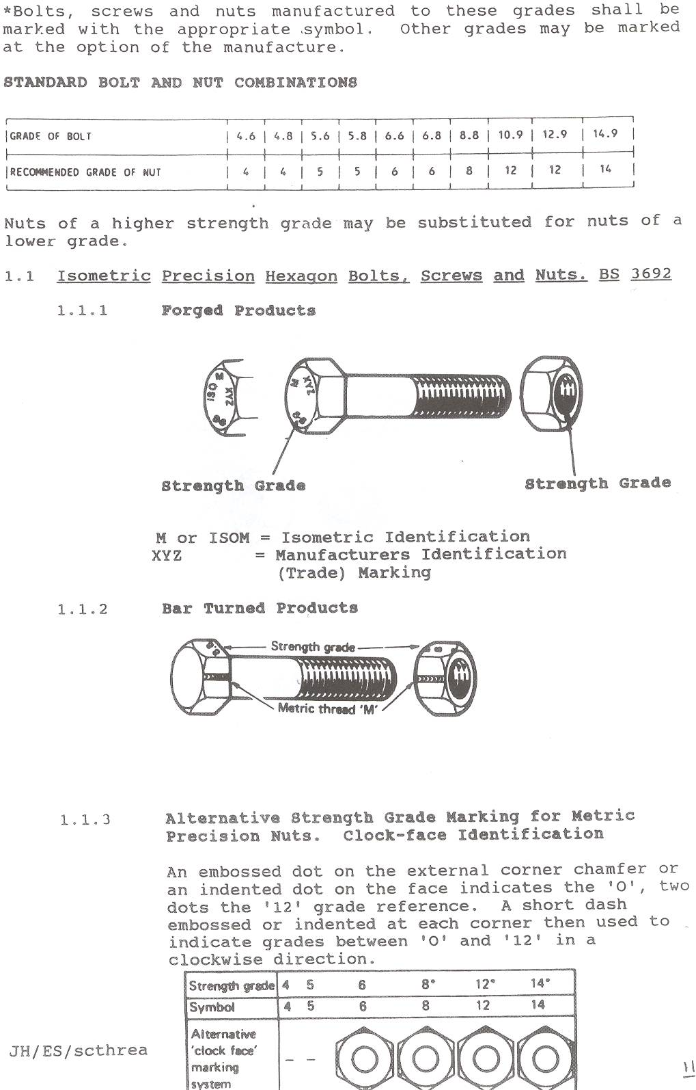

M or ISM = Isometric Identification
XYZ = Manufacturers Identification (Trade) Marking

1.1.2 Bar Turned Products

    - Alternative Strength Grade Marking for Metric Precision Nuts. Clock-face Identification

An embossed dot on the external corner chamfer or an indented dot on the face indicates the ‘0’, two dots the ‘12’ grade reference. A short dash embossed or indented at each corner then used to indicate grades between ‘0’ and ‘12’ in a clockwise direction.

Strength Grade | 4 | 5 | 6 | 8* | 12* | 14*
Symbol | 4 | 5 | 6 | 8 | 12 | 14
Alternative ‘clock face’ marking system | - | -

Grade of Bolt | 4 | 5 | 6 | 8* | 12* | 14*
Recommended Grade of Nut | 4 | 5 | 6 | 8 | 12 | 14
Alternative ‘clock face’ marking system | - | - | - | - | - | -

* Marking of strength grade is mandatory.

Or on the bearing or non-bearing face

1.2 Isometric Black Hexagon Bolts, Screws and Nuts. BS 4190

Bolts and screws of diameter 6mm and larger shall be identified as being ISO metric.

    - Forged Products

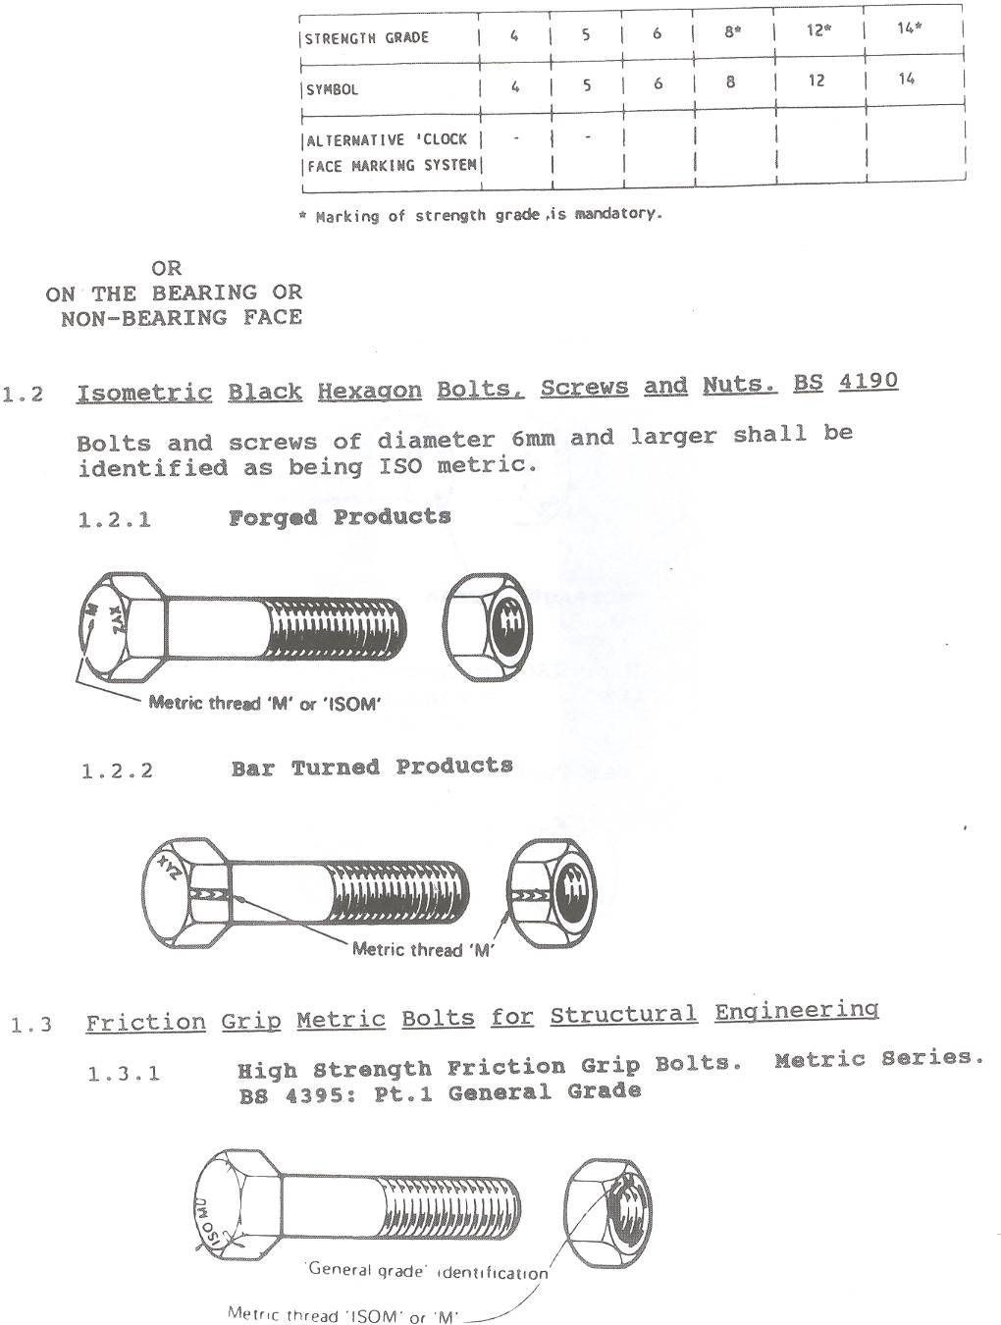

    - Bar Turned Products

  - Friction Grip Metric Bolts for Structural Engineering

    - High Strength Friction Grip Bolts. Metric Series. BS 4395: Pt.1 General Grade

1.3.2 High Strength Friction Grip Bolts. Metric Series BS 4395: Pt. 2 Higher Grade

  - Machine Screws and Machine Screw Nuts. Metric Series BS 4183

No identification marking.

The minimum strength values for the various metals are:

Steel 392 N/mm², Grade 4
Brass 314 N/mm²
Aluminium Alloy 314 N/mm²

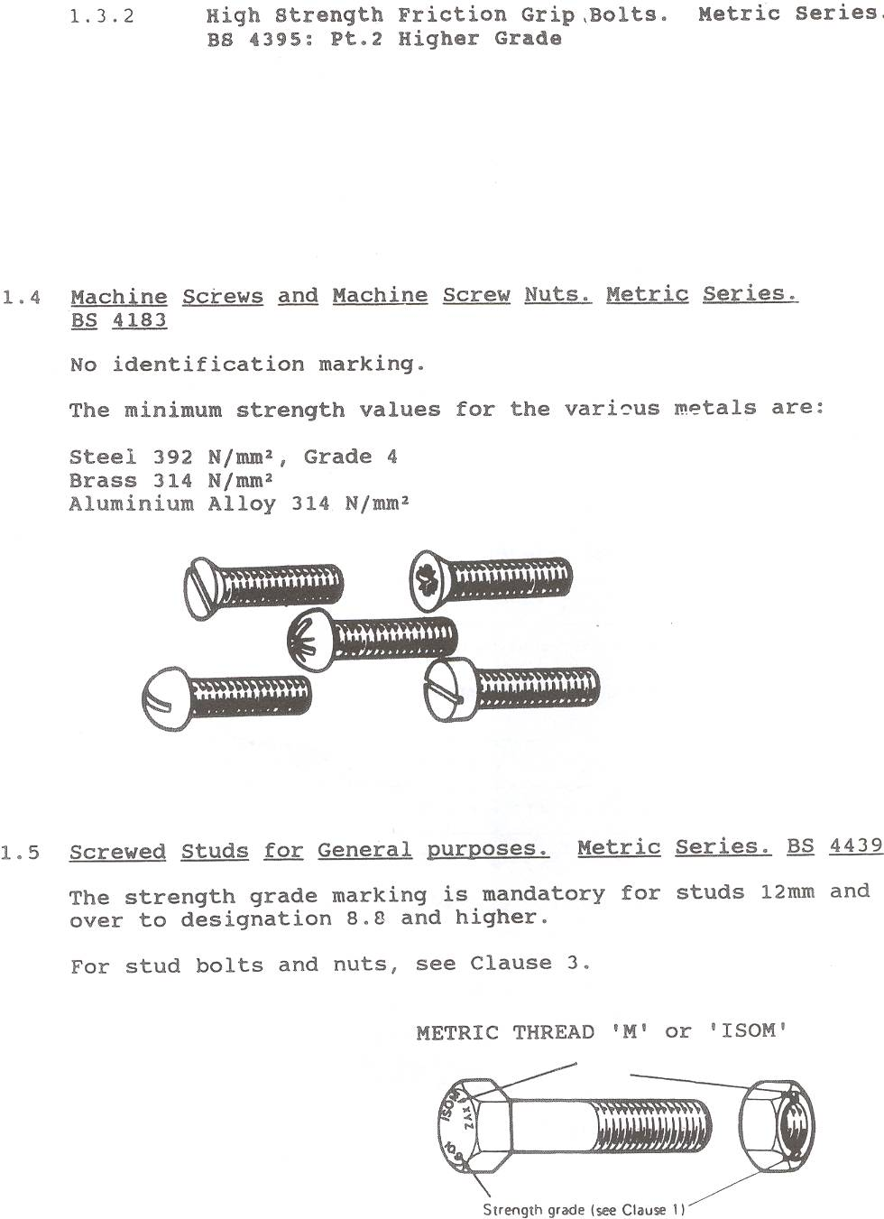

1.5 Screwed Studs for General purposes. Metric Series. BS 4439

The strength grade marking is mandatory for studs 12mm and over to designation 8.8 and higher.

For stud bolts and nuts, see Clause 3.

2. Unified (ISO Inch) Bolts, Screws and Nuts

The range of strength grades are as shown in the following tables:

Strength Grade Designations of Steel Bolts and Screws

Strength Grade Designation |  | A | B | P* | S* | T* | V* | X*
Tensile Strength | Cont/in² | 28 | 28 | 35 | 50 | 55 | 65 | 75
Tensile Strength | N/mm² | 432 | 432 | 540 | 772 | 849 | 1004 | 1158

Strength Grade Designations of Steel Nuts

Strength Grade Designation |  | 0 | 1* | 3* | 5*
Proof Load Stress | Cont/in² | 35 | 50 | 55 | 75
Proof Load Stress | N/mm² | 540 | 772 | 849 | 1158

*Bolts, screws and nuts manufactured to these grades shall be marked with the appropriate symbol.

Standard Bolt and Nut Combinations

Grade of Bolt | A | B | P | S | T | V | X
Recommended Grade of Nut | 0 | 0 | 0 | 1 | 3 | 5 | 5

Nuts of a higher strength grade may be substituted for nuts of a lower strength grade.

2.1 Unified Black Hexagon Bolts, Screws and Nuts (UNC and UNF Threads) BS 1769

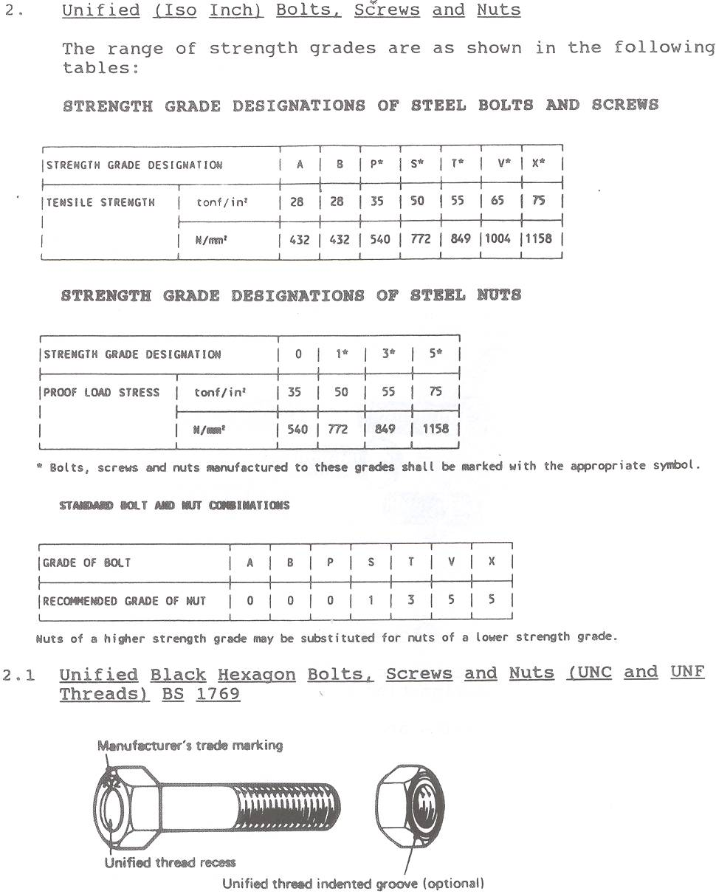
2.2 Unified Precision Hexagon Bolts, Screws and Nuts (UNC and UNF Threads) Normal Series. BS 1768
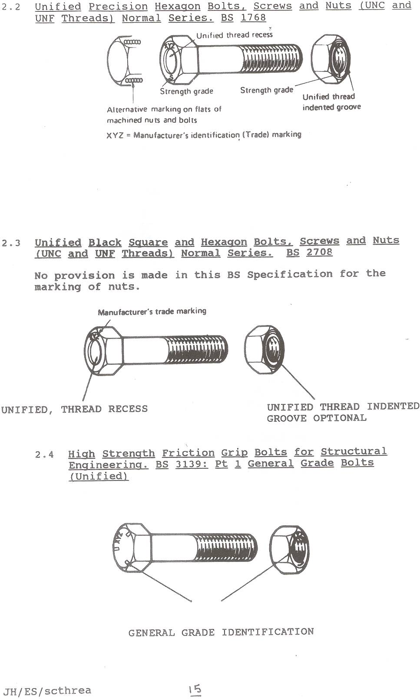

2.3 Unified Black Square and Hexagon Bolts, Screws and Nuts (UNC and UNF Threads) Normal series. BS 2708

No provision is made in this BS Specification for the marking of nuts.

2.4 High Strength Friction Grip Bolts for Structural Engineering. BS 3139: Pt 1 General Grade Bolts (Unified)

  - Screwed Studs BS 2693: Pt 1. General Purpose Studs (Unified)

Strengths A and B are not required to be marked by this British Standard, only studs 3/8in. and over of strengths R and T may be marked if specified by the purchaser.

For stud bolts and nuts see clause 3.

GRADES
Code Symbol Strength Grade | Minimum Tensile Strength
Code Symbol Strength Grade | Tonf/in² | N/mm²
A | 28 | 432
B | 28 | 432
R | 45 | 694
T | 55 | 849

Steel Studs Unified Thread
Strength Grade Shallow Dog Point
R = 45 tonf/in² on nut end

  - Unified Machine Screws and Machine Screw Nuts. BS 1981

No identification marking. The minimum strength values for the various materials are:

Steel 392 N/mm²
Brass 314 N/mm²
Aluminium Alloy 314 N/mm²

Stud Bolts and Nuts BS1750

Each stud and nut is marked with the manufacturers identification and the material marking. Details of the various material grads are shown in BS1750.

These stud bolts and nuts are unified, marking is as shown below.

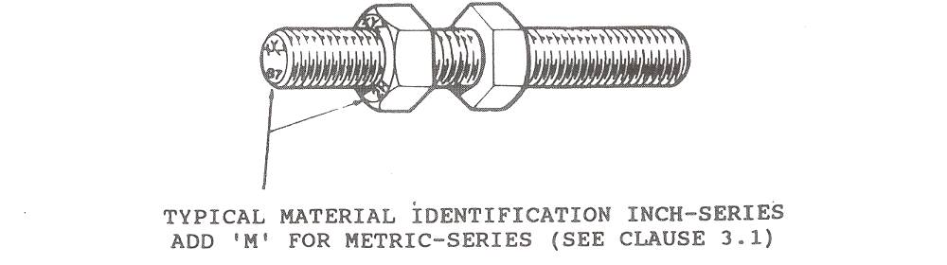
3.1 Isometric Thread Identification

Stud bolts and nuts screwed with ISO metric threads will be similarly marked as above but with the addition of the letter ‘M’.

4. Tapped Holes
There is no British Standard convention for marking tapped holes. When it is necessary to identify the thread it is recommended that three touching circles ‘000’ be used to identify unified threads and ‘M’ be used to denote metric threads. This mark is stamped near to the tapped hole, or, in the case of miscellaneous items, conveniently near to the thread.

- Screwed Items other than Fasteners

For identification of screwed items other than fasteners such as eye-bolts, refer to the appropriate British Standard.

